2008-2014 WRX and STi
Rear:
- Open Hatch or Trunk and remove Trunk Carpet
- Hatch Only: Remove plastic covers on the side panels to access rear top hats.
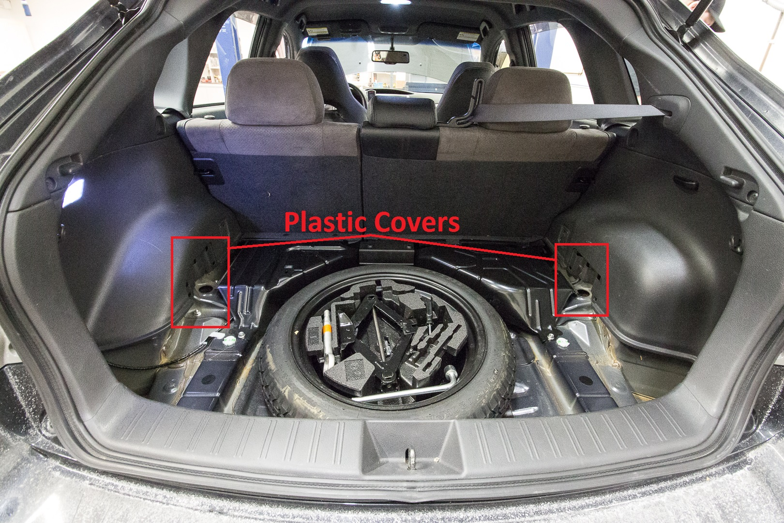
- Remove 2 14mm nuts on each side. These hold the top hat to the body of the vehicle.
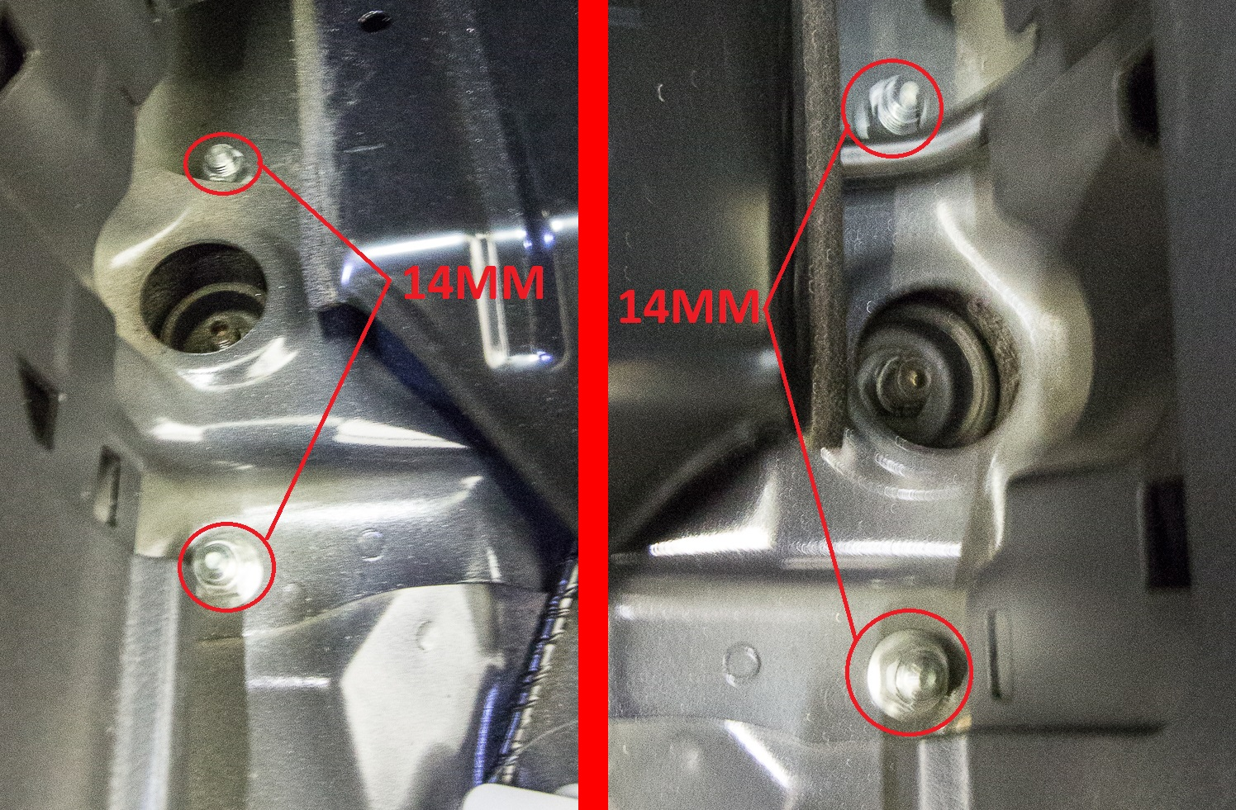
- Raise and support vehicle and then remove the wheels.
- Remove the 17mm nuts and bolts from the control arm on both sides. Keep track on what hole this bolt came out of as the shock bolt is different.
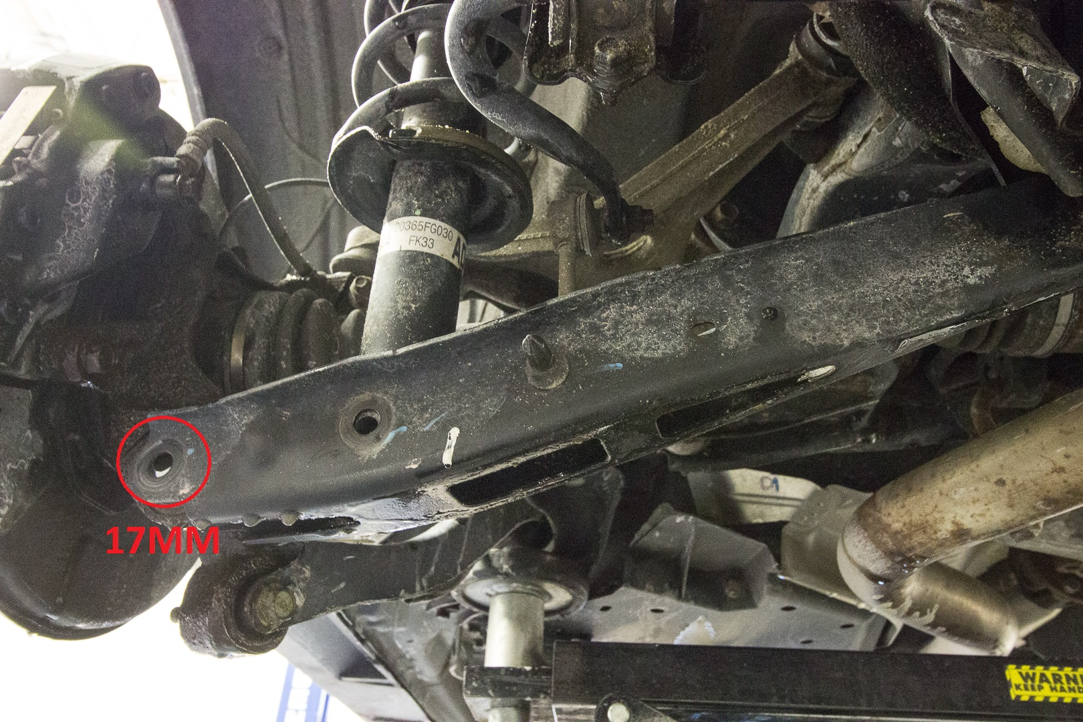
- Remove 17mm bolt and nuts holding the shock in.
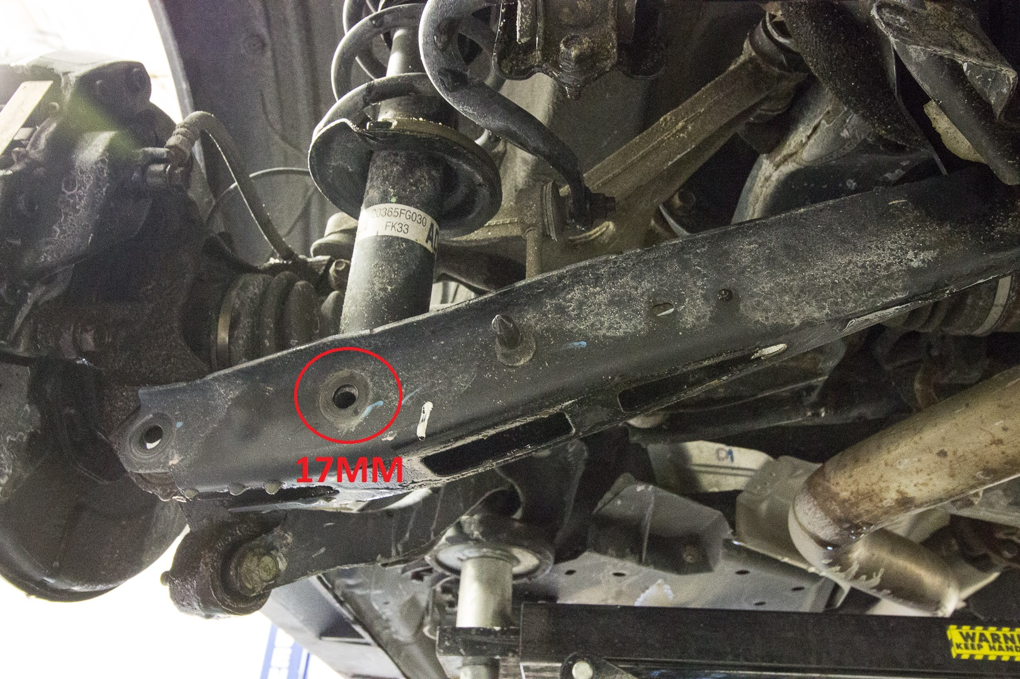

- Pull/push down on the arm and remove the factory shock and spring assembly.
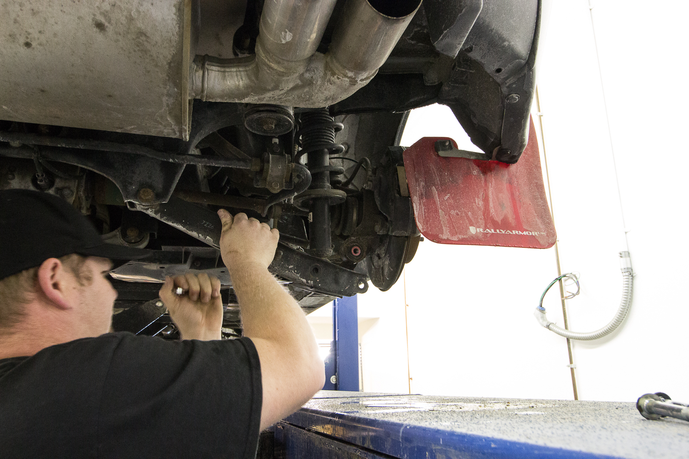
- Grab the anti-seized ISC coilovers. Note: If the shaft is installed in the bottom mount and is threaded just past the window in the bottom mount the final height with stock tires will be just about flush with the fender.
- A 2nd person is helpful here. Remove the 2, 14mm nuts from the coilover top hat. Pass the coilover up so that the top hat mounts into the car. Have a 2nd person thread the nuts on. Do the same for the other side.
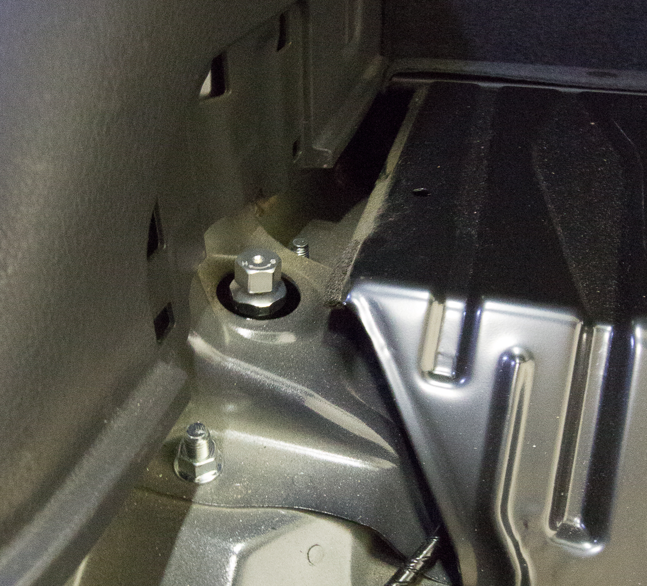
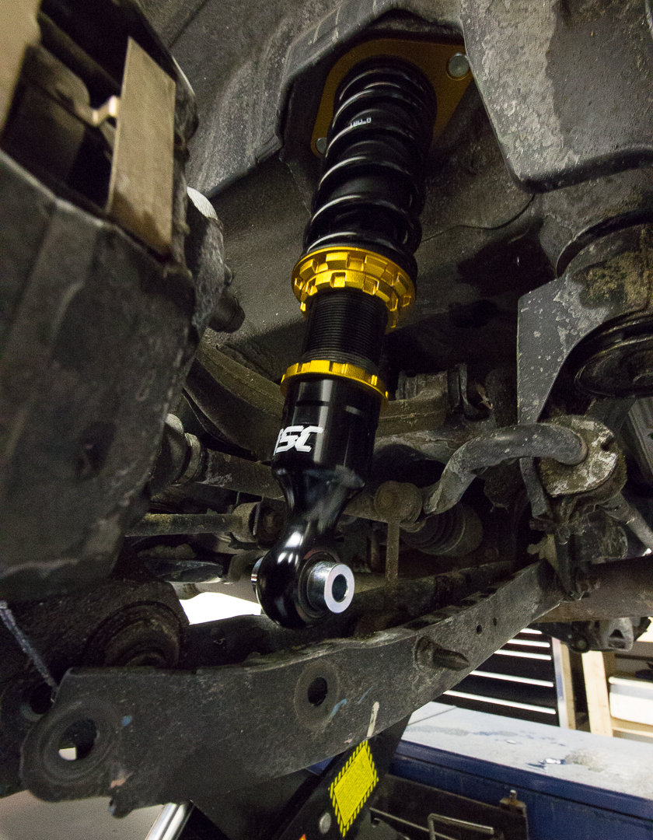
- Reinstall the outer 17mm bolt and nut. You may need to pull/push the hub down to line up.
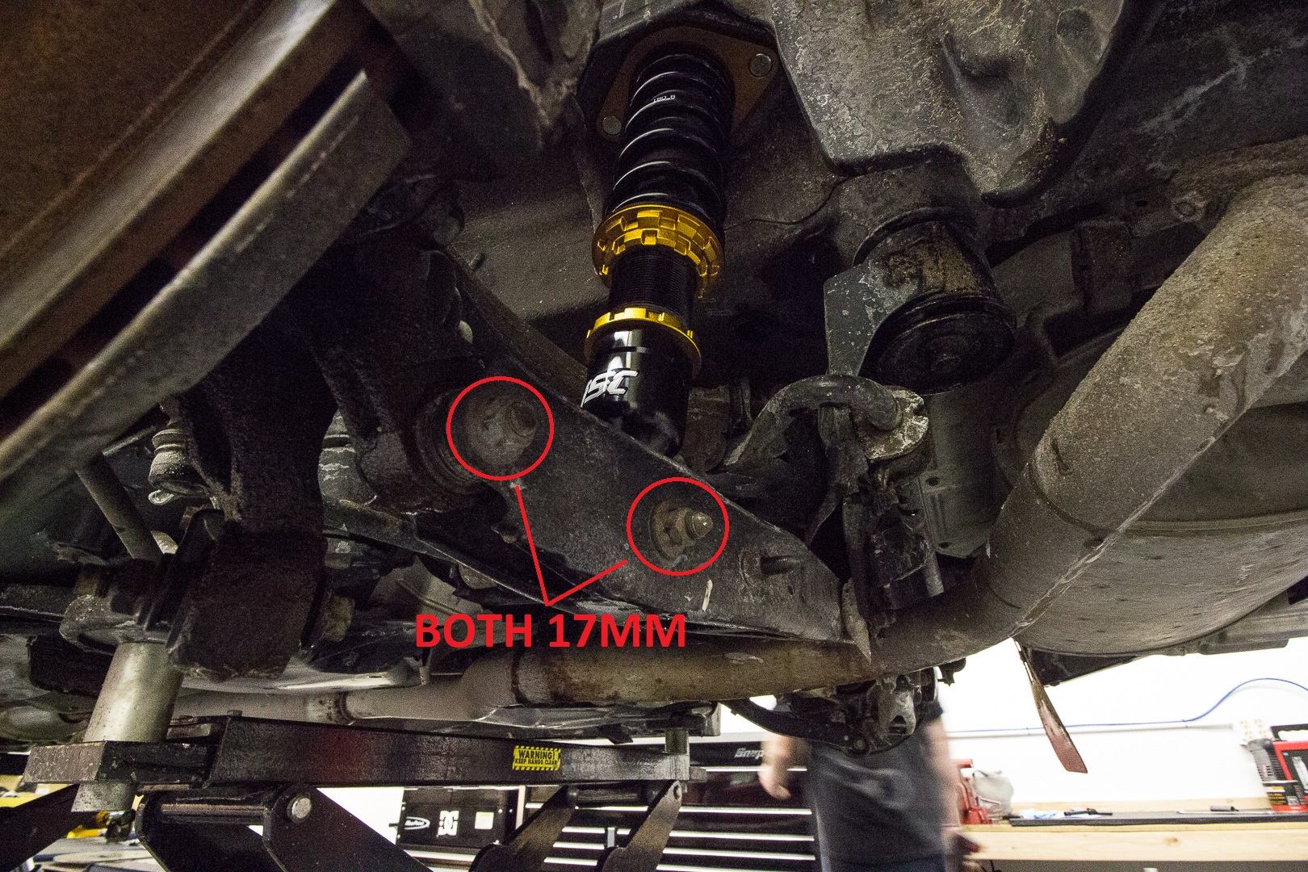
- Use a jack to push up on the control arm to line up the shock holes into the control arm. This is a tight fit.
- Install the shock 17mm nut and bolt. Tighten all lower nuts and bolts/14mm top nuts to factory specifications.
Front:
Note: Do both sides at the same time, this makes for an easier install.
- Remove the front wheels.
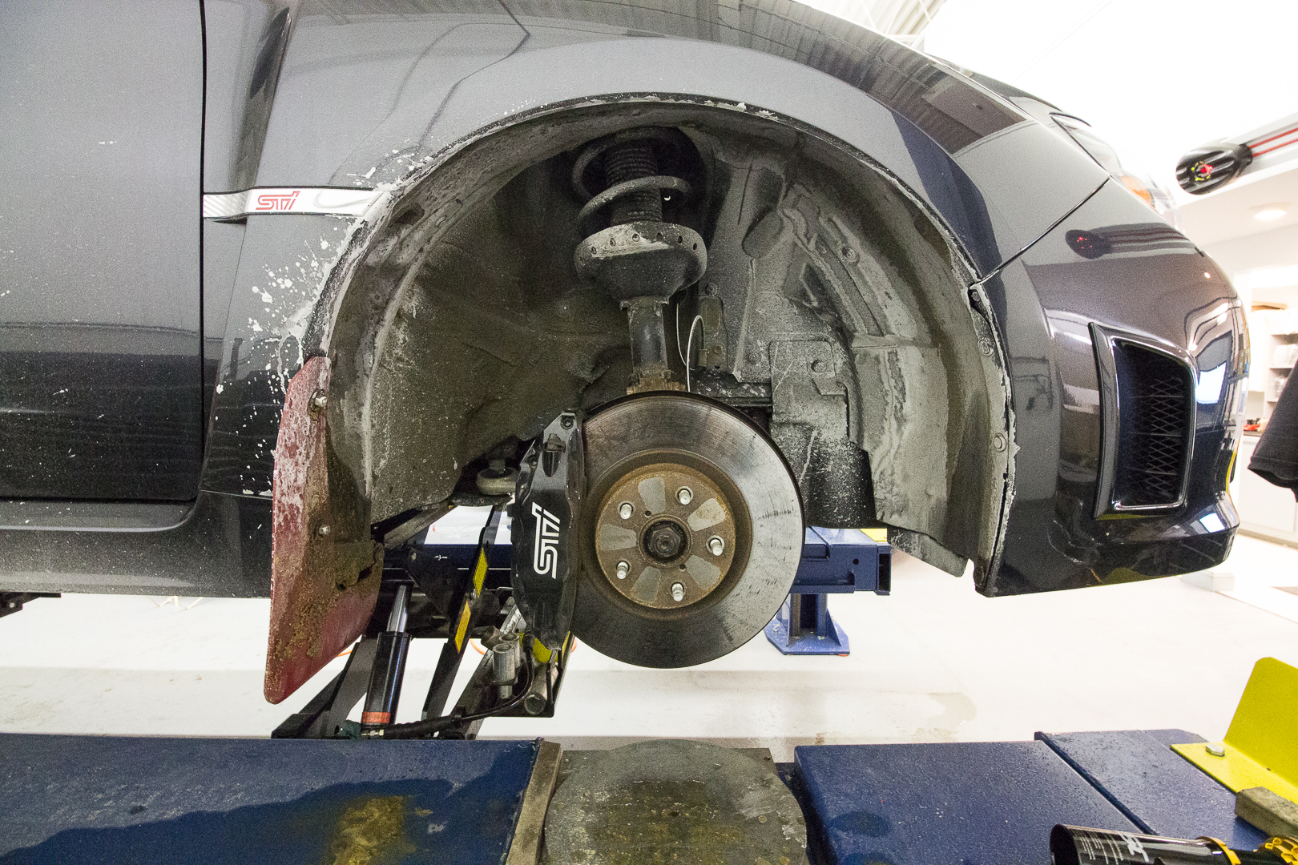
- Remove the 12mm bolts from the abs and brake line tabs.
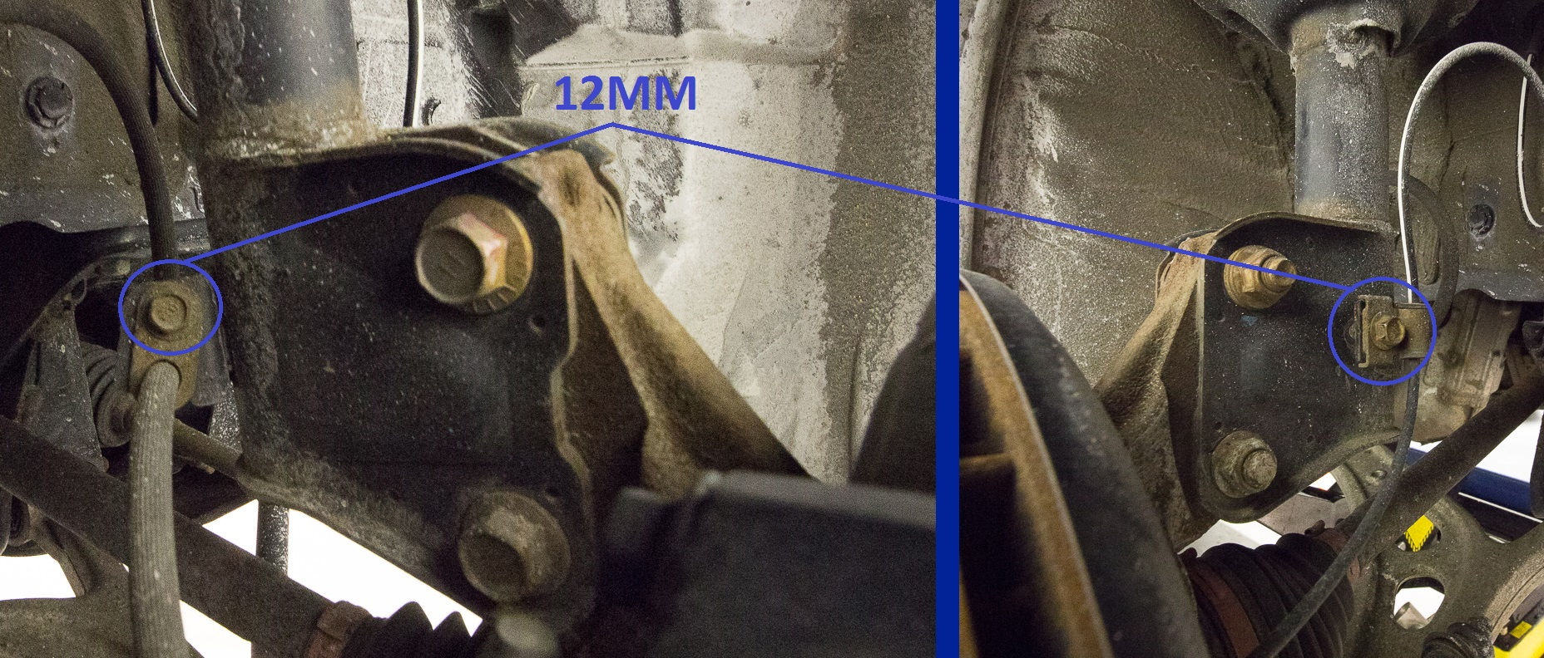
- Remove the two 19mm nuts and bolts from the strut bottom mount. Note: Top bolt is a cam bolt and has to reinstalled on the top.
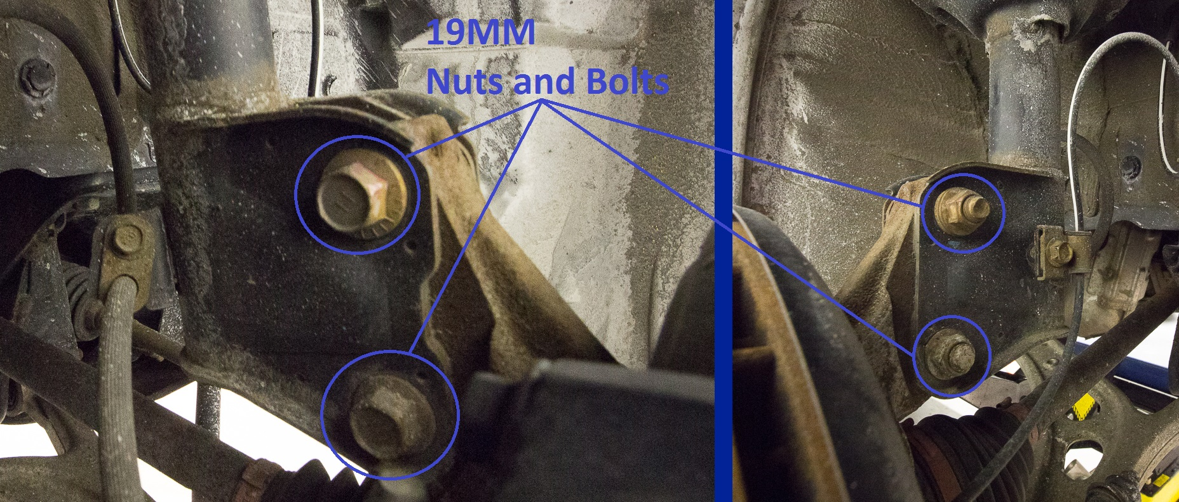
- Lower the spindle down.
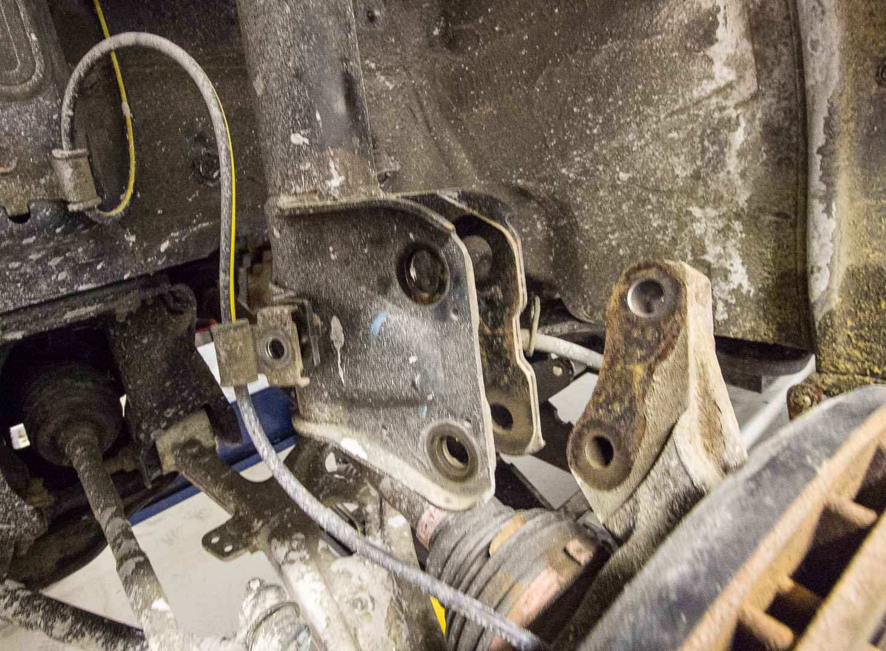
- Remove the 3, 12mm nuts on the top. Before removing the last one hold the strut to keep it from falling.
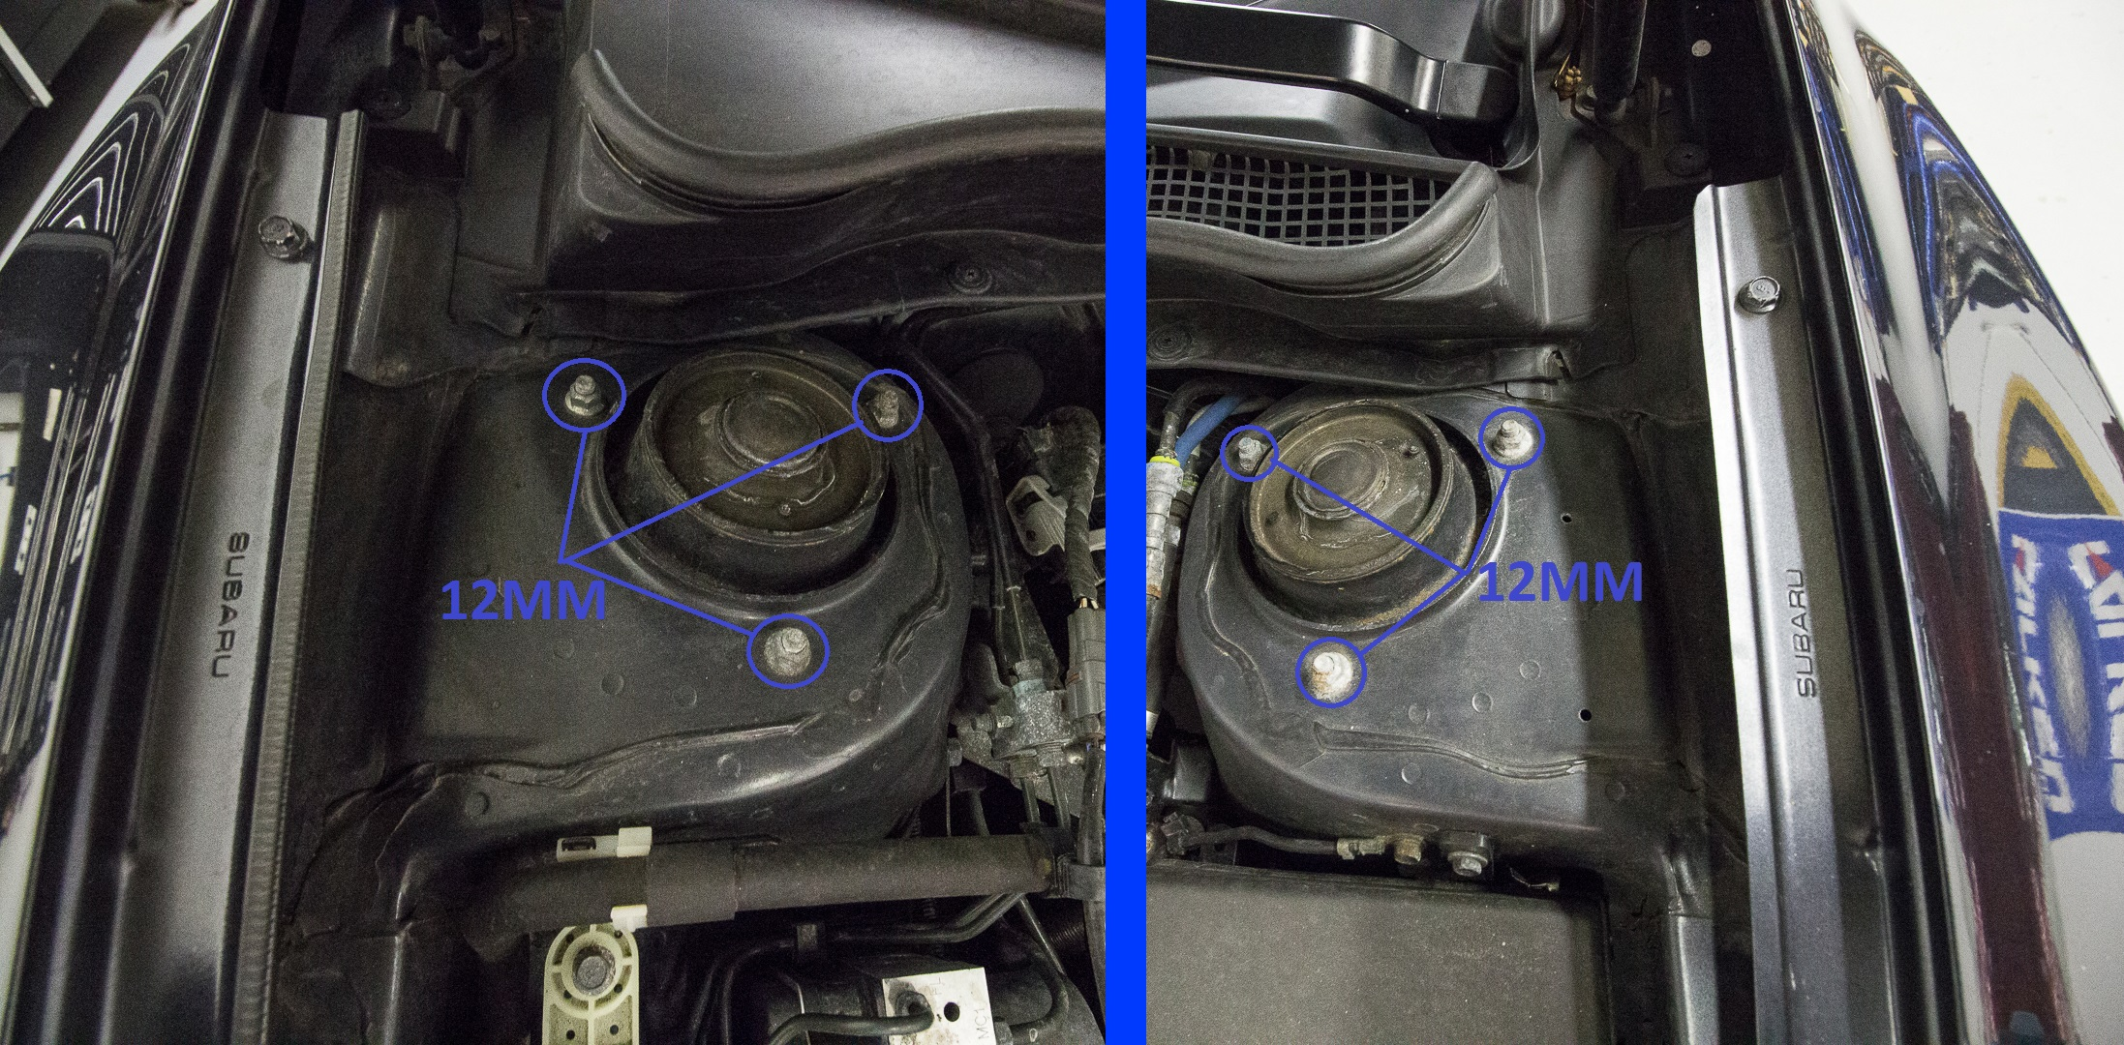
- Grab your new fancy anti-seized coilover and remove the 12mm nuts from the top plate. Note: With the shaft threaded into the bottom mount to the point where the bottom of the shaft is almost flush with the bottom of the bottom mount the factory wheels will be almost flush with the fender.
- Verify you have the correct side. ABS tab faces the front of the car and the camber adjusters on the top plate should be parallel to the firewall.
- Install the top of the coilover into the car and tighten the top 12mm nuts to spec.
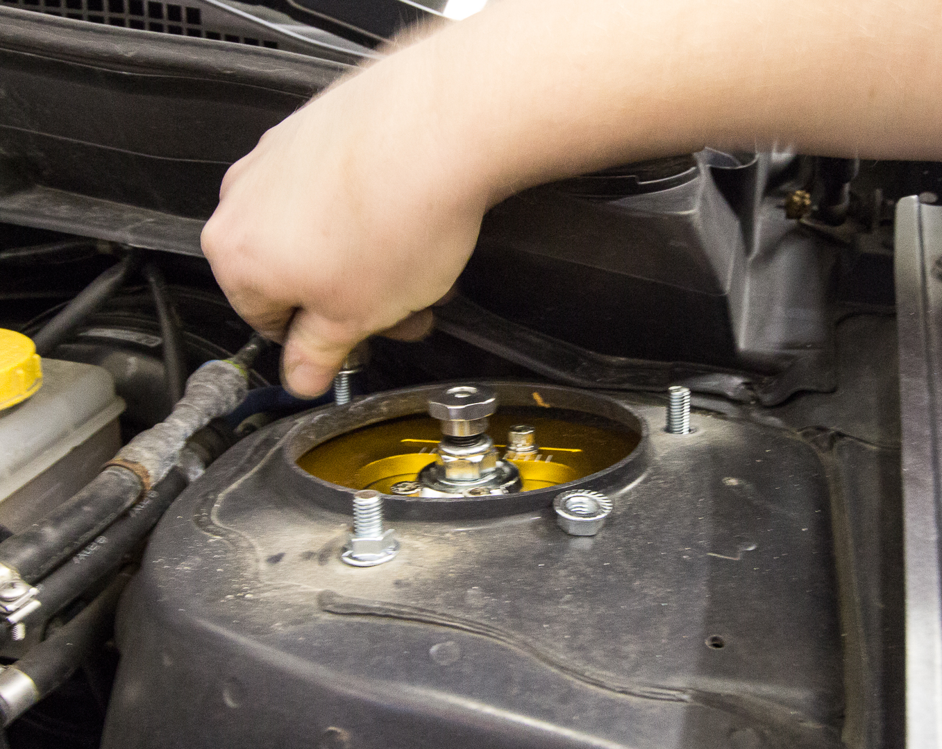
- Using a jack, lift the spindle into the coilover.
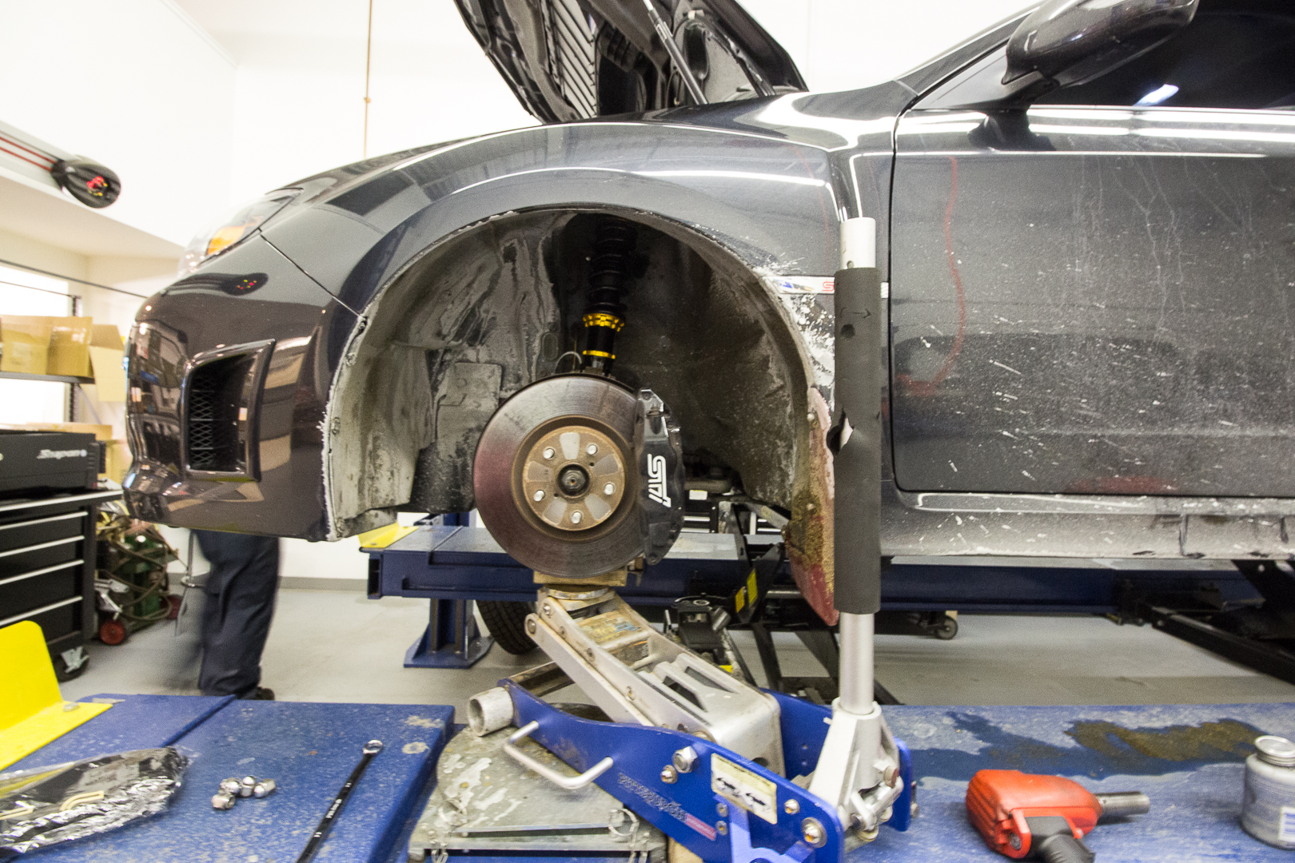

- Install the top 19mm cam bolt
- Install the lower 19mm bolt.
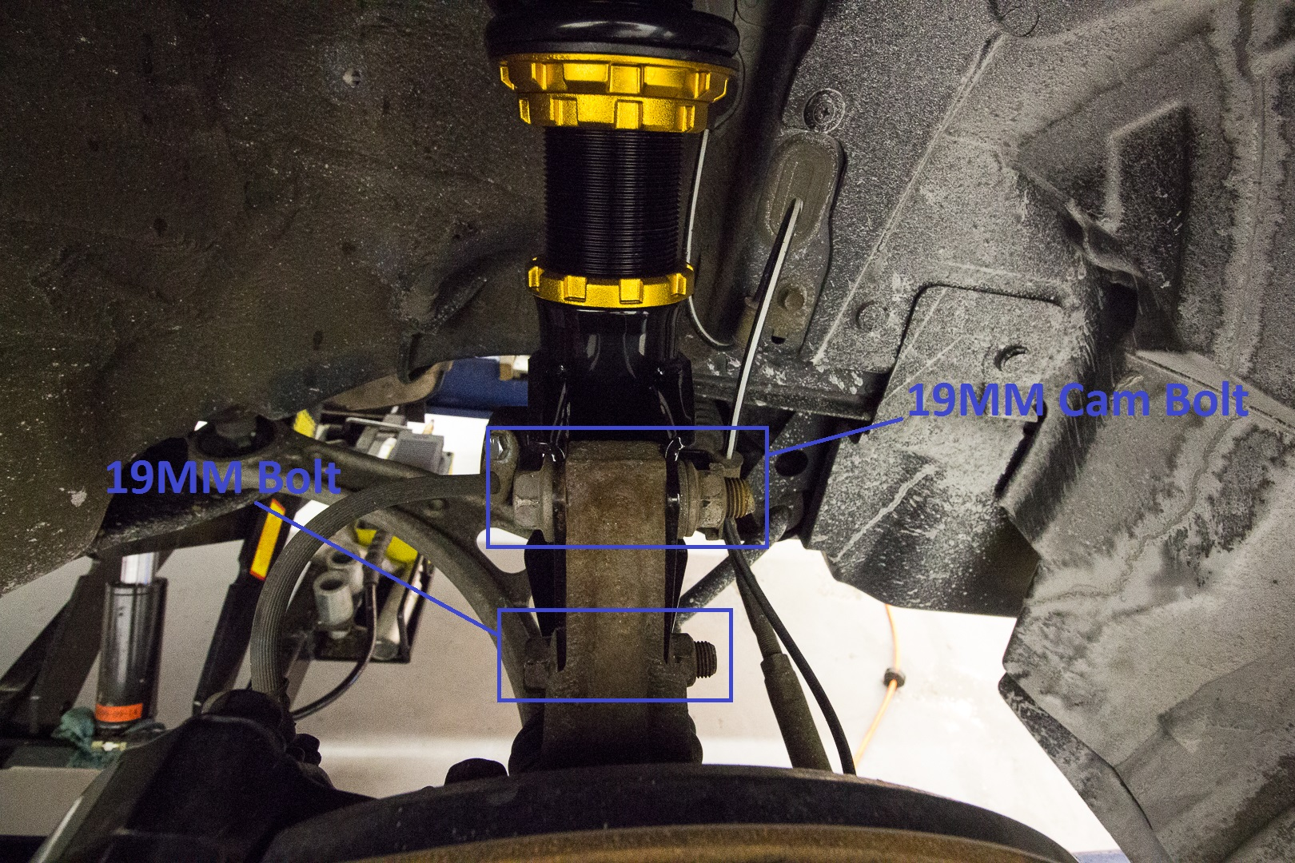
- Check the orientation of the cam bolt. It is best to start with natural lines on the cam bolt facing up.
- Tighten the 19mm nuts to spec while making sure the cam bolt does not rotate.
- Install provided 12mm bolt and nuts into the AB and brake line tabs and tighten to spec.
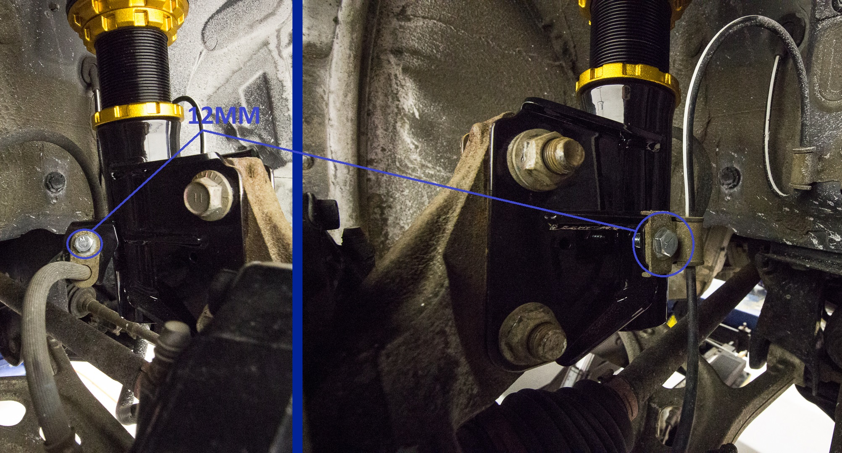
- Set pre-load on all 4 coilovers. 5mm is recommended. Set lock rings and choose height.
- Install wheels.
- Check height and make adjustments as necessary.
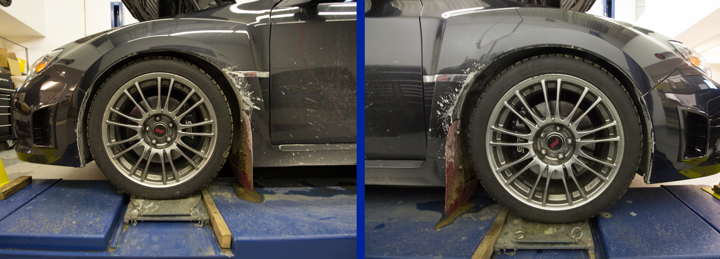
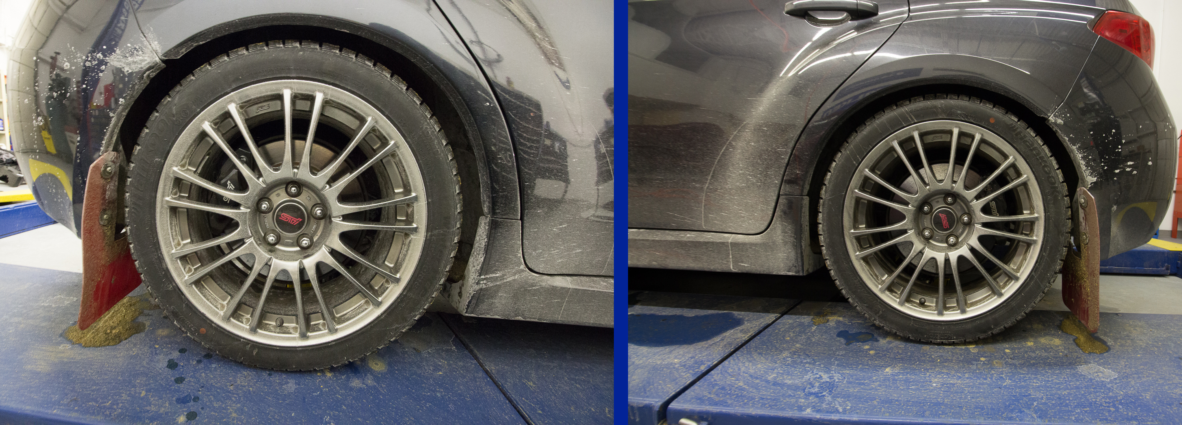
- ENJOY!

