ISC Suspension N1 Coilover Installation for 08+ Lancer Evolution X
Rear:
- Remove the carpet and other misc. covers from the trunk to access the tops of the rear strut mounts.
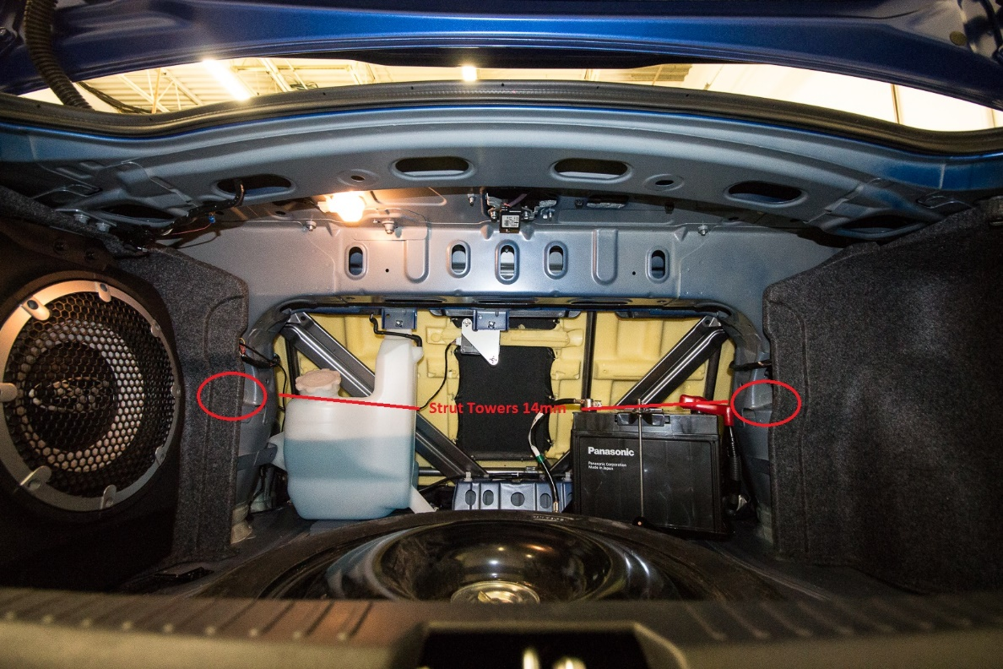
- Remove the 17mm Bolt that holds the strut in place to the lateral link
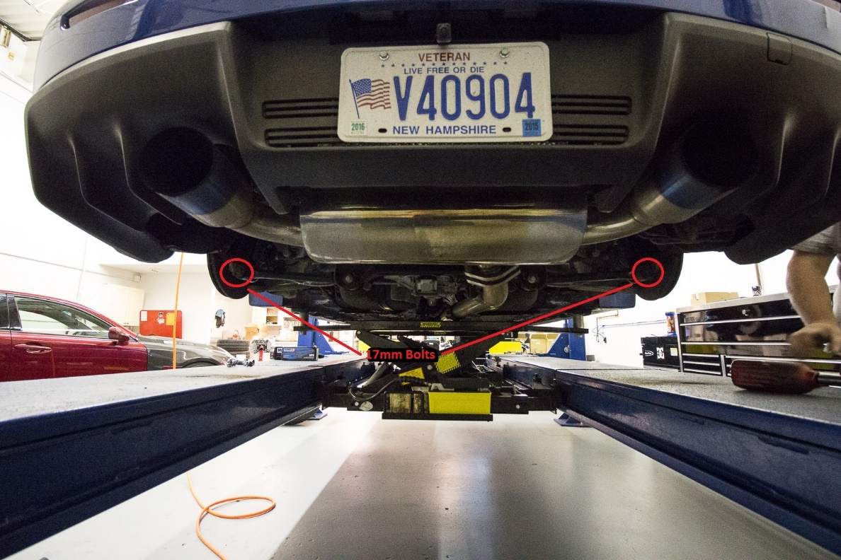
- Unbolt the top 14mm bolts
- Anti-Seize your new rear coilovers
- Install your coilovers and attach the top 14mm nuts in place if you have rear extenders you can route them as below.
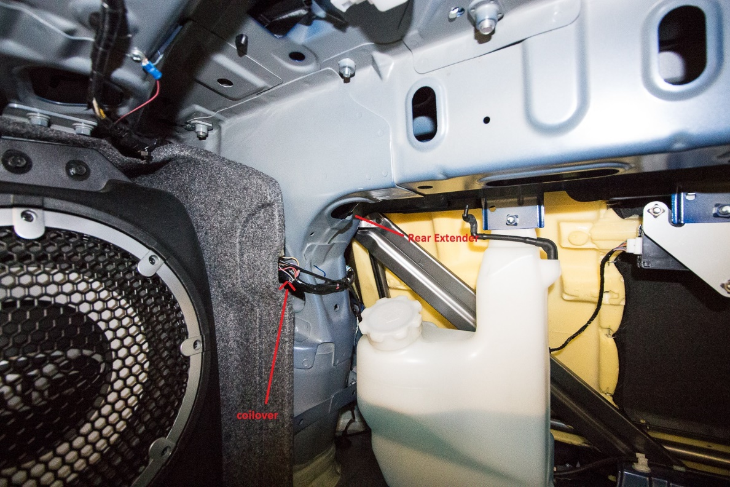
- Re-install the bottom mount into the lateral link and tighten with the 17mm bolt.
- Adjust height as needed for what you’d like
Front:
- Remove the Wheel
- Remove the plastic bottom pieces from the base of the coilover that allows the ABS line to wrap around.
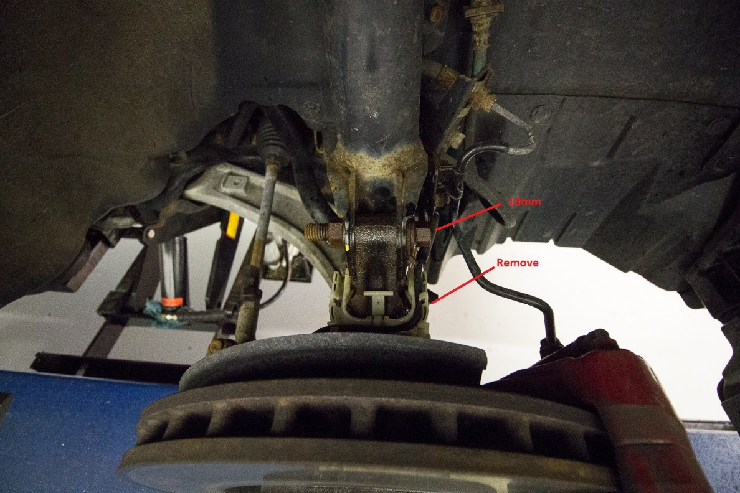
- Remove the ABS bracket held in place with a 12mm bolt
- Remove the two bottom 19mm Bolts that hold the base of the strut in place.
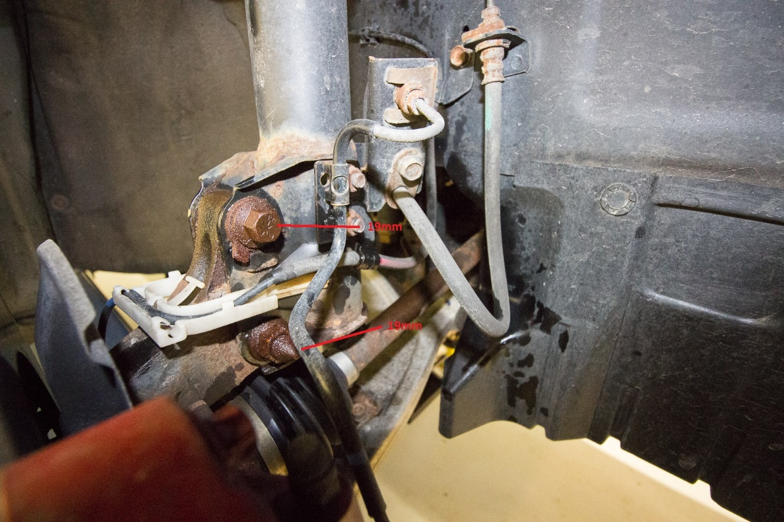
- Remove the three top 14mm Nuts that hold the nut in place.
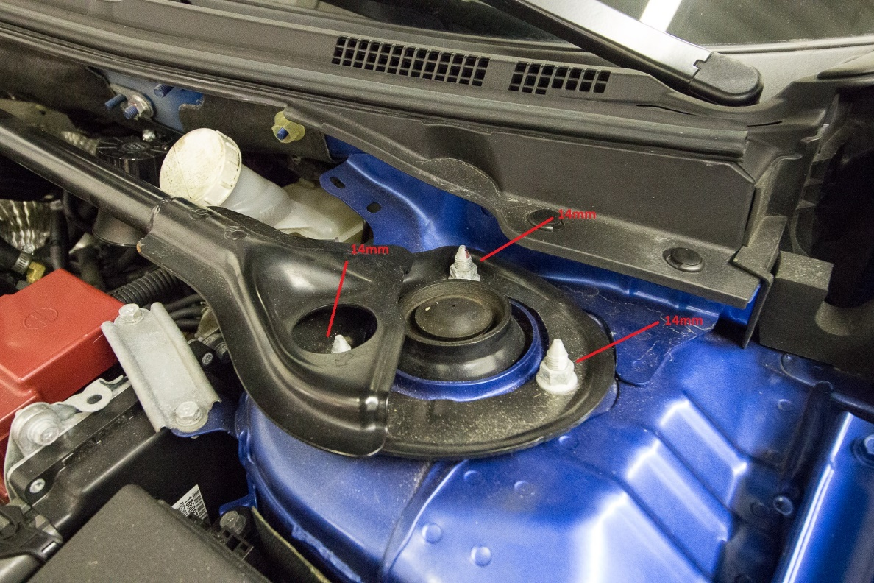
- Anti-Seize your coilovers
- Install your coilovers and ensure the camber plate orientation is correct as shown
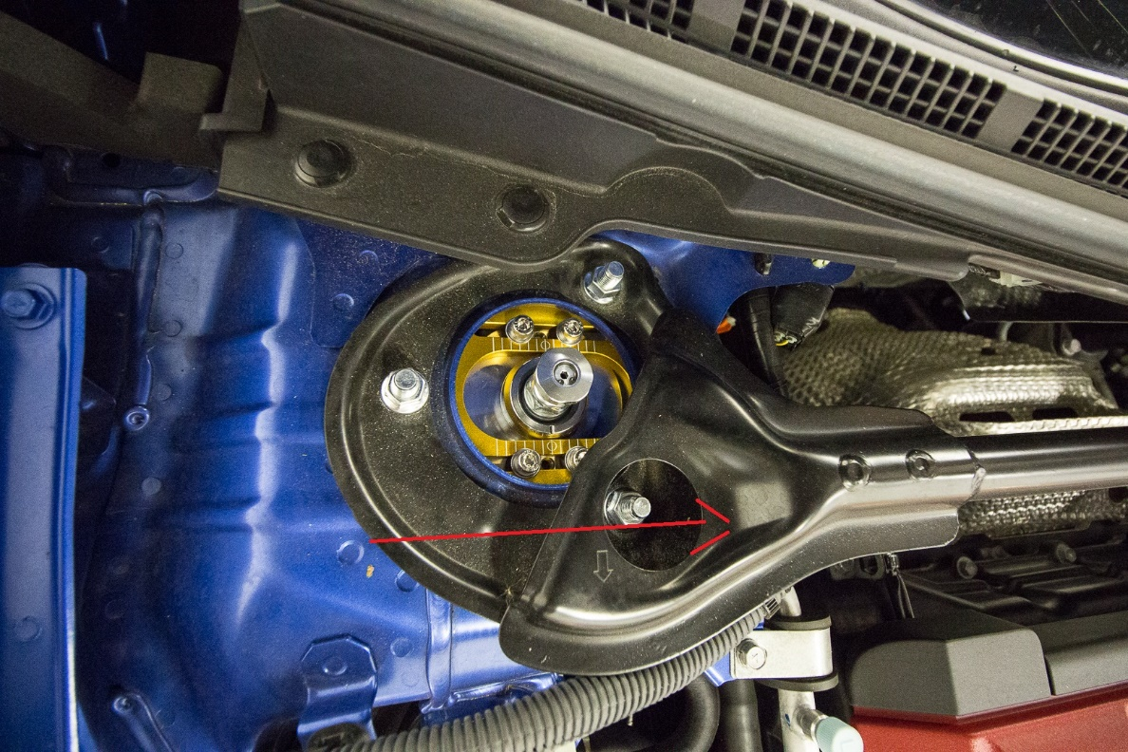
- Tighten the top 14mm bolts on top
- Anti-Seize all bolts
- Adjust height as needed

