Step 1: Place the car on jack stands, front, rear, or all 4.
Step 2: (Front) Remove the Cowl that is held in place by 2 screws and 3 pop its. You may be able to perform the install without removing the wiper blade arms but it will be easier if you do. 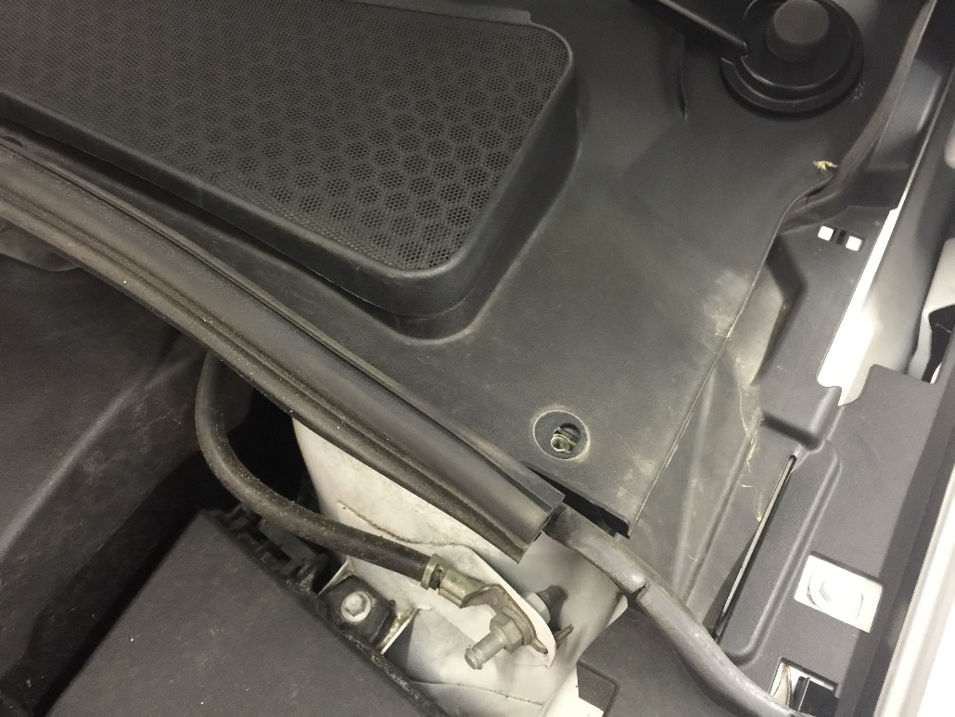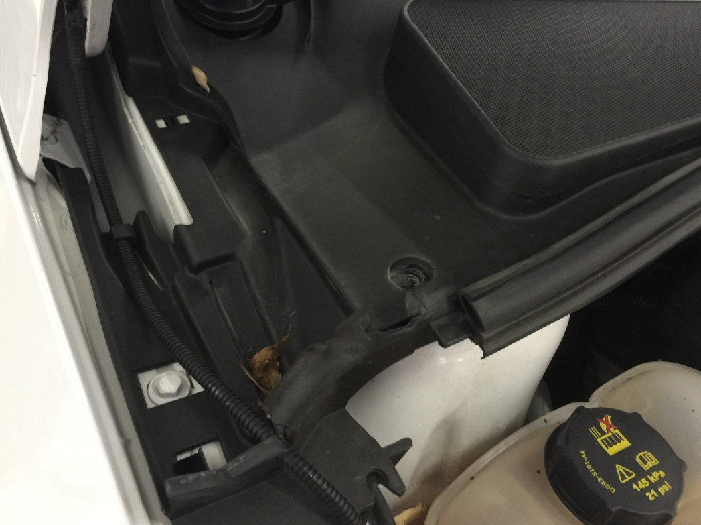
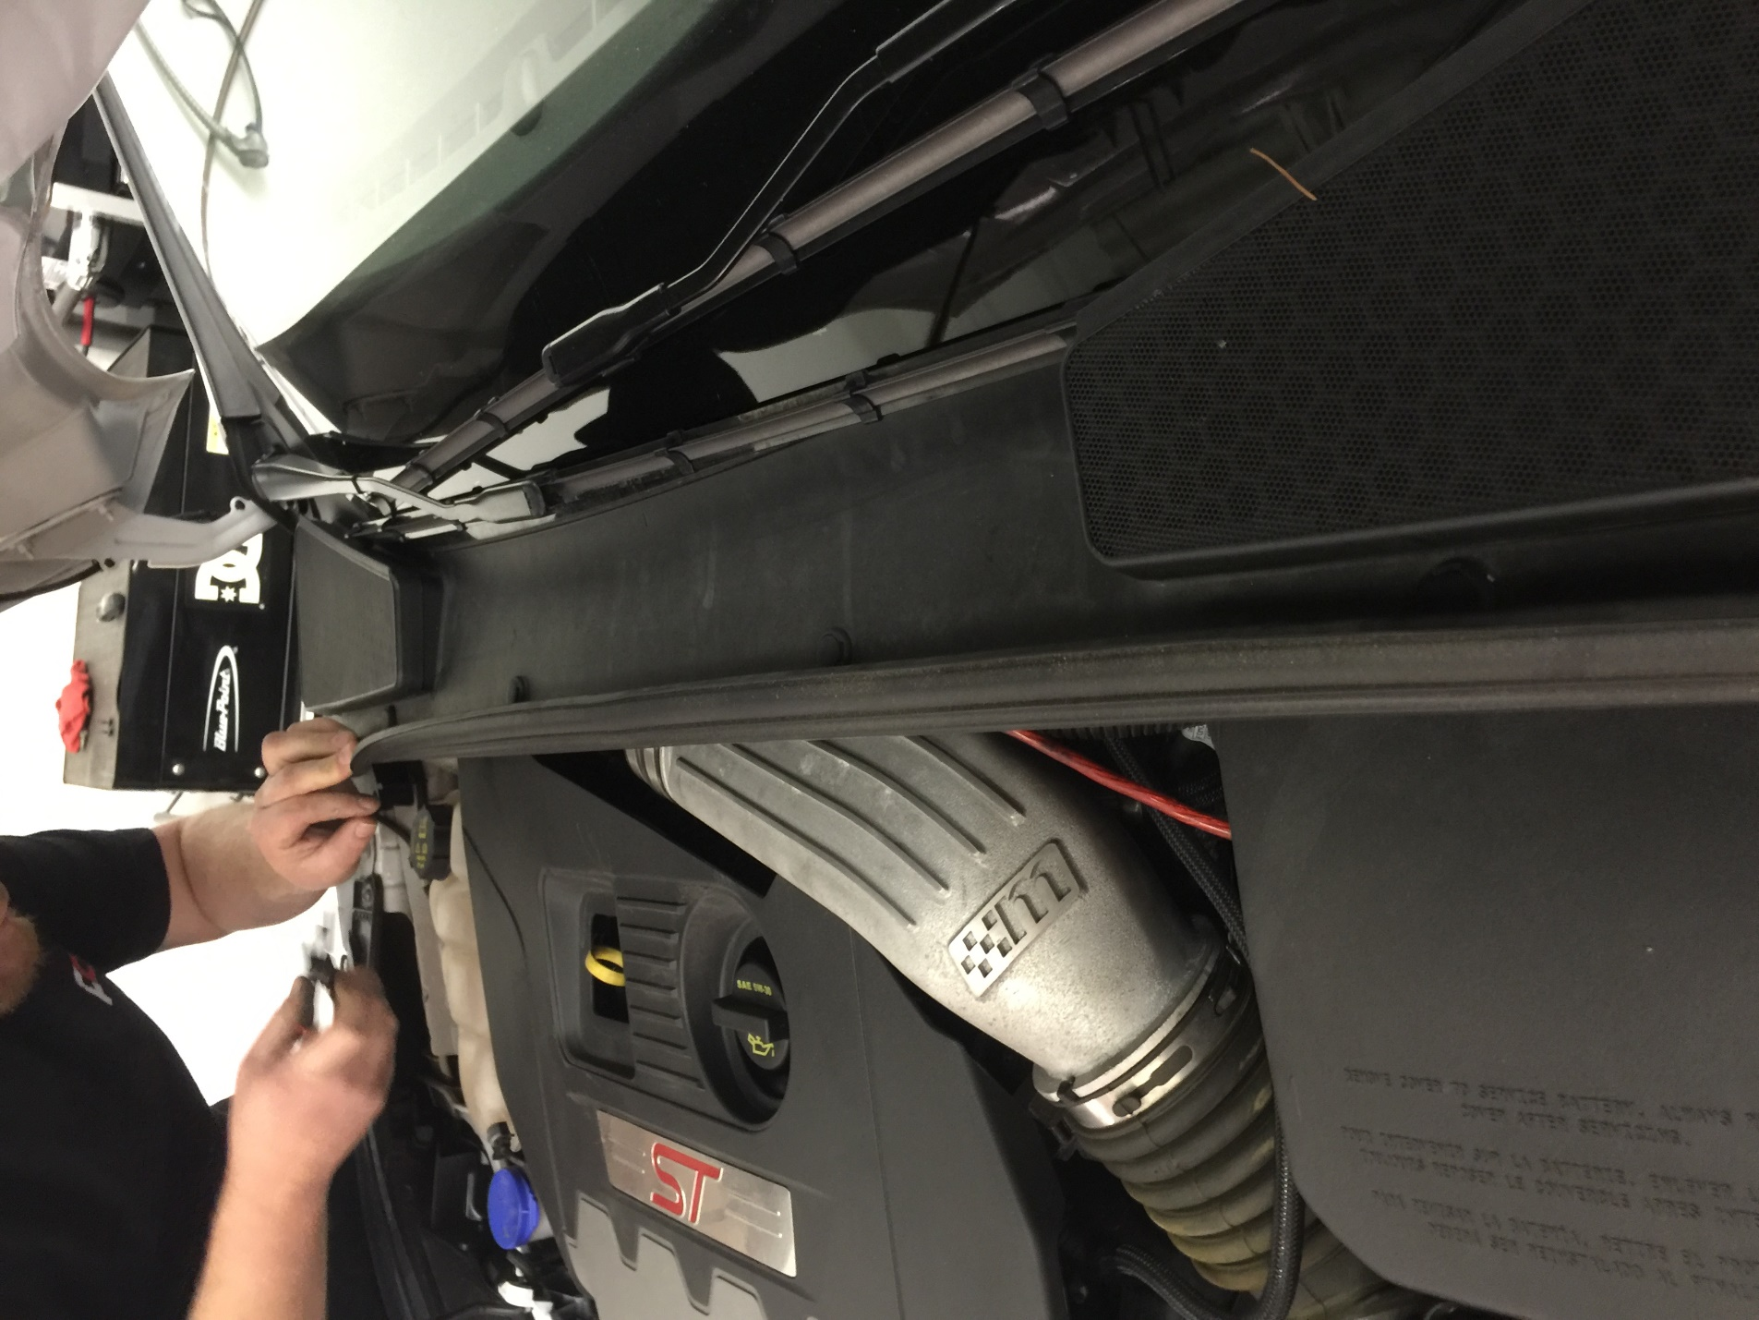

Step 3: Remove the ABS brake line with an 8mm socket. 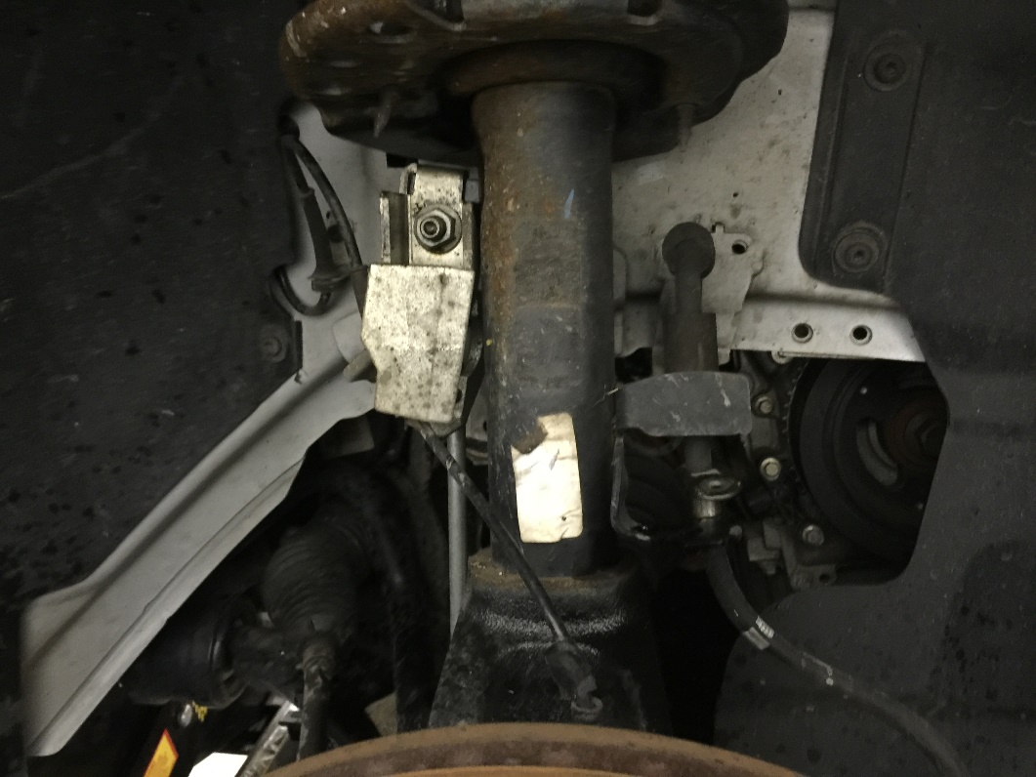

Step 4: Remove the endlinks bolt with a through socket (15mm) and allen key (5mm). 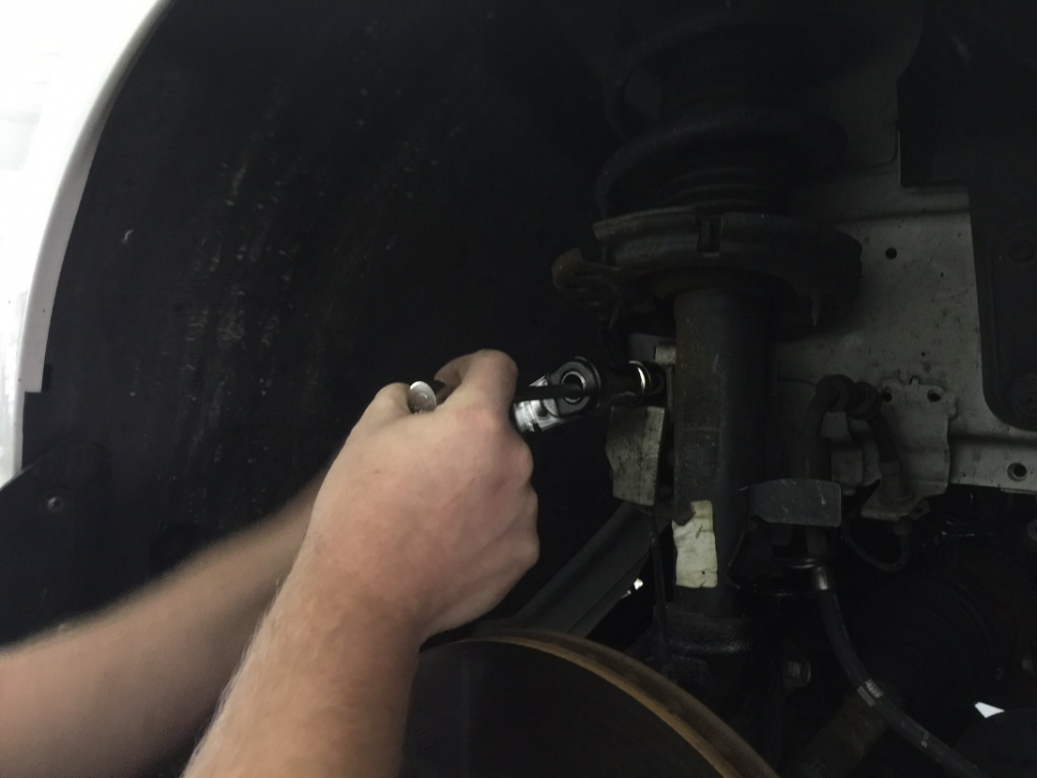

Step 5: Remove the 15mm bolt that holds the bottom bracket to the base of the strut.
Step 6: Using a spreader tool (VW) spread apart the bottom bracket that attaches to the base of the strut. Using leverage, pull the bottom bracket off the bottom of the strut. (You may need a friend to help)
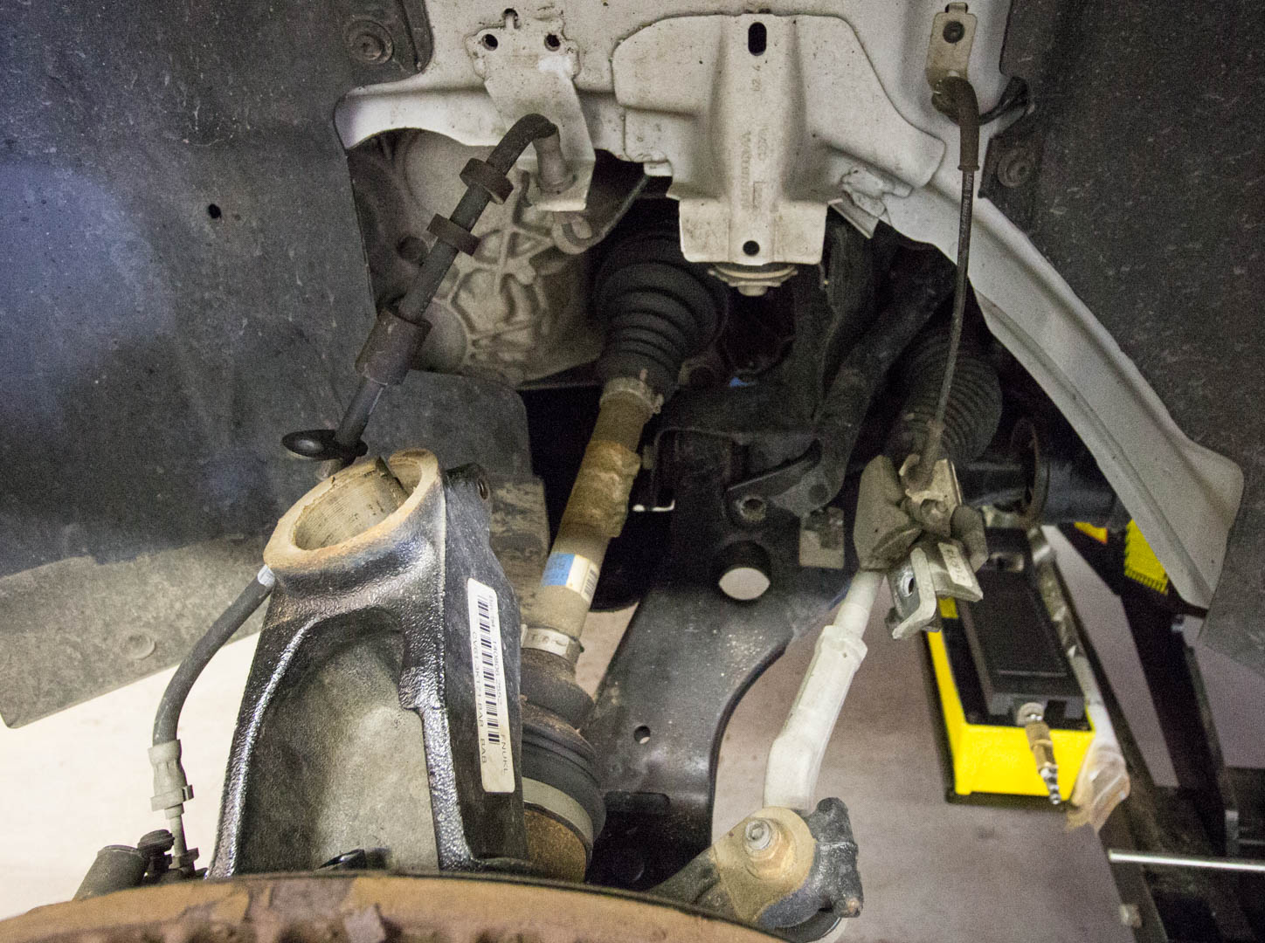
Step 7: Remove the top bolts that are 13mm and remove the entire strut assembly.
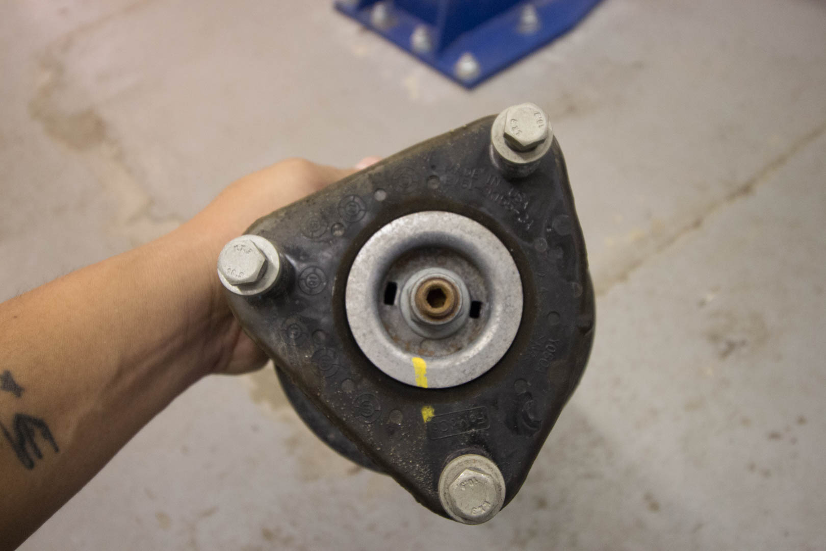

Step 8: Install your new coilover and tighten the supplied 12mm nuts on top.
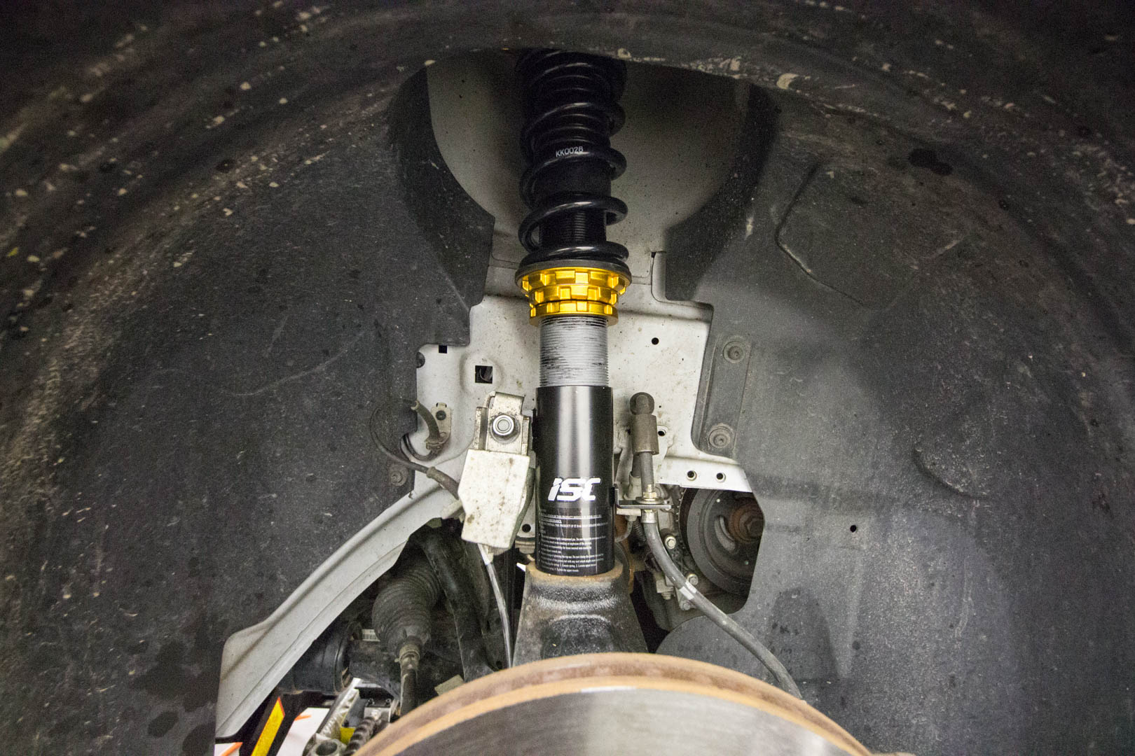
Step 9: Re-install the bottom bracket onto the bottom of the bottom mount for your new coilover. Re-install the brake line and install the new end links.
Step 10: Set your preload to 5mm
Step 11: Perform the same steps for the opposite side.

Step 12: (Rear) Remove the 15mm bolt that holds the control arm.
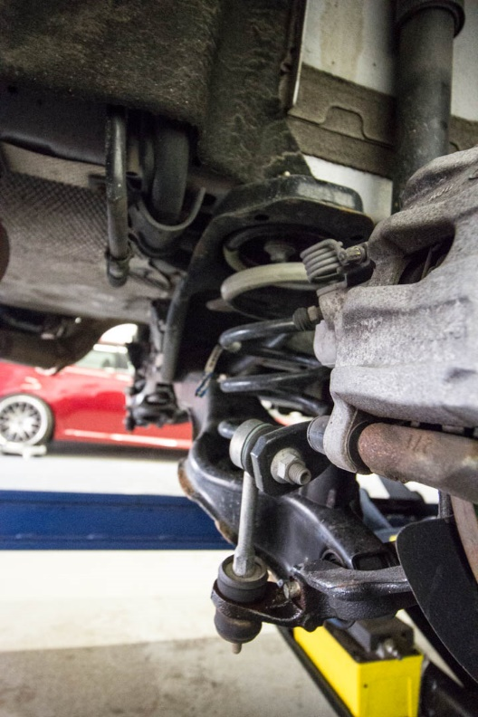
Step 13: Carefully remove the spring by lowering the control arm.
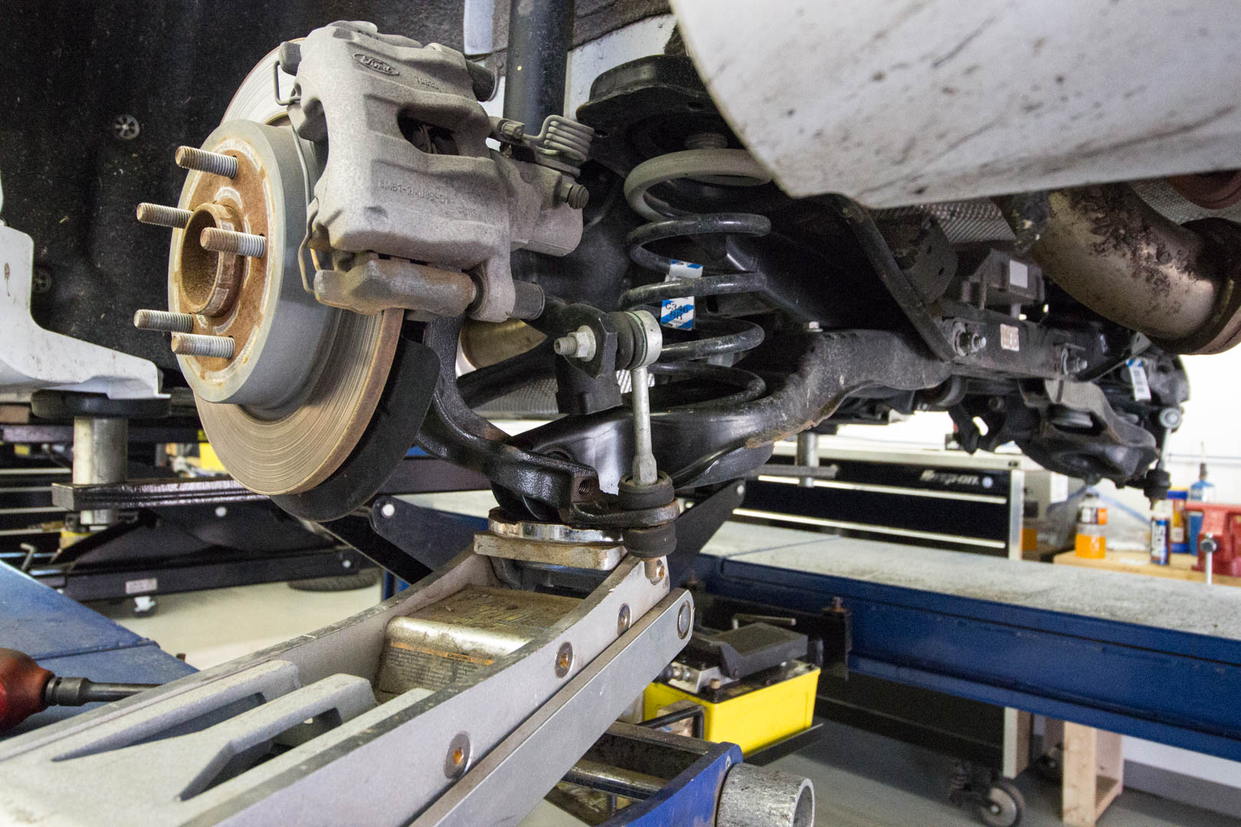
Step 14: Remove the top and bottom rubber pieces from the control arm. You will only re-use the bottom piece.
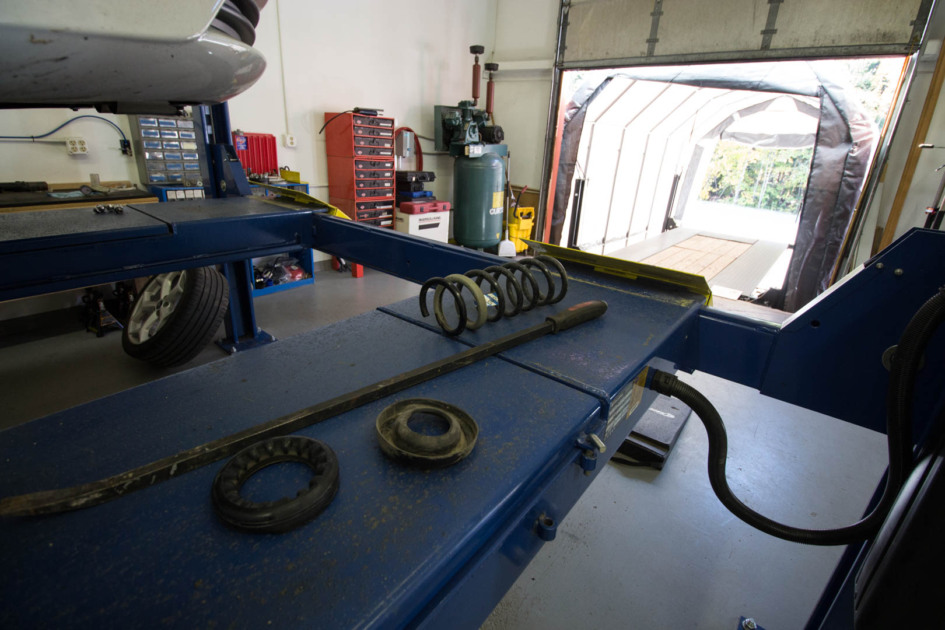

Step 15: Install your new ISC Spring and spring perch like shown.
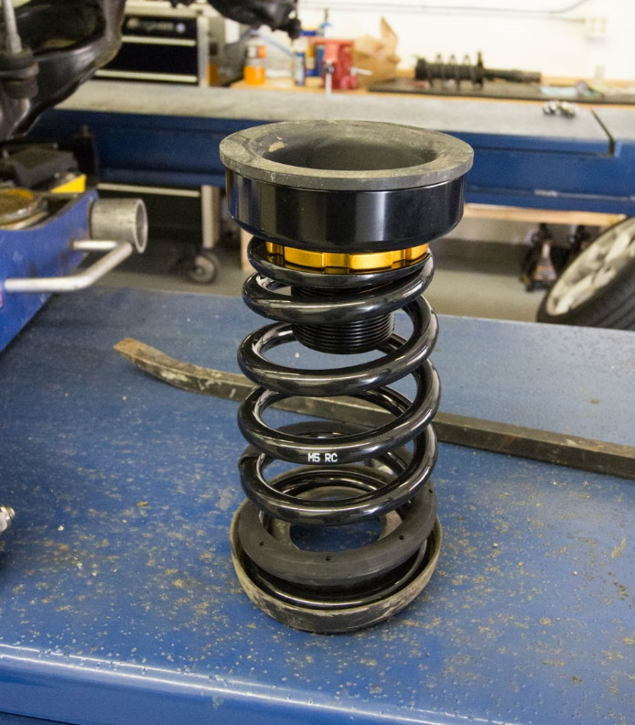
Step 16: Re-install the 15mm bolt that holds the control arm.
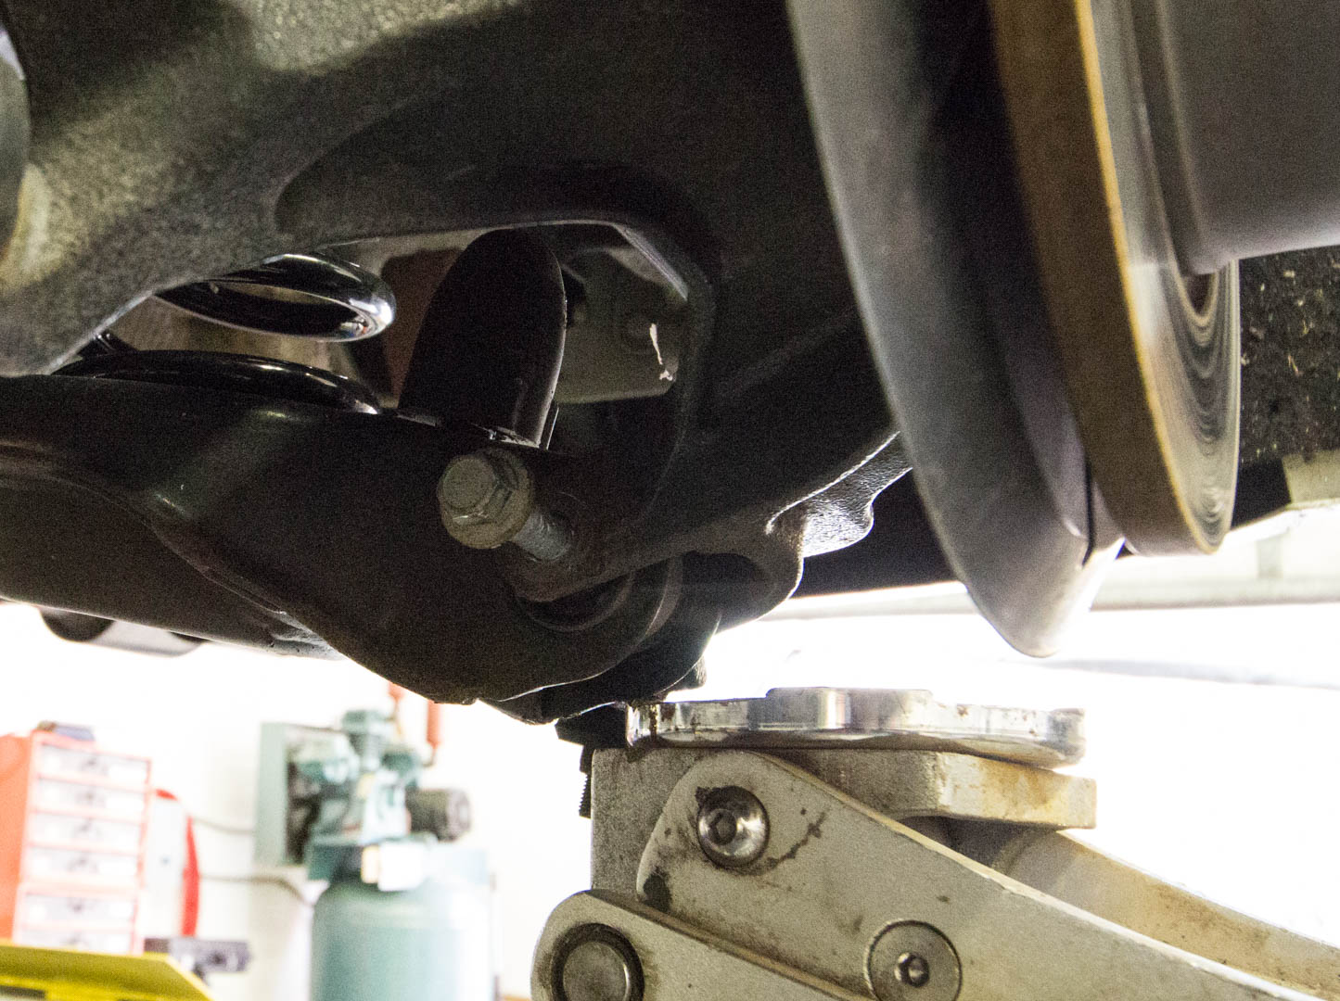
Step 17: Remove the 15mm bolt that holds the bottom of the shock to the vehicle.
Step 18: Remove the top 2 13mm bolts that hold the shock to the vehicle and then remove the entire shock.
Step 19: Install your new shock into your vehicle. The adjustments made here will affect the amount of travel your shock sees.
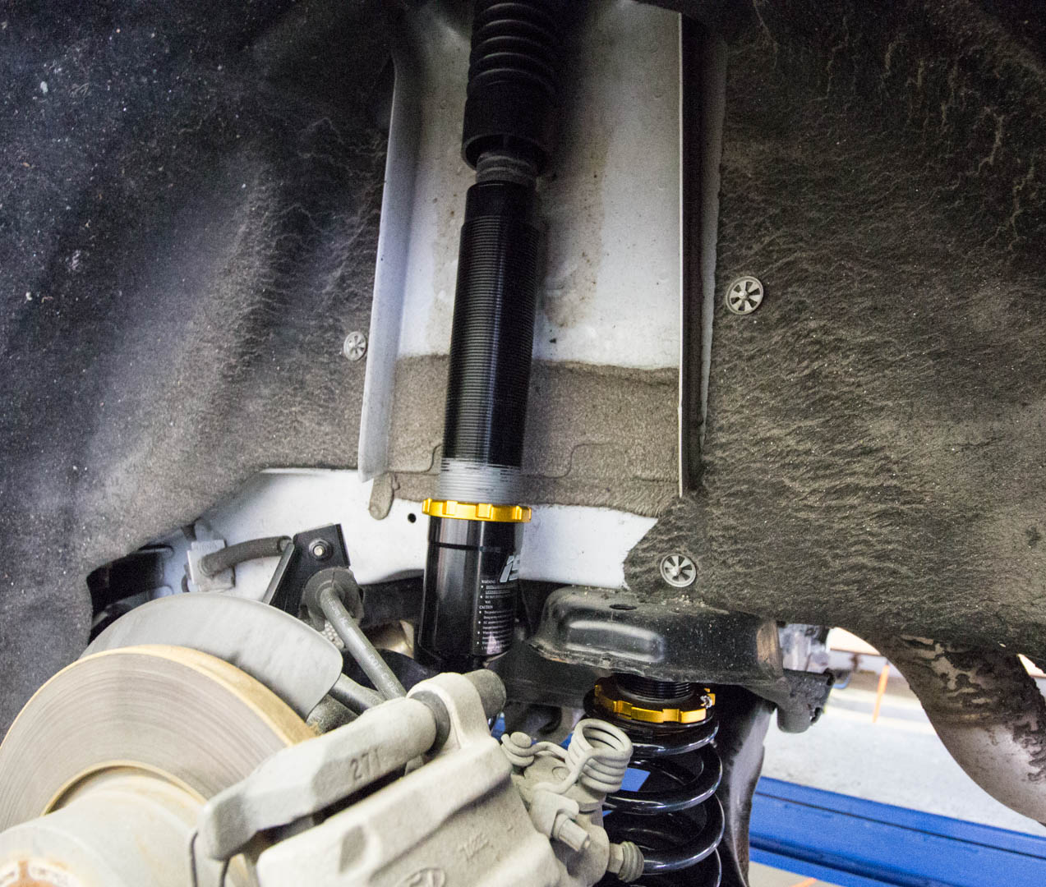
Step 20: Repeat for the other side.
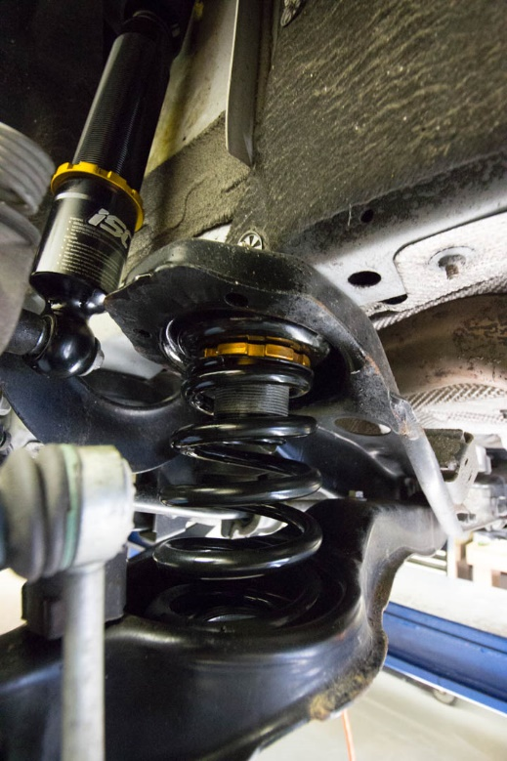
Congrats, you are now done! Go get an alignment once you have dialed in your adjustments and height to avoid wear on your tires.

