ISC Suspension Air Cup install guide

Air Cup kit includes:
X2 ISC Suspension Air Cups
X2 ISC Replacement springs

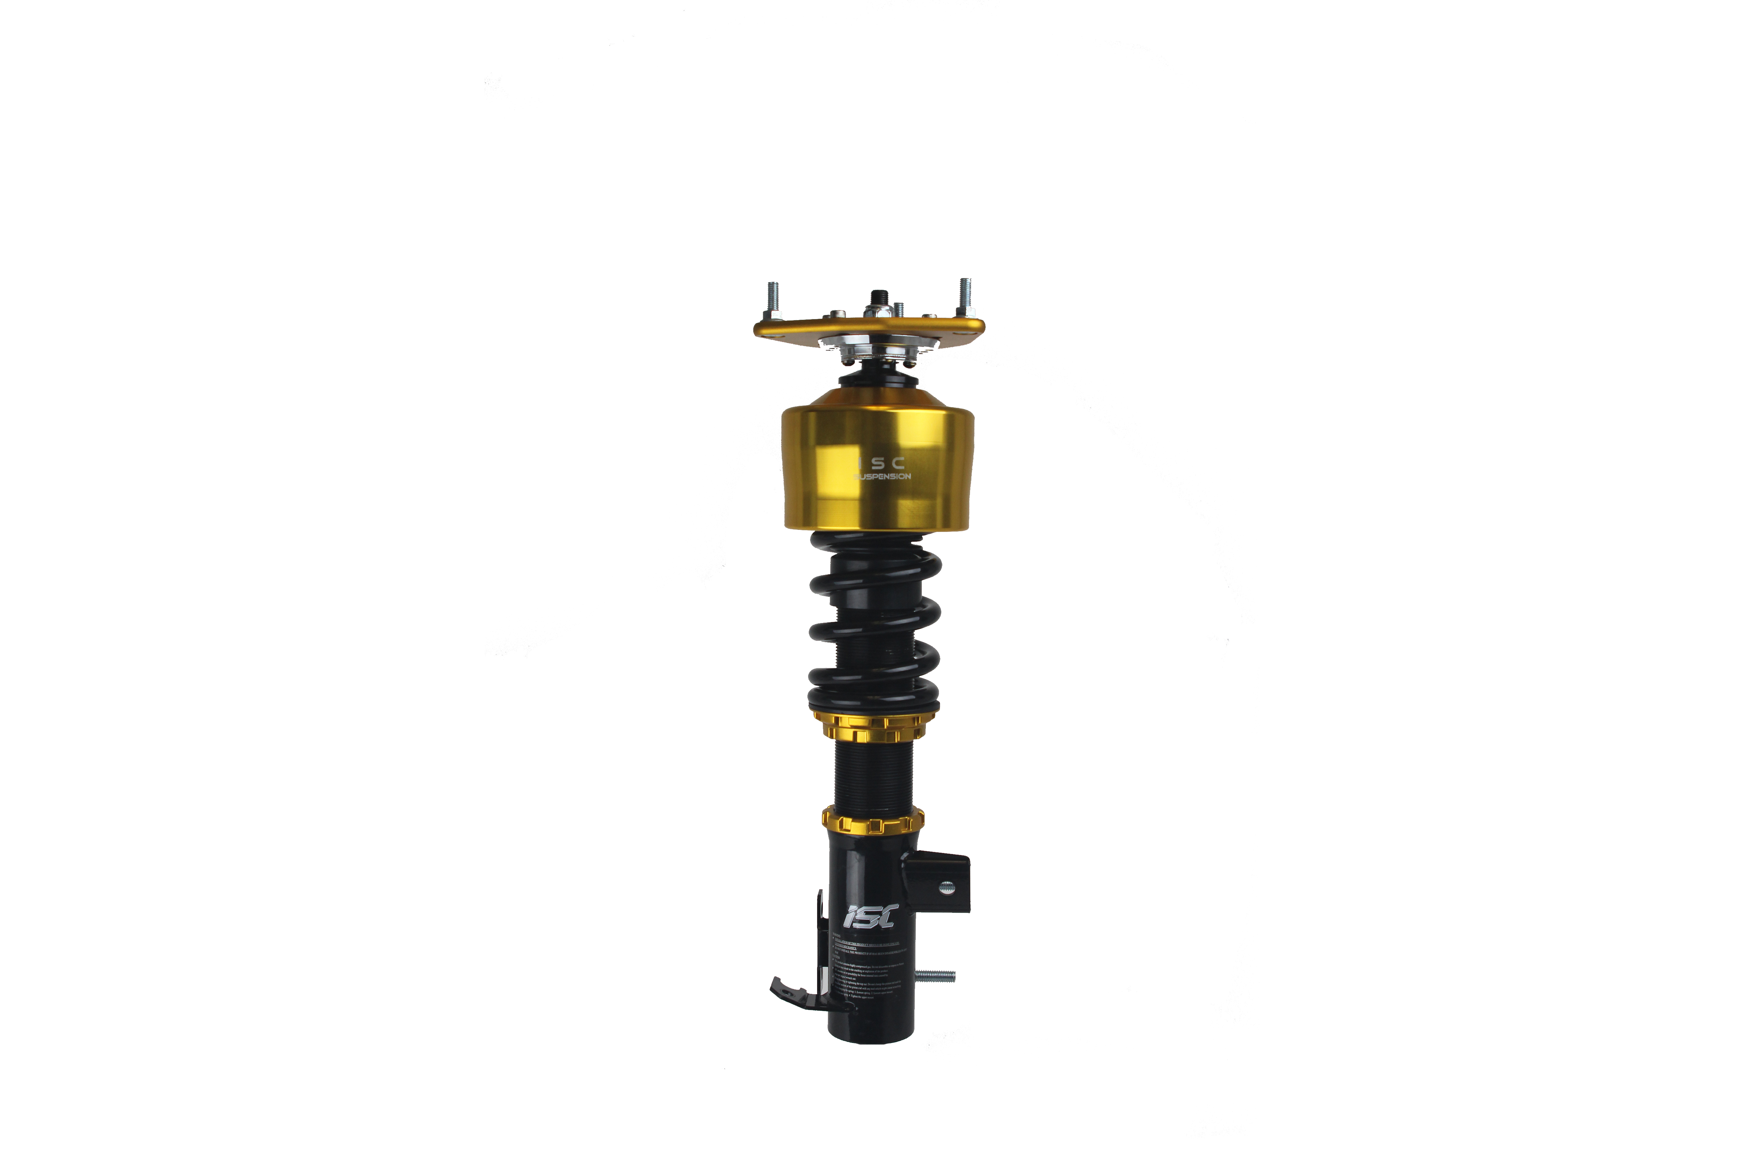

For use with 20mm ISC Suspension N1 coilovers
Features:
-up to 50mm of on demand height adjustment
-integrated thrust bearing race
-Anodized gold finish with ISC Suspension etched logo

Installation time: 30 minutes to install air cups on to coilovers
Tools needed:
-ISC Spanner tools
-5mm allen key
-19mm pass through socket or 19mm wrench
-ratchet

Begin by removing the top 19mm nut. This will allow for the removal of your camber plate, thrust bearing and spring. Remove the thrust bearing. You will be replacing the gold bottom of the thrust bearing with the air cup.
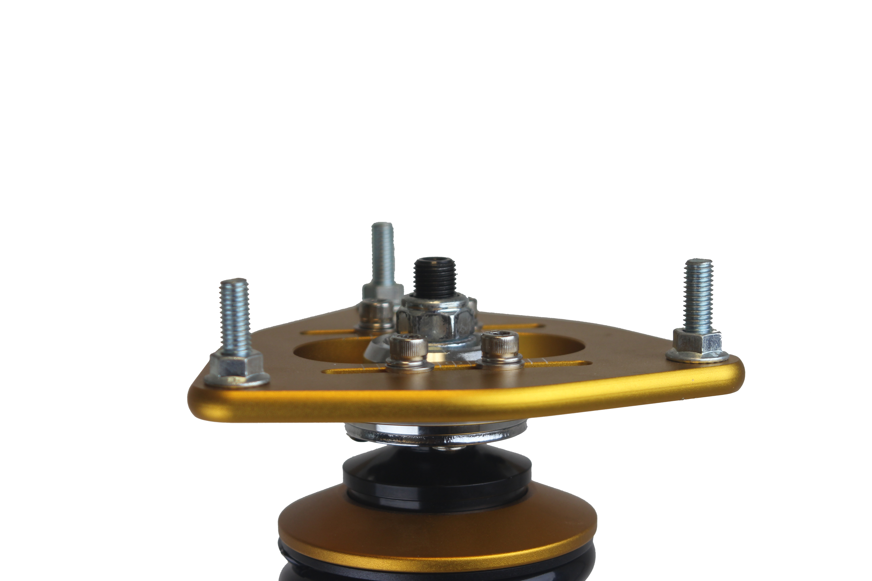
*Note the air cup has an integrated seat to retain use of your thrust bearing*

Replace the spring your coilovers came with, with the shorter spring supplied with the Air Cups.
Install the air cups onto the shaft once your spring is place.

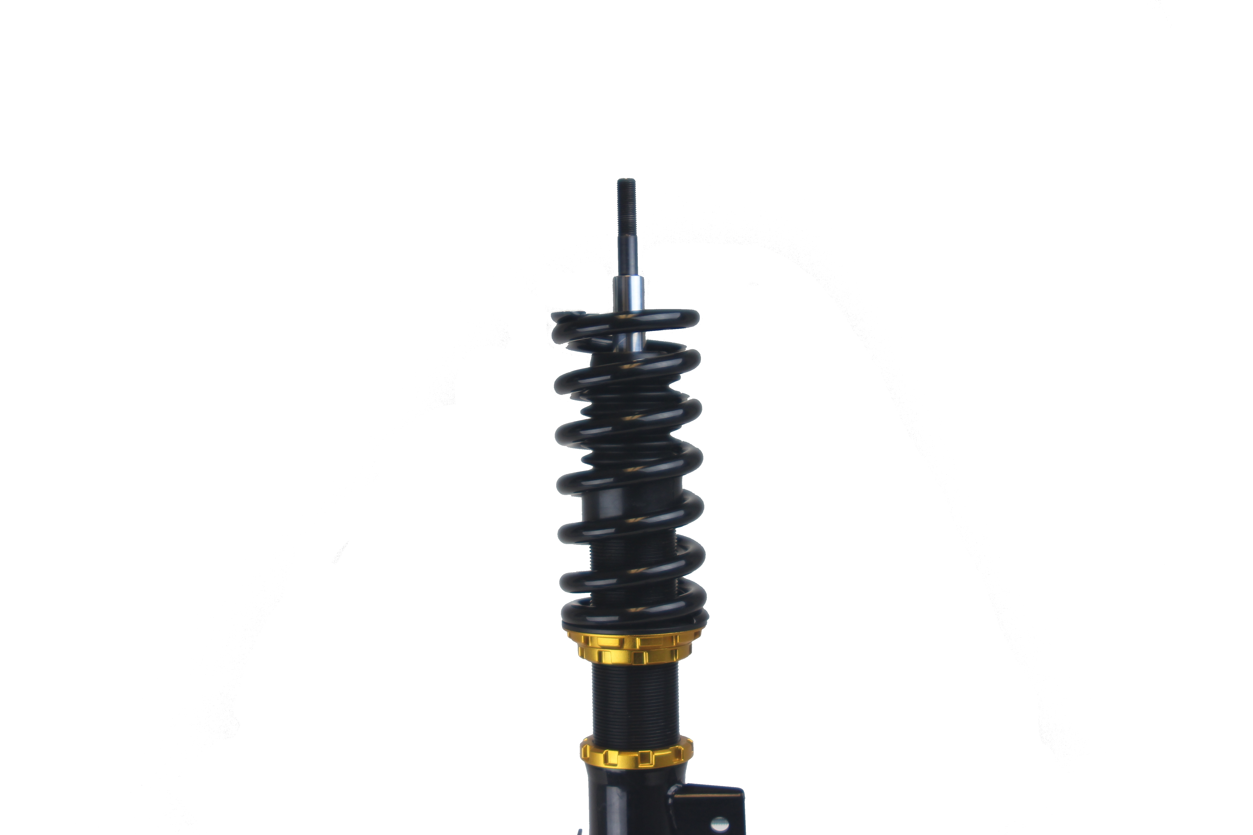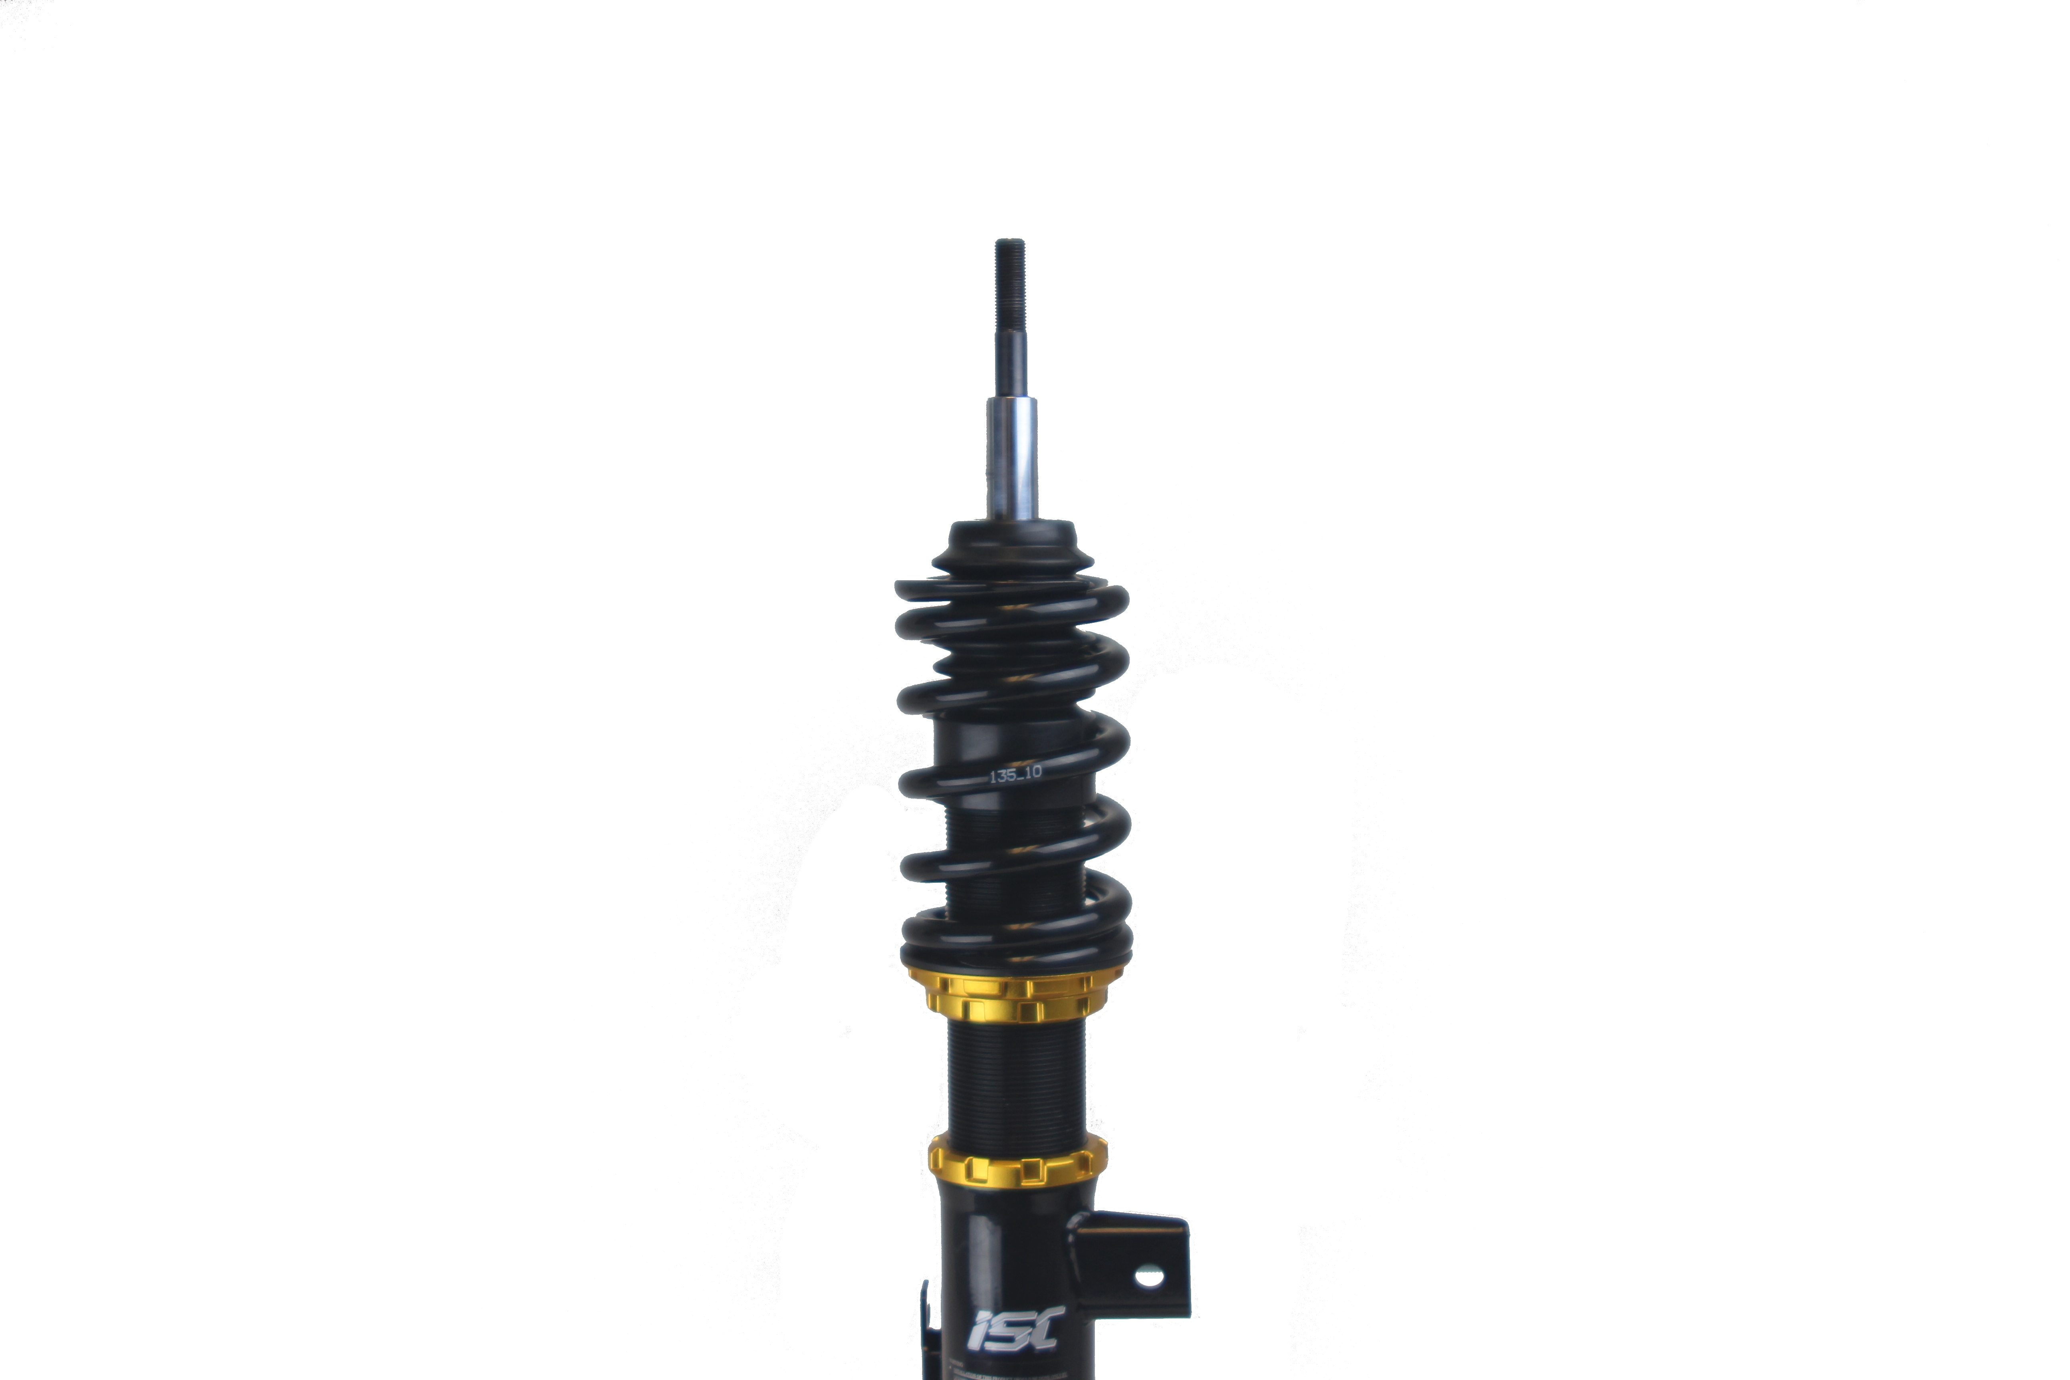

Place the bearing from your thrust bearing into the seat on top of the air cup, followed by the black cap. The black cap will seat onto the recessed area of the shaft.
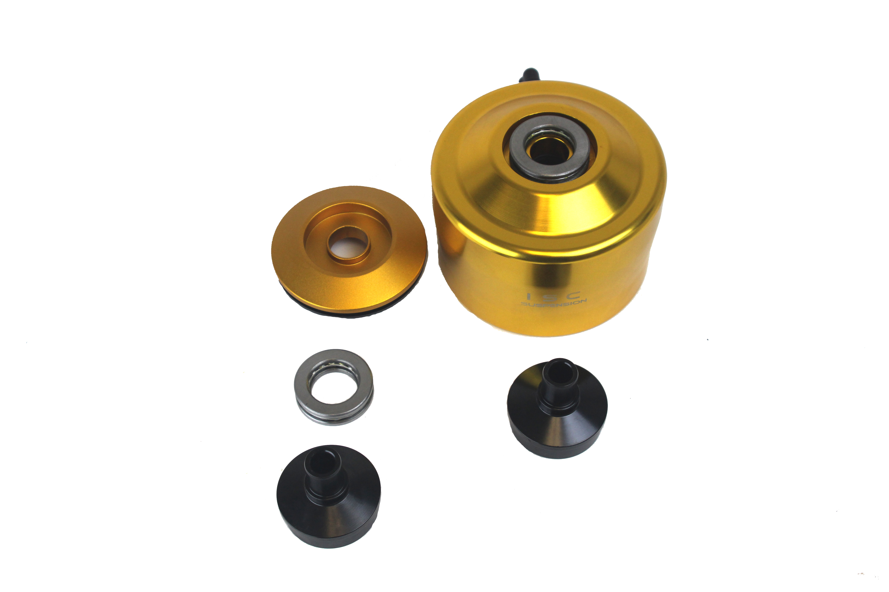

Place the aircup over the rod. Lower the aircup so there is enough room for the black thrust bearing cap to rest on the center rod.
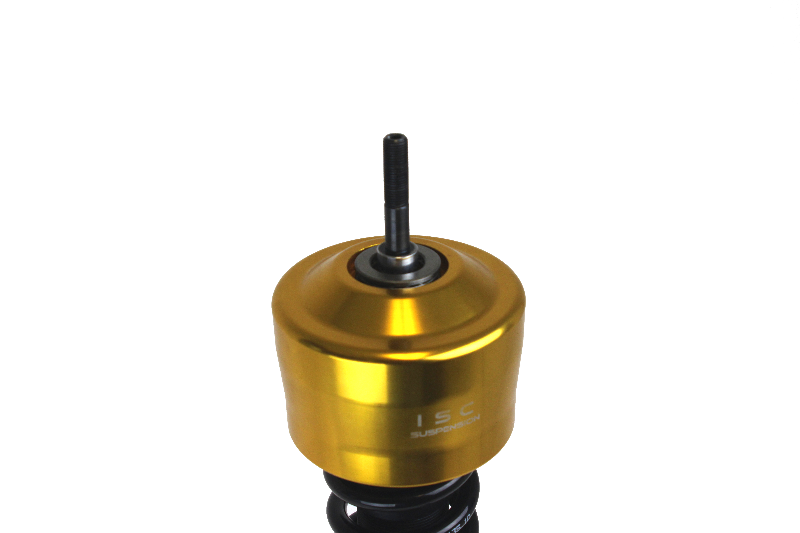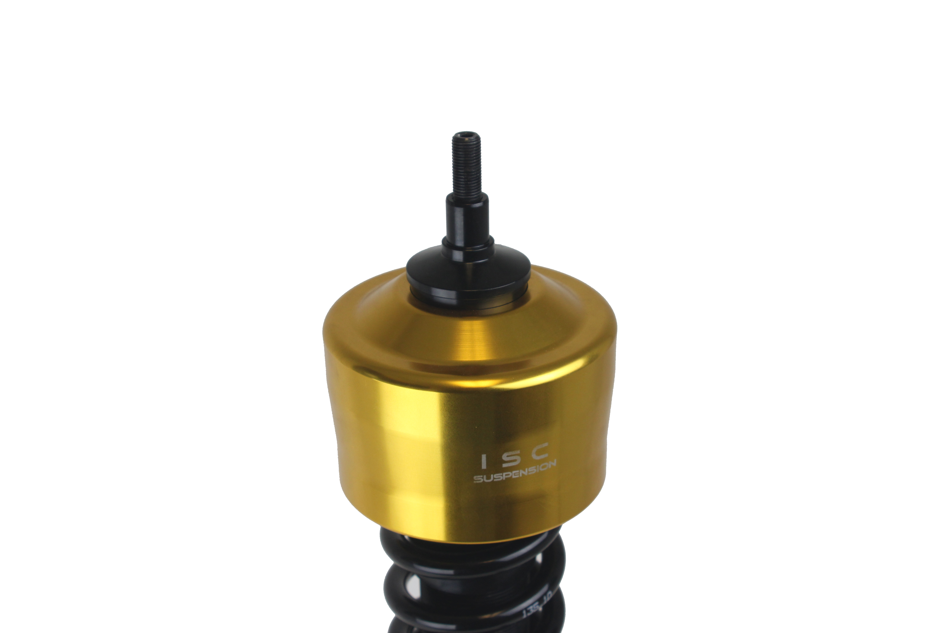

Replace the camber plate and 19mm nut once the aircup is installed on the coilover.
As soon as the camber plate is properly tightened, you may install the coilover with aircup onto
your vehicle.

To dial in the adjustment range of the air cup, first verify your ride height is set, then use the 2 collars under the spring to adjust the gap between the air cup and spring.

*This write up is for installing ISC Suspension Air cups onto the coilover. Installation of the pair onto your vehicle as well as air management varies by vehicle*
*Air management is sold separately and is up to what the end user wants to use*

