2014-2018 Subaru Forester ISC N1 Coilover Installation Guide
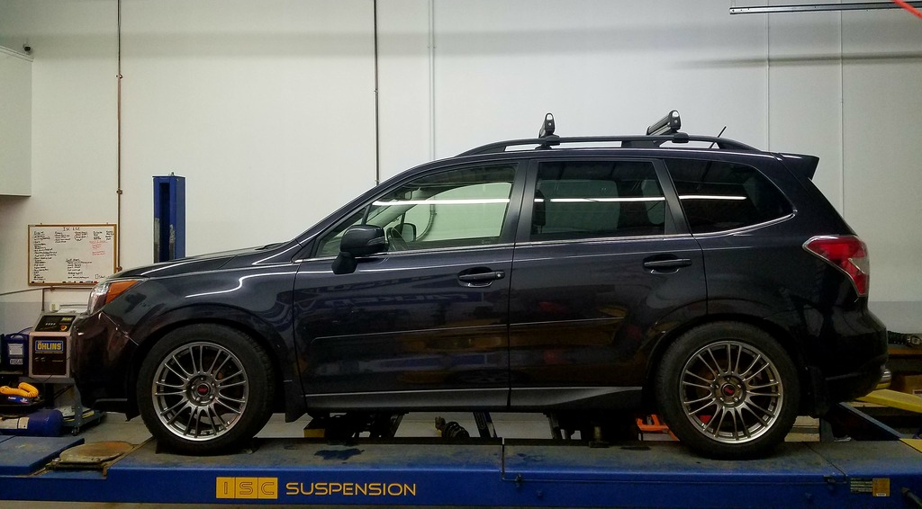

Video Guide- https://www.youtube.com/watch?v=OJPYr9nrzlc&t=51s

Part Number- ISC-S021-C
http://iscsuspension-na.com/store/#!/12-Subaru-Forester-N1-coilover-kit/p/102084610/category=12617056

Tools Needed:
Provided ISC Spanner Tools
Wheel Key/ 19mm Socket
17mm Socket/Wrench
14mm Socket/Wrench
12mm Socket/ Wrench
Flathead Screwdriver
Needle Nose Pliers
Impact Gun (Helpful)
Jack/Jack Stands (or lift)
PB Blaster (or similar)

Anti-Seize:
If you live in an area that gets nasty winter months we suggest anti-seizing your coilovers. Specifically under the preload collars, and inside the bottom mount area where the threaded shock body threads into. Off the shelf standard auto parts grade anti-seize does just fine.
Setting Preload:
ISC SUSPENSION N1 COILOVER DO NOT COME PRELOADED FROM THE FACTORY. We recommend a preload of 5mm on all corners of the suspension. To set this, you will need to compress the spring using the large gold collar. Simply tighten this up until it stops spinning. You can then take a measurement of the spring. This should yield you 0 preload. From here you need to compress the spring an additional 5mm.
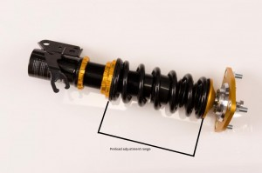
A quick way to be able to know the length of your spring is to look at it. On the spring is a series of number. Example, 18008. This means the spring is 180mm with an 8kg spring rate. The first three numbers are the length. You may also see 200, 140 etc.
If you add 5mm of preload to a 180mm spring you will have an end result of 175mm. This is the proper preload measurement.
Note: Measure your prior height settings to use as a baseline, from the center of the fender to the ground, then jack the car and secure it on jack stands or put it on the lift.

Fronts:
Removing the OEM struts:
- Remove your OEM front struts: Remove your wheel (using a 19mm socket or your lug nut wheel key).
- Remove ABS clip. This clip attached your ABS line to the OEM strut, use pliers or a screwdriver to pop this off the strut, let it hang freely once disconnected.
- Use a 12mm socket/ wrench to remove the brake line bracket, let is hang freely.
- Remove the 2x lower strut mounts which connect the OEM strut to the hub. Use a 19mm wrench/socket. The top and bottom are specific, so take a note as to which one goes where when it it time to put them back on with your new coilovers. Sometimes these can be stubborn, PB Blaster or similar may come in handy.
- Now make your way to the strut tops (located in the engine bay) remove the 3x top nuts which are 12mm, using a socket/ wrench. This will release the entire strut from the vehicle now. Note: make sure someone is under the vehicle to catch the strut so if it falls free it will not hit your axle boot or get tangled in the ABS or brake line.
- Remove the strut
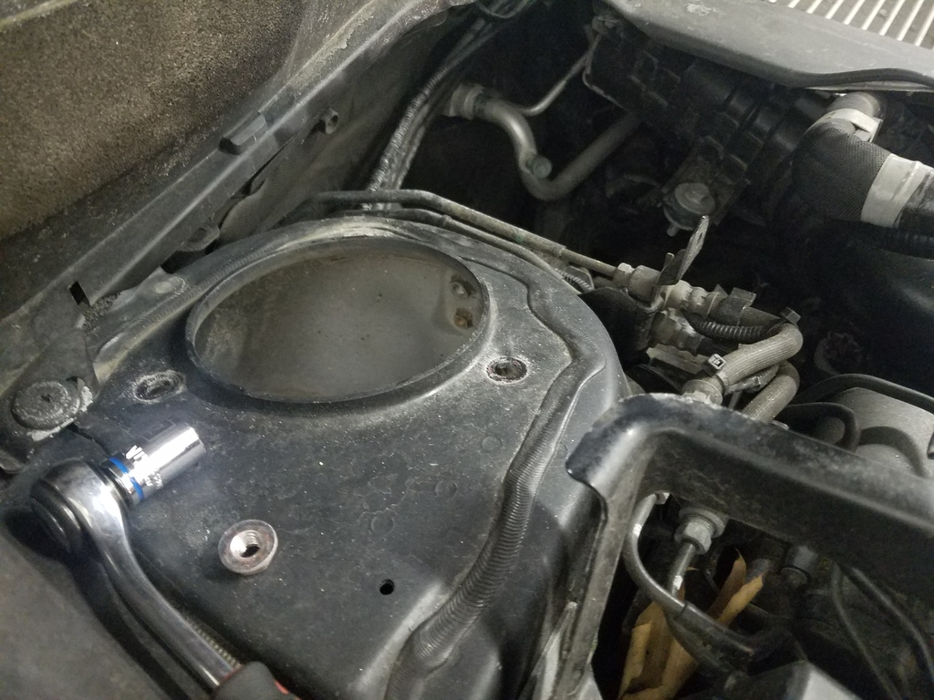
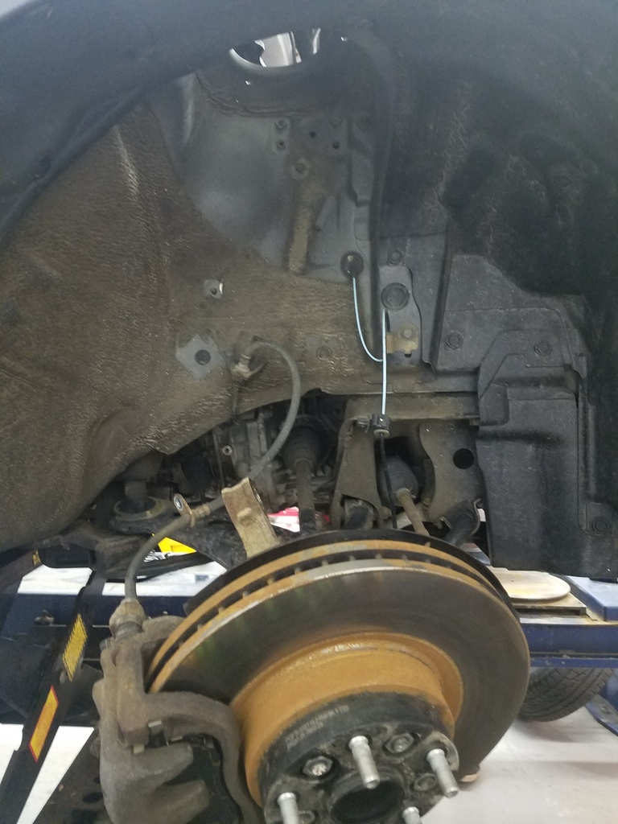

Installing the front coilovers:

- Line the top of the coilover up with the strut tower, secure the top of the coilover with the new12mm nuts that are included with your coilovers, now your coilover can stand freely on its own.
- Adjust the length of the coilover to the anticipated desired ride height, chances are you will have to fine tune this later.
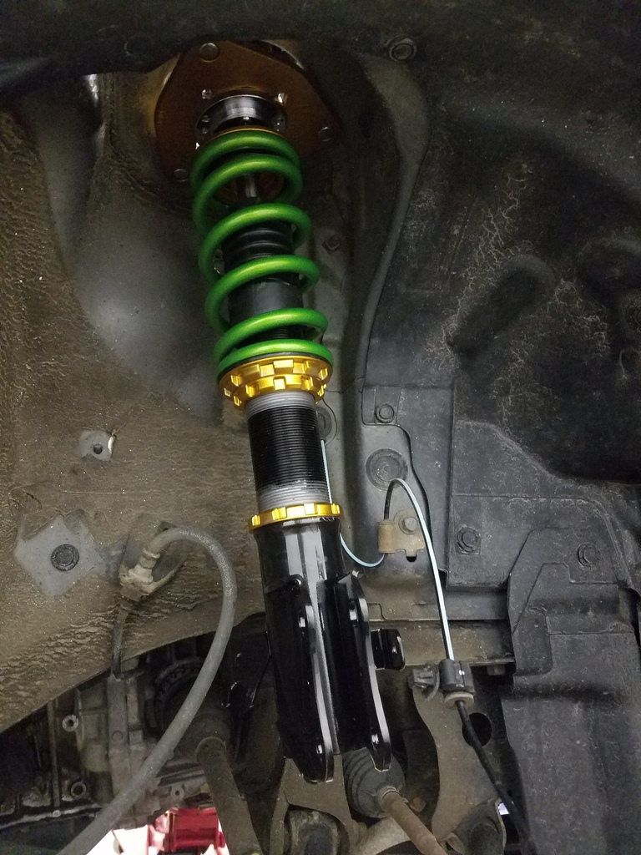

- Use a jack or a friend the lift the OEM knuckle and align it with the coilover bottom mount, use the OEM 19mm hardware to secure everything once it is lined up.
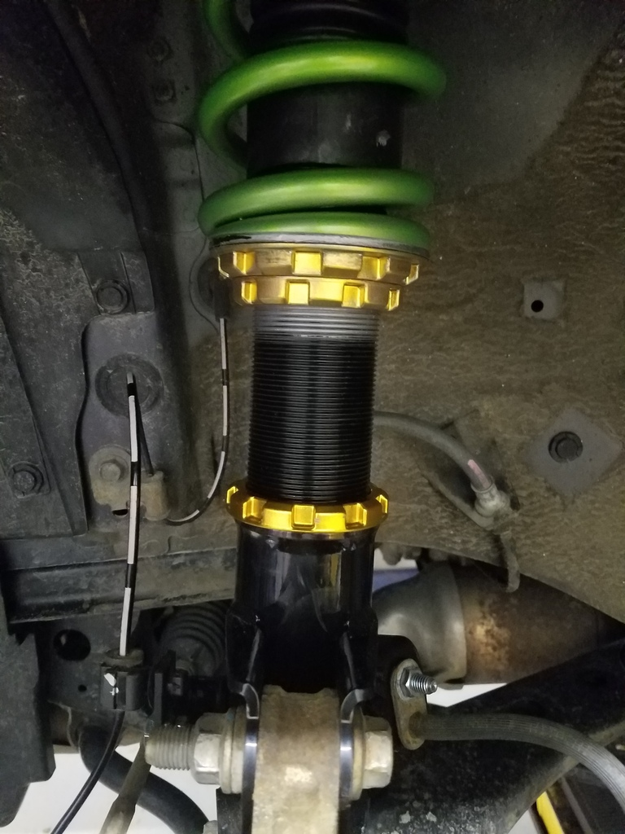

10) Mount up the ABS/ Brake lines, tighten your locking collars on the coilovers (even though for fine tuning you may have to repeat the height adjustment steps)

Rears:
- Remove rear wheels, remove trunk liner, and put seats down. Pop clips with flathead and remove the foam molding inserts. Remove small plastic access panel by hand for better access to the OEM strut.
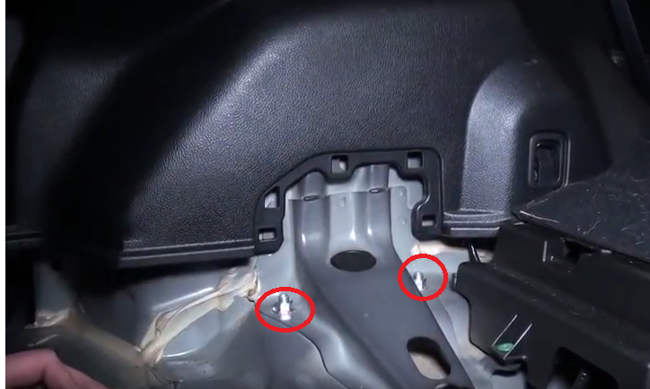
- Disconnect all components from the rear lower control arm, including endlink, strut, and where control arm attaches to knuckle. This will allow you to remove the OEM rear strut easier.
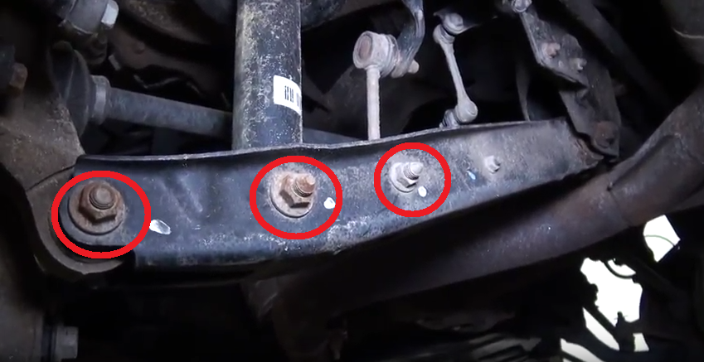

Note: It may also help to release the trailing arm:
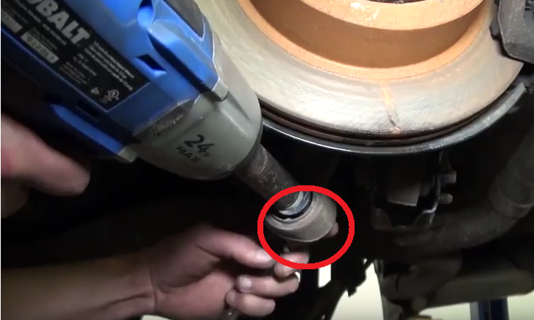

13) Go back to the OEM strut top, and remove the 2x 14mm nuts that are now the only thing holding the strut to the vehicle, make sure someone it down below to assist with properly removing the strut.

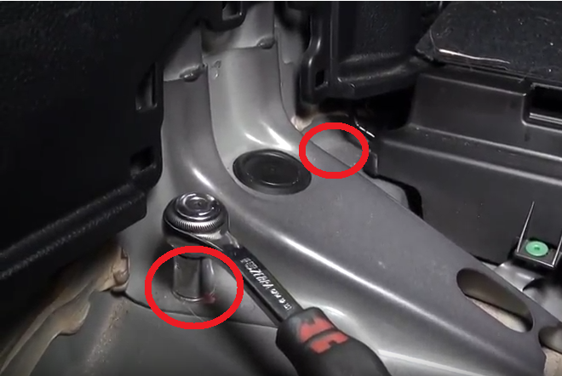

14) If possible while you are still in the trunk from removing the strut have someone pass up the coilover, secure the top of the coilover with the provided 14mm hardware, the coilover will now hang freely and be secure from the top strut mount. Head over to the bottom mount/ rear control arm area.
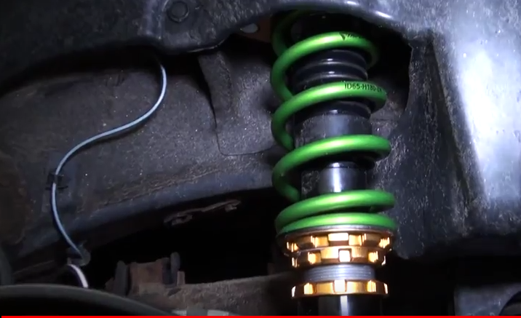

15) Repeat the prior steps by connecting the coilover bottom mount to the control arm, as well as the endlink, control arms to knuckle, then trailing arm mount if you disconnected that as well.
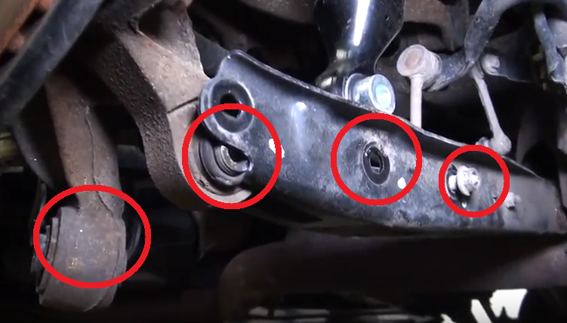

16) Make sure everything is 100% tight, including your coilover locking collars even though you may have to revisit this step to dial in your desired height settings.

17) After height settings are obtained, toque wheels, and get the vehicle aligned. We suggest starting the dampening in the middle (16 clicks) and adjusting harder or softer depending on your preference.

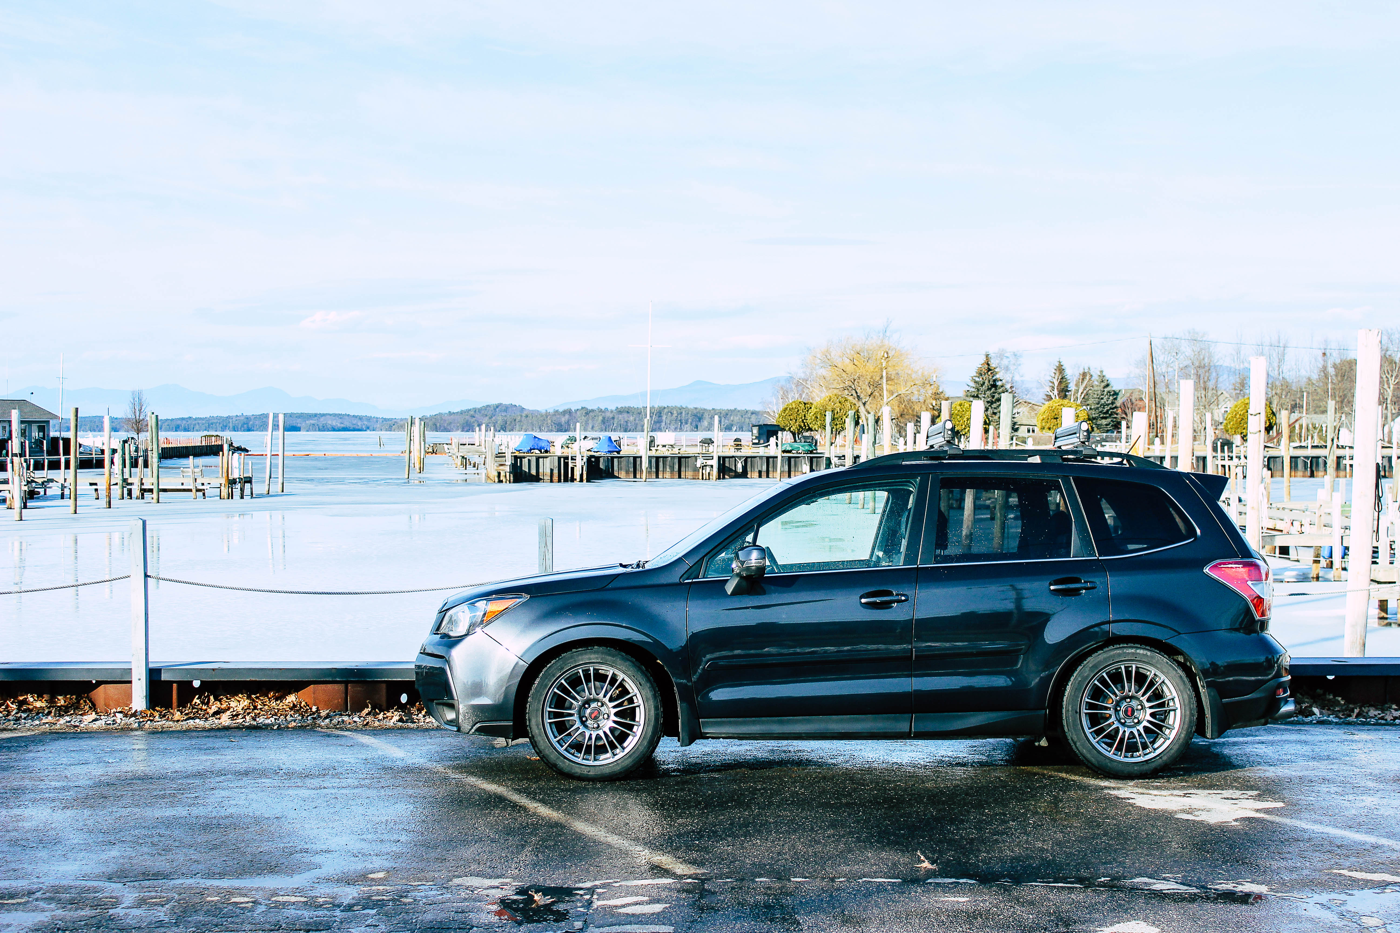
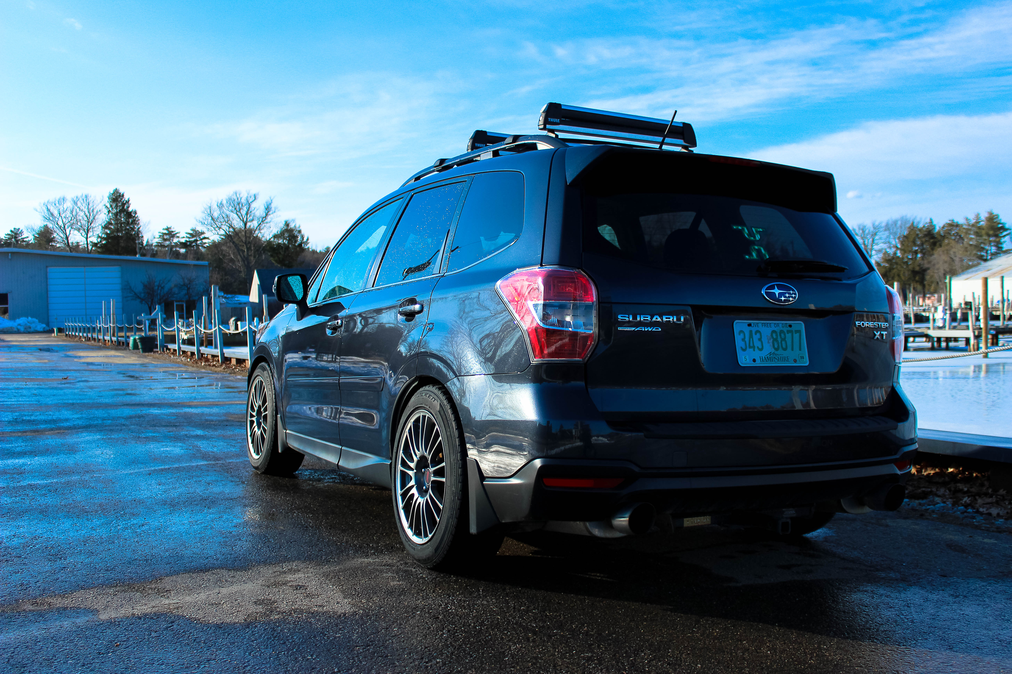

For further questions please contact support@iscsuspension-na.com.

