Before you begin remember how important anti-seize is. Remember to anti seize all collars and bottom mounts to prevent any form of seizure. Also, take measurements of mid finder height to the ground to aid in height adjustment later on.

DISCLAIMER: These instructions are for use of installing ISC N1 Coilovers. ISC North America and or its affiliates are NOT responsible for any failures of damage as a result of improper installation or setup.

Removal and Installation of Honda Civic ISC N1
Coilovers

Jamaal a proud ISC Coilover owner

1. Carefully raise the car and put it securely on Jack Stands. Use factory specified jacking locations.
2. Once in the air remove the wheels.
3. Remove the 2 17/19mm bolts that hold the bottom mount in place. Also remove the 12mm brake line bolt
and abs line clip. Be careful not to break the clip that’s holds the abs line in place.

Repeat this process for the other side

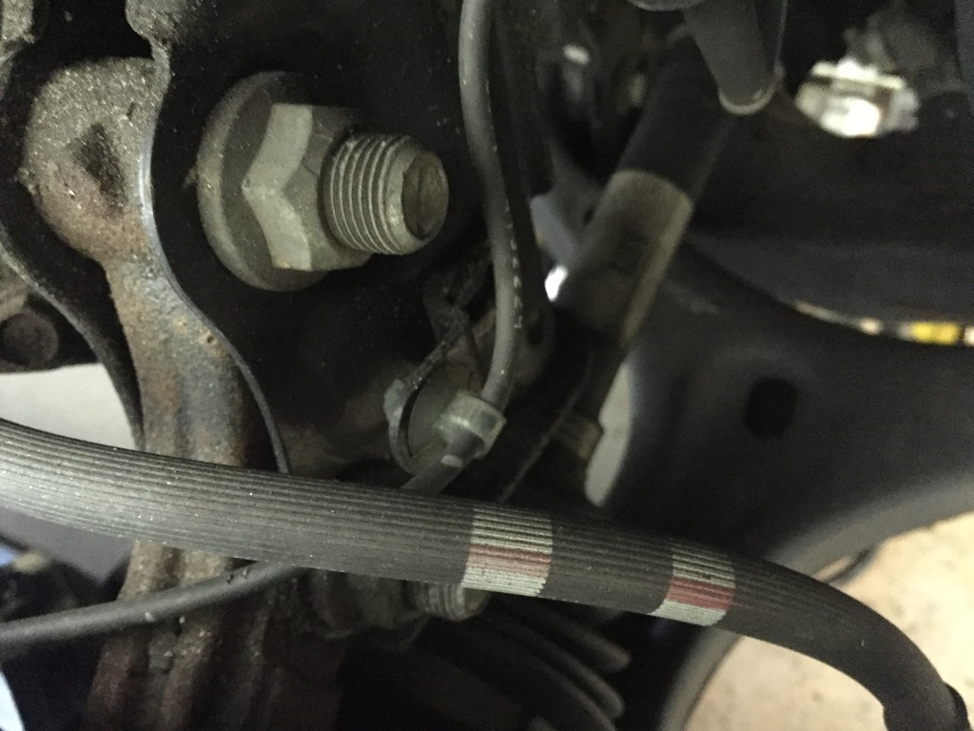
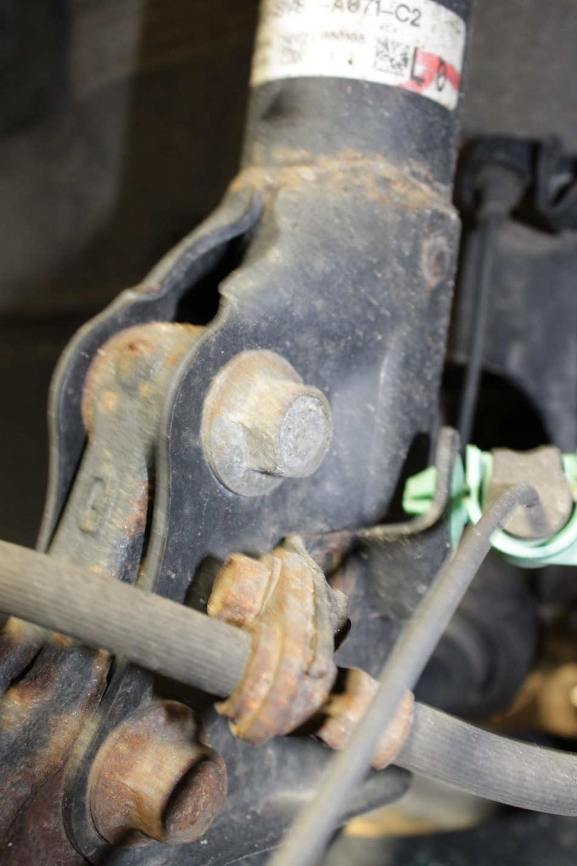
4. Head to the top of the car and remove the plastic panel that hides the three top 14mm nuts
that hold the top of the strut. Loosen these once you loosen the bottom, this will allow you to remove the strut.

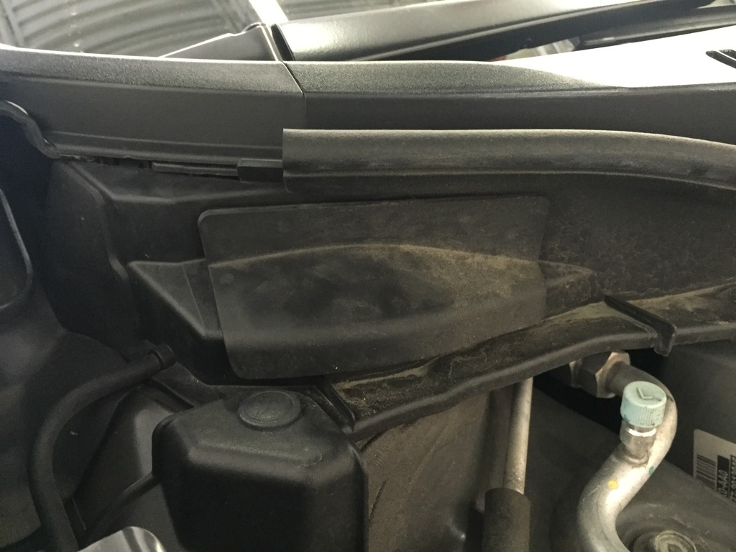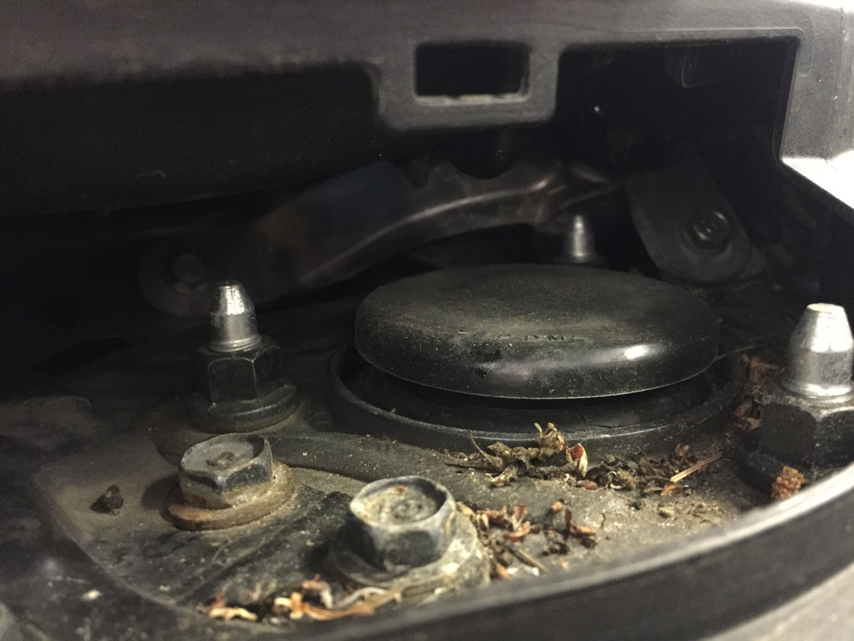

5. Once this slowly remove the factory strut/spring. Keep in mind after doing this the strut will drop, so it’s good to have another person give you a hand.

6. Now move onto installing the fronts. Set your preload to about 5mm or 1 spanner tool width. To accomplish this bring the top collar up so that it is preventing any play on the spring moving. From there adjust 5mm and then bring the lower collar up to lock it in place.

7. Set your ride height with the bottom collar, don’t worry if it’s too high or too low you can adjust
this with the coilovers on the car. Don’t forget to anti seize the collars and the bottom mounts.

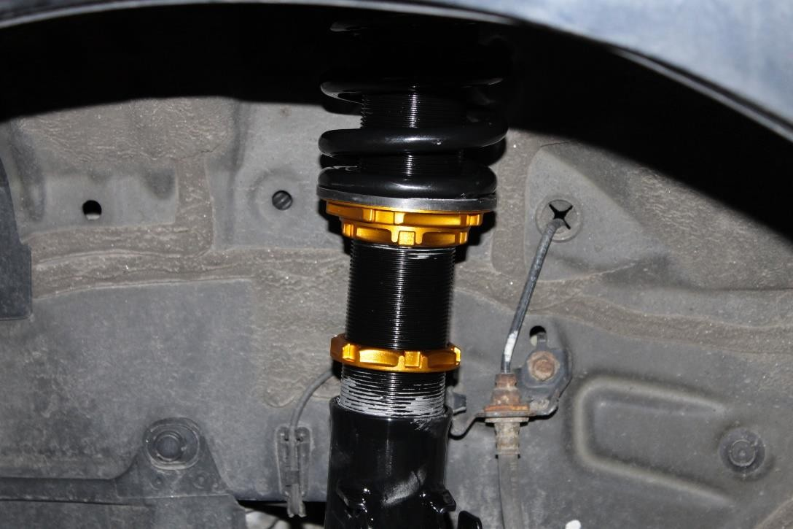

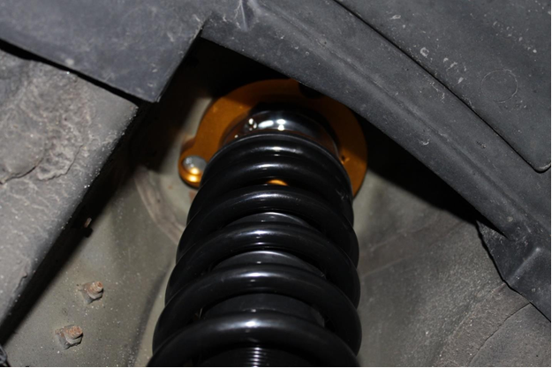

8. Now move onto the rear, to remove the rear unbolt the top of the Shock 14mm nut and the bottom 14mm bolt that holds the shock in place. Keep in mind how you remove this because installation of the ISC Shock is the same as installation on the OEM shock.

9. To remove the spring utilize a spring compressor which you can rent from a local parts store. You will be reusing the upper cone and lower spring isolator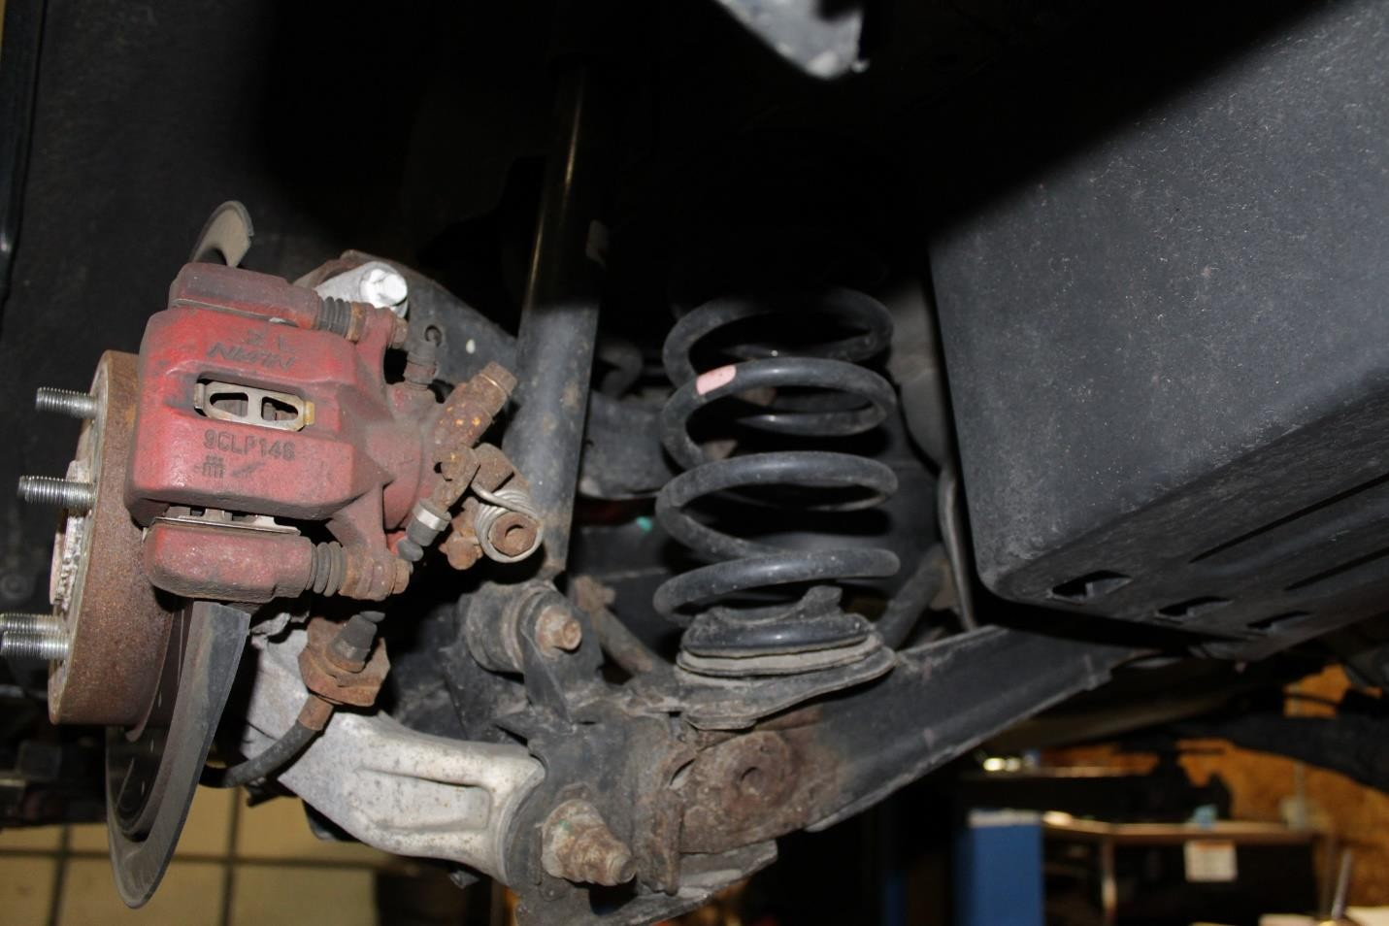

10. As for the rear shock, there is a 14mm nut located behind the side carpet in the trunk that secures the top of the shock. You will need to use a 5mm allen key and 14mm wrench to remove and reuse your oem bushings on the ISC shock. The bottom of the rear shock is a 14mm nut and bolt.

11. Set the ISC Rear spring up for ride height. Make sure to anti seize everything properly.

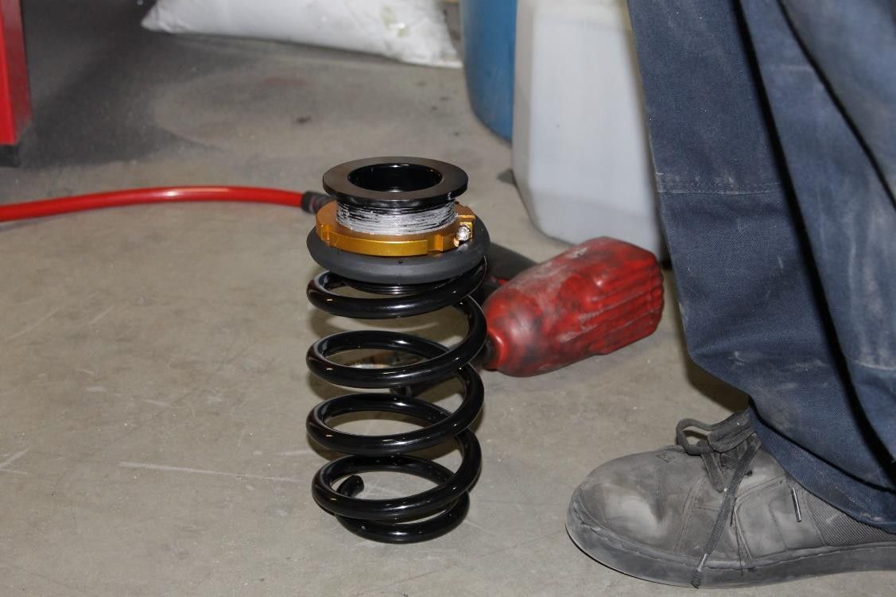

12. Set your preload to match the ride height on the spring. Use the 5mm allen bolt to loosen and tighten the adjusting collar These components are dependent upon each other. The shock is a limiter for how low the car can drop down.
install the rear shock absorber.

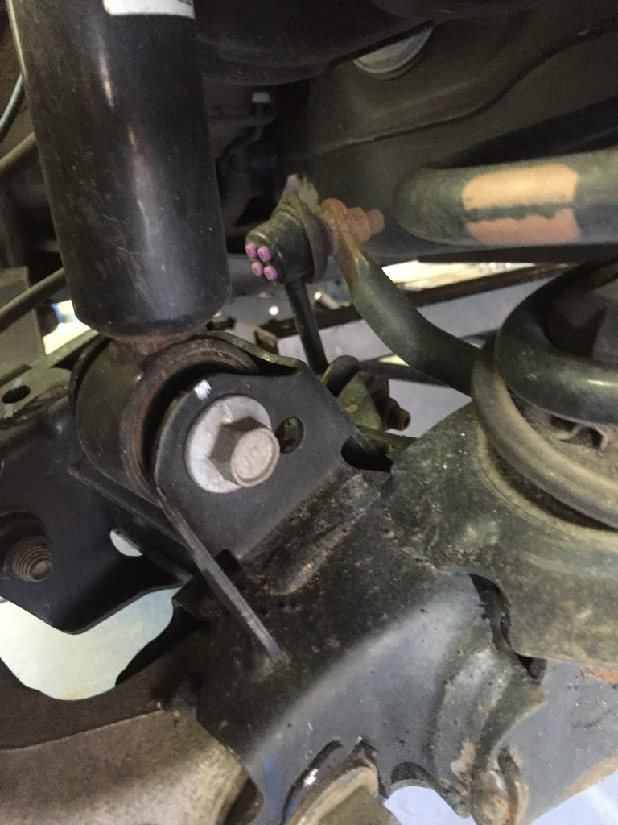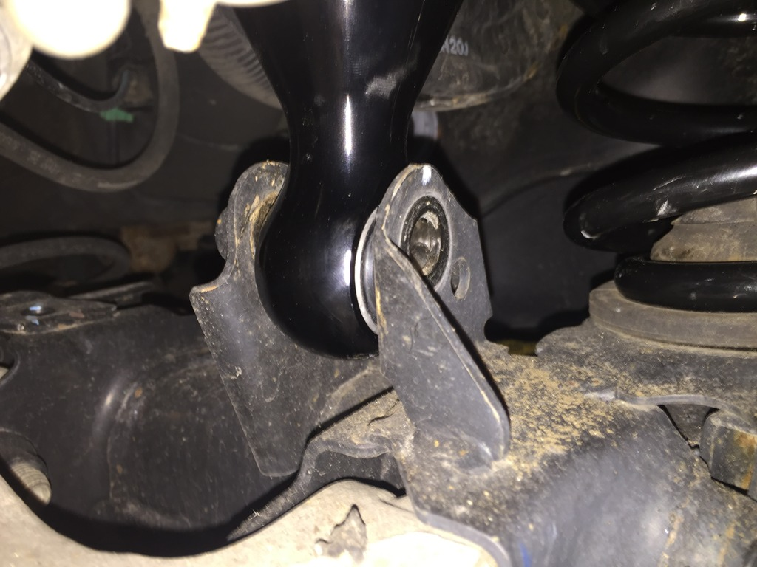

13. (REAR) Use the provided 19mm nut and wrench with a 5mm allen key to tighten the rear shock to the car on the top, snug like how the factory one was. Line up your bottom mount with the lower control arm and insert your bolt and nut and torque to oem spec.

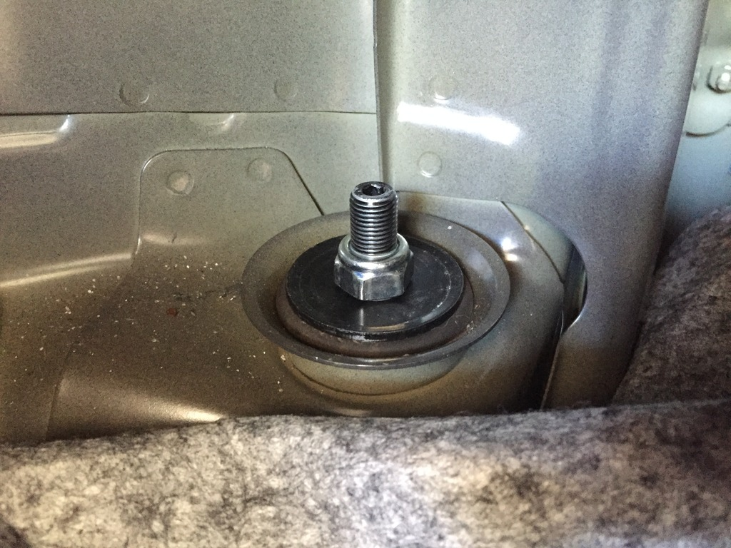

14. Accomplish this for the other side, and you are done. Before taking the car for a ride, check all of your nuts and bolts to be sure they are tight. Also remember that the coilovers will settle and sit a little lower then when you first lower the car. After installation, be sure to have the car professionally aligned.

For questions please contact support@iscsuspension-na.com

