ISC F026 (2015+ Ford Mustang) Coilover Install Guide
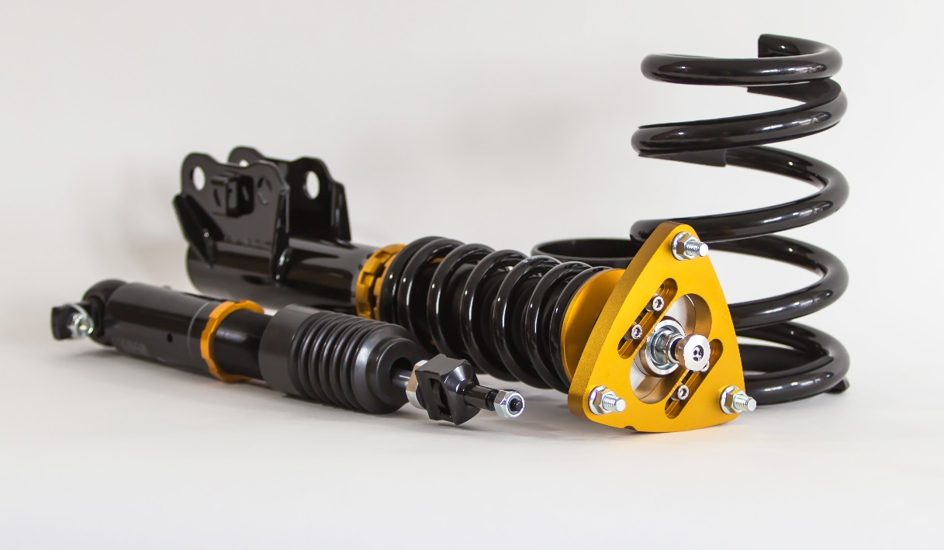
- Remove Wheels, lugnuts are 21mm
- FRONT
- Remove ABS wire from the strut, it is a plastic clip
- Remove swaybar endlink from sway bar. It is an 18mm nut, and 8mm hex to keep it from spinning.
- Remove brake caliper to gain access to strut mount bolts. Caliper bolt is 15mm.
- Remove strut mount nuts, 24mm.
- These bolts are spline pressed in like a wheel stud, you will need to tap the bolts out with a hammer as they will not spin out.
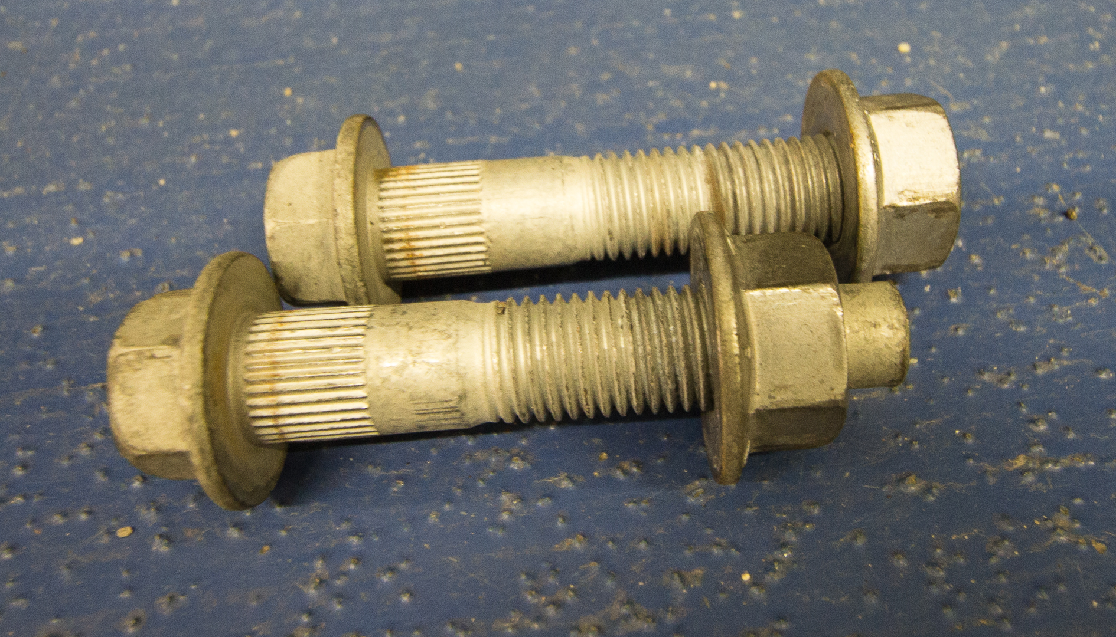
- Let the spindle drop easily to ensure that you are not putting stress on the abs line.
- Remove strut top nuts, they are 15mm leave one nut on and remove it while you have a solid hand on the strut. An additional person can also help with this.
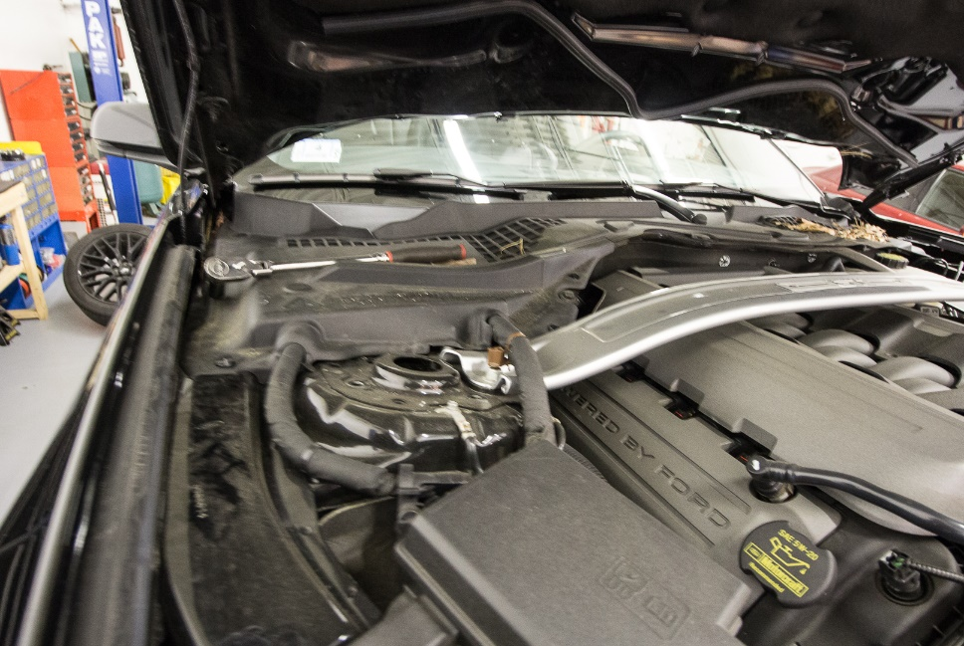
- Anti-seize coilovers before install
- Tighten top 14mm coilover nuts to spec
- Lift spindle into bottom mount
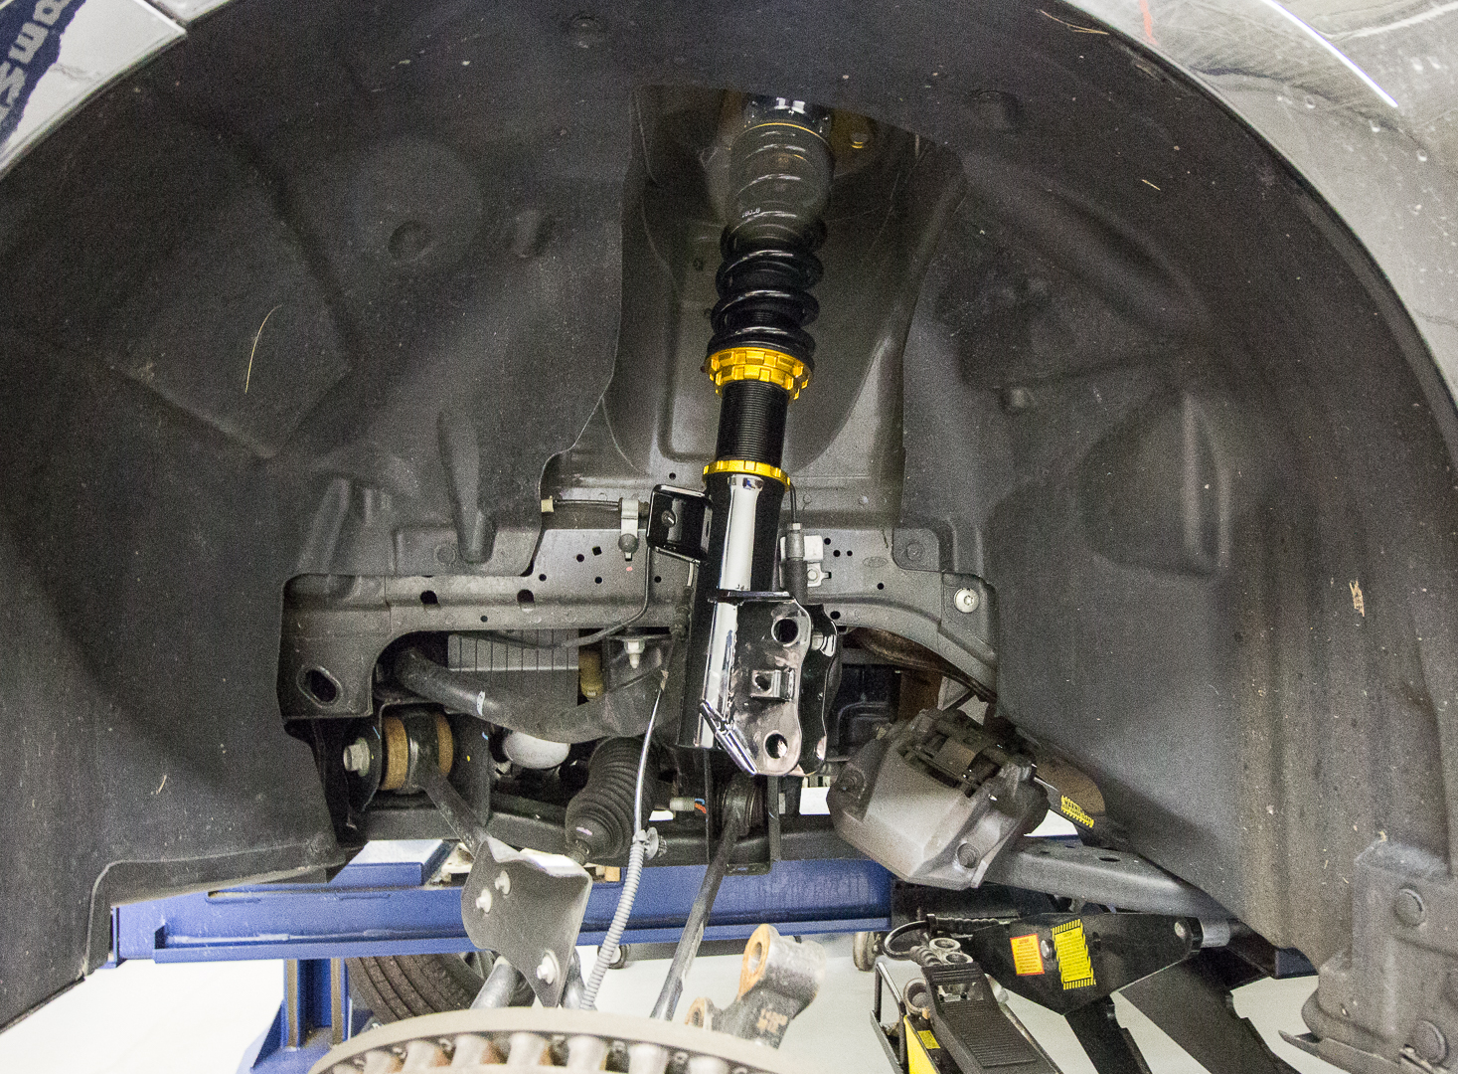
Spindle dropped
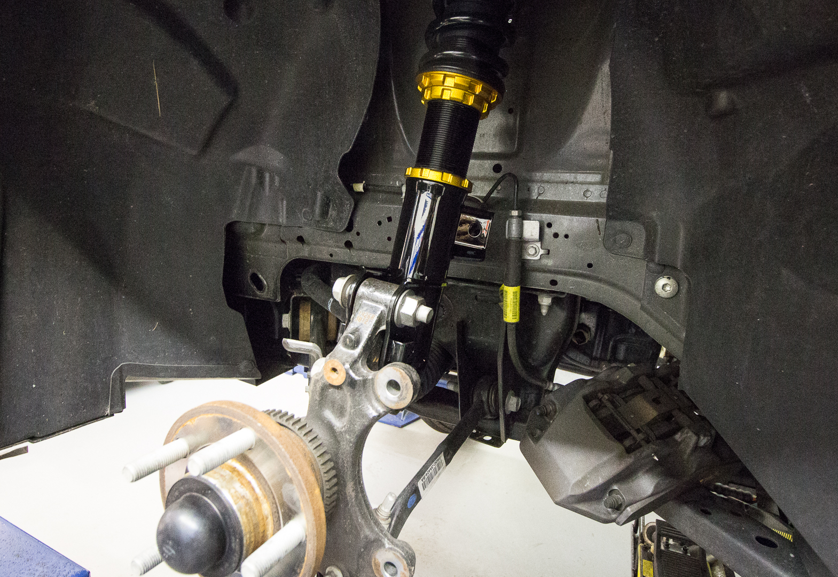
Spindle installed
- Install lower strut bolt note: Before tightening the ISC mounts are slotted on top for minor camber adjustment so depending on application move the spindle in or out and then tighten down.
- Install ISC end links, adjust them so the sway bar is level with the lower control arm. Tighten the end link nuts 19mm with 6mm Allen to keep them from spinning. Lock down jam nuts on end link adjusters.
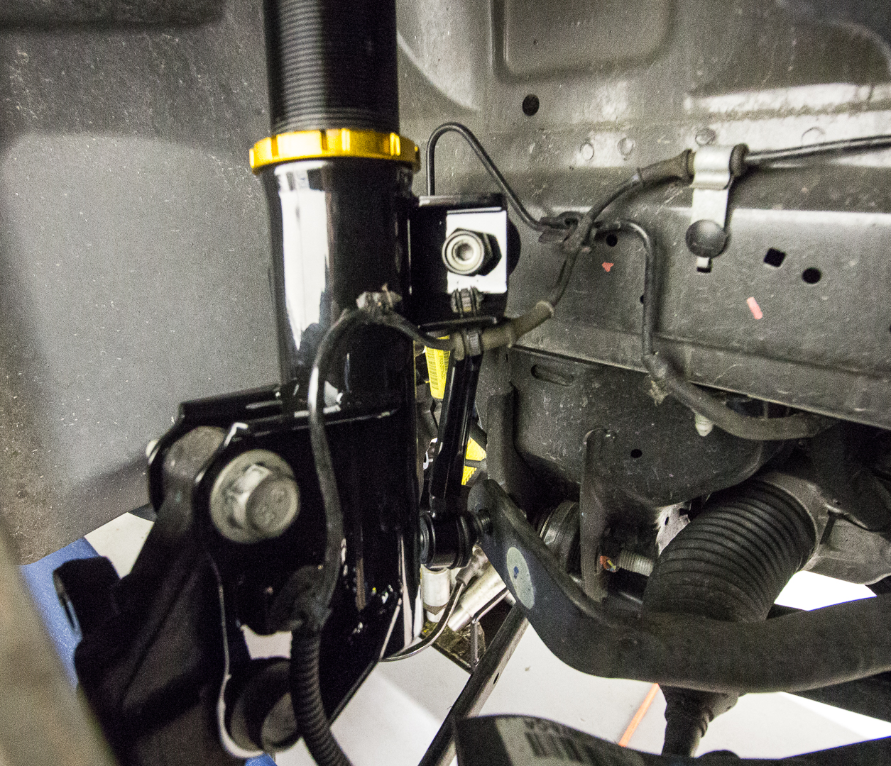
Positioning of Endlinks same side multiple angles
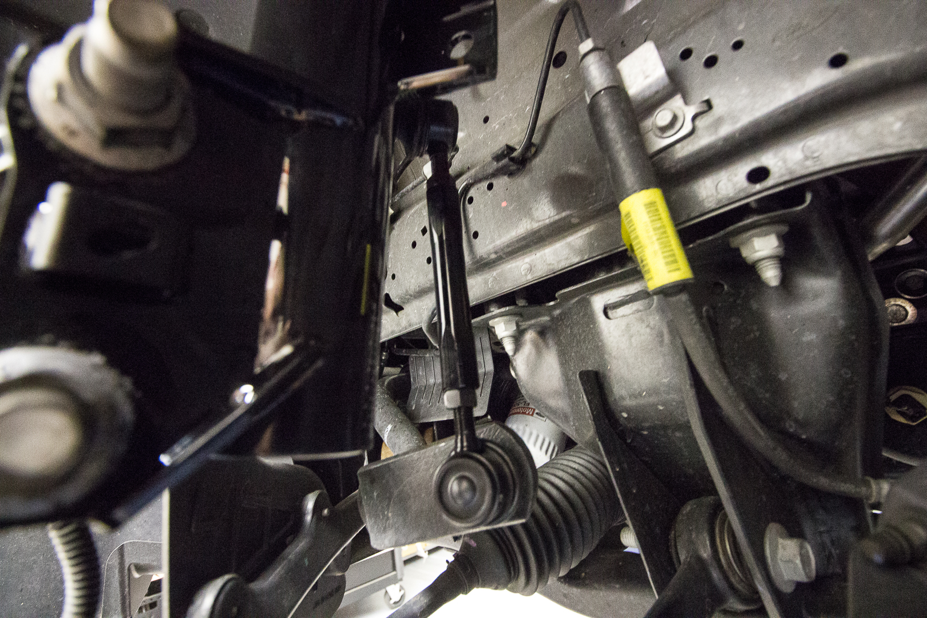
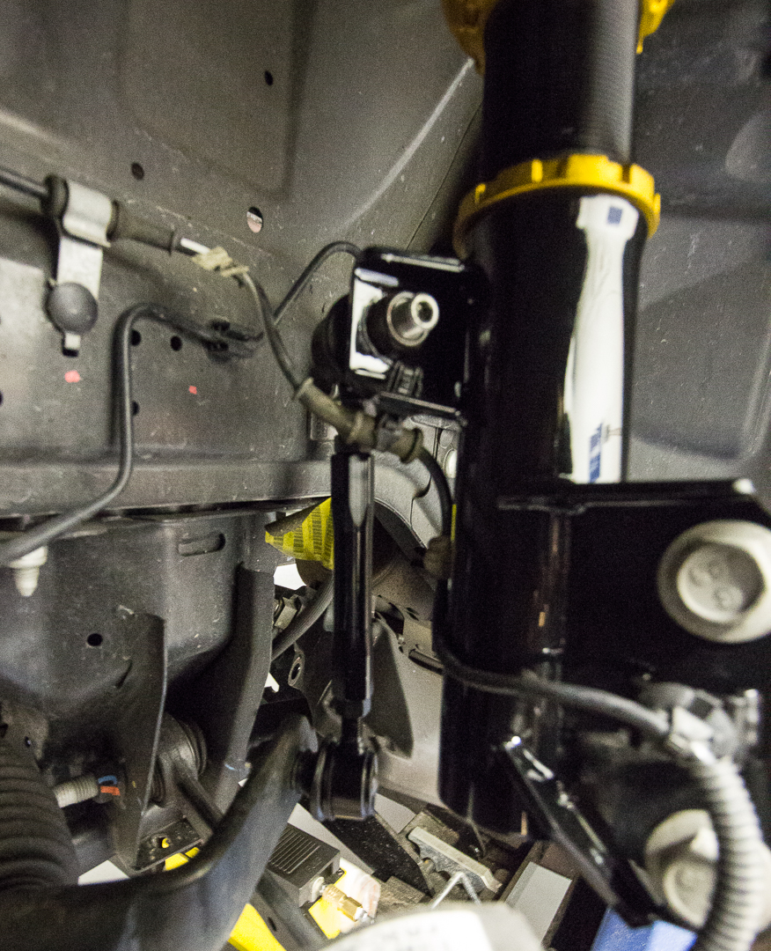
- Re-Install brake calipers and lines
- Set pre-load (5mm)
- Set ride-height (max height for coilovers will yield a 1 increase in height from OEM max drop will see 3 inches under stock.
- REAR:
- Remove Shocks, top bolts: 18mm Lower Bolts: 15mm
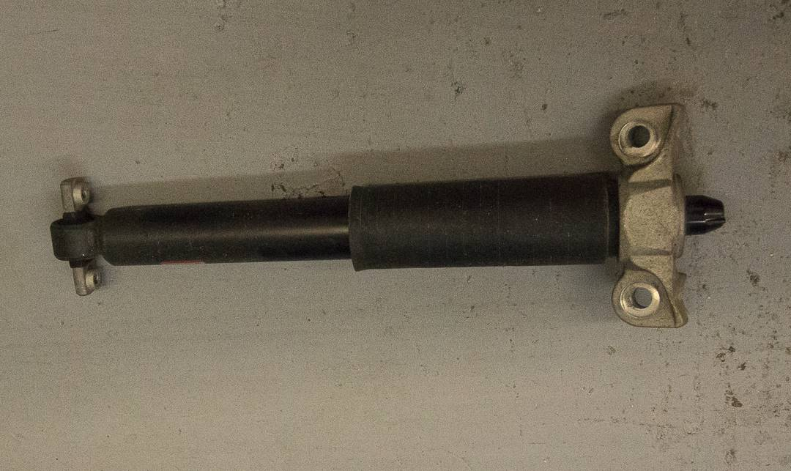
- Remove brake line bracket
- Remove 4, 21mm subframe bolts while supported, carefully lower to remove tension on springs.
- Remove stock rear spring
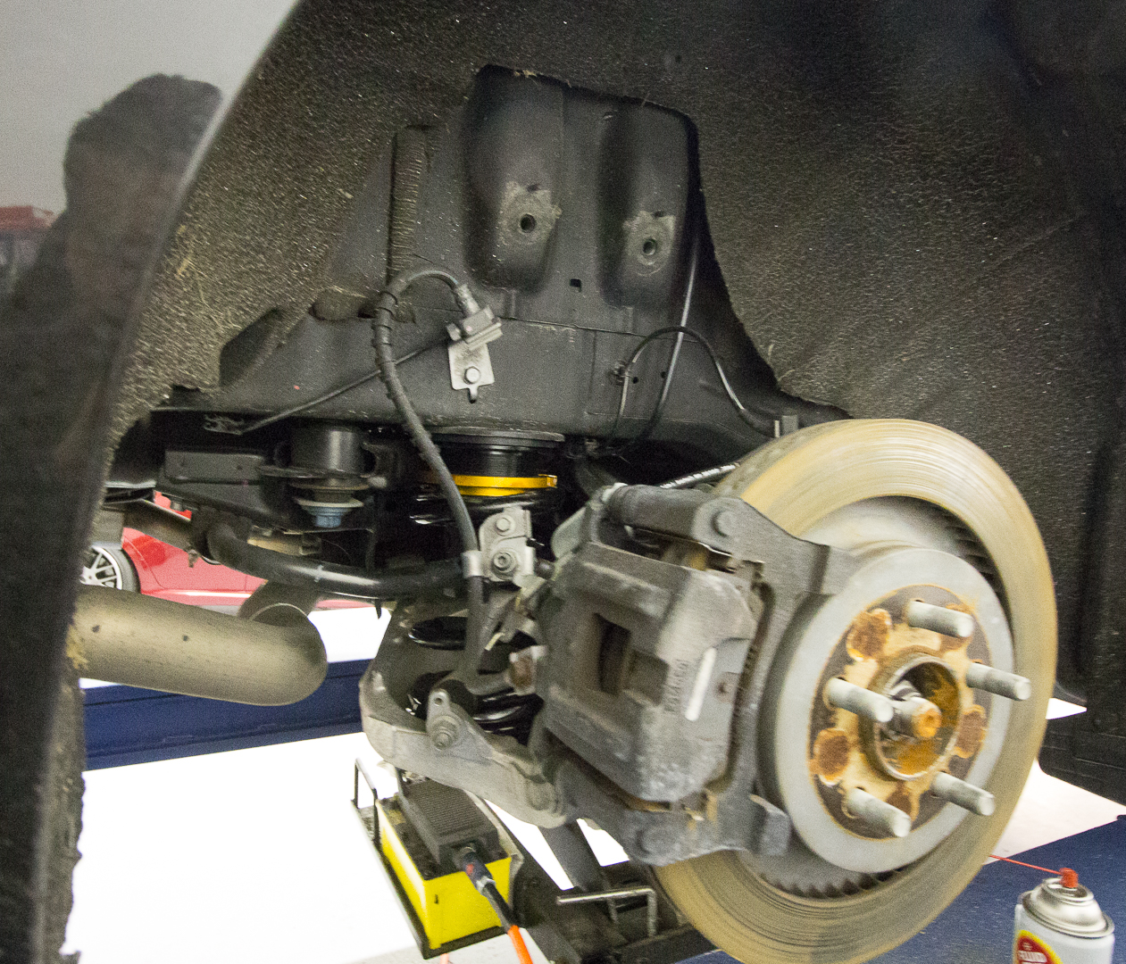
- Anti-seize rear cups, set height. Max height will be about 1 inch lower than stock, 2 rotations on collars = ¼ height adjustment.
- Install spring on bottom making sure it’s seated correctly in mount.
- Install cup on top with ISC rubber between cup and body.
- Reinstall the sub frame bolts
- Lower the car to check height and make adjustments if necessary.
- For shock, OEM top mount must be reused. Remove dust cap and then remove the top 15mm nut. Remove the top mount and transfer it to the ISC top. Install with the new 17mm nut.
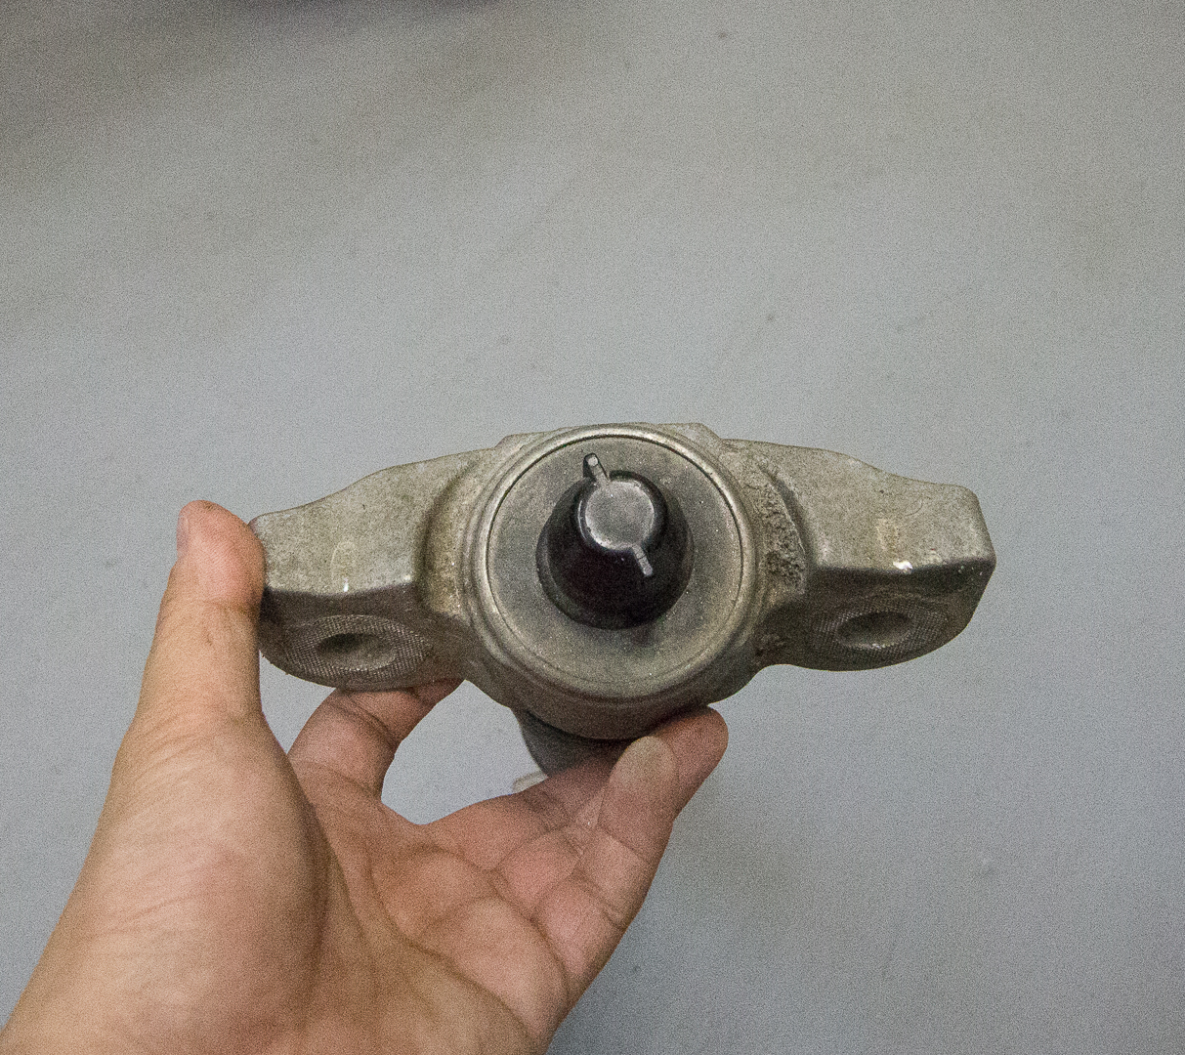
OEM top mount
- Anti-seize the shaft where and mount and collar will be.
- Thread the shaft into the bottom mount until it passes the window hole in the mount.
- Install complete shaft into car
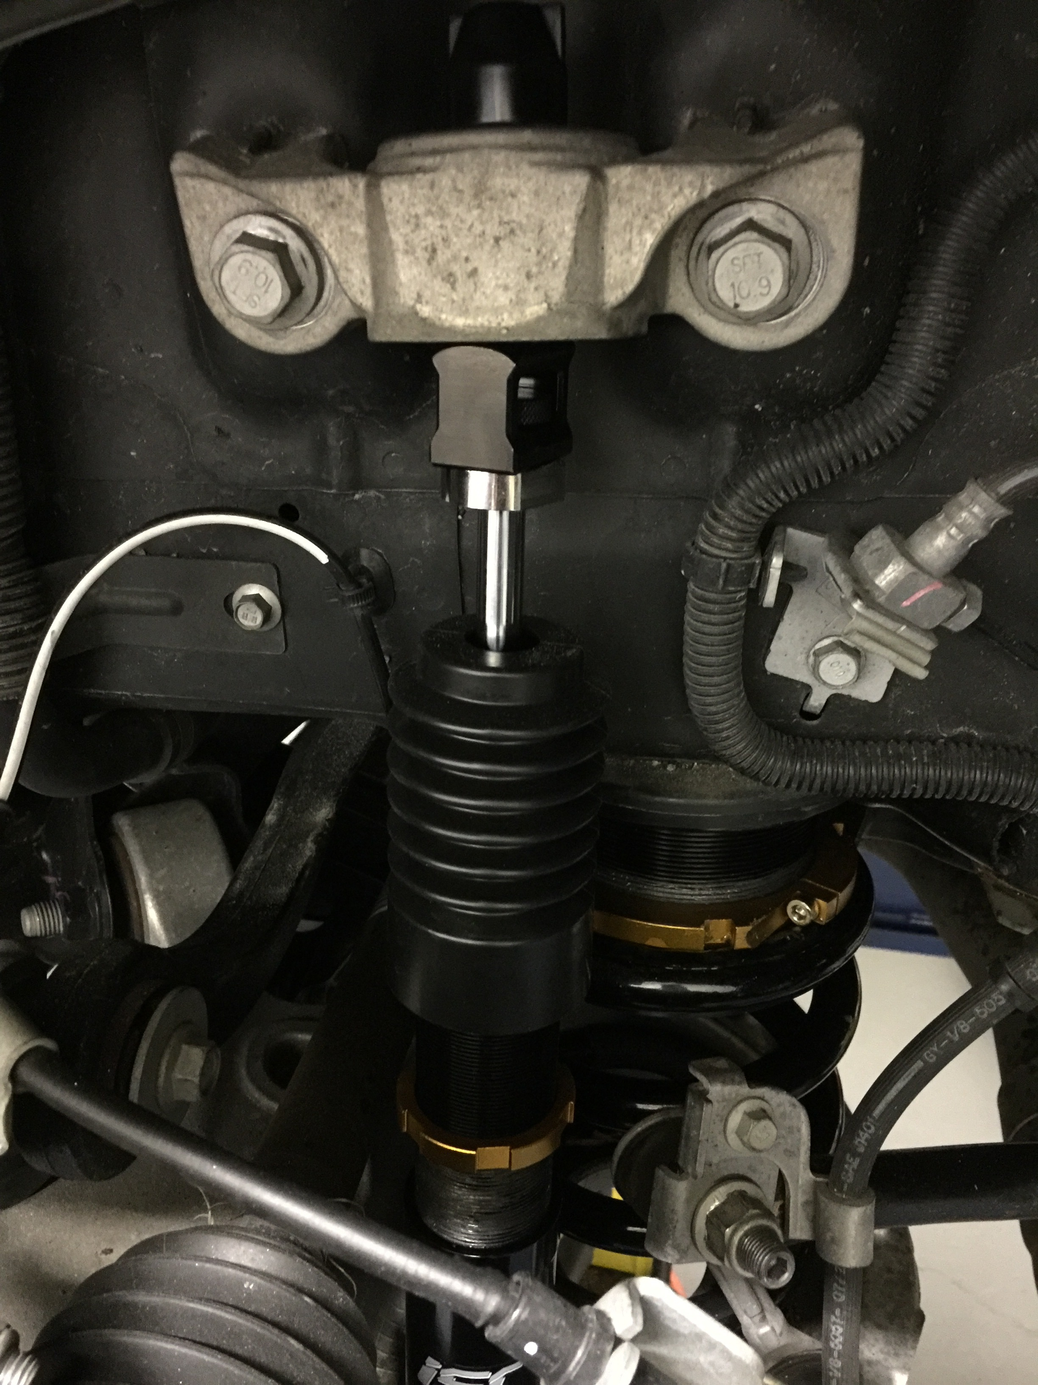
- Reuse OEM 15mm bolts with the new 17mm nuts.
- Install top OEM 18mm bolts.
- Tighten all to spec.
- Thread the shaft into the mount until there is 5mm of preload on the spring and lock down the locking collars. The preload will physical move the car down 5mm.
- Rear will see min drop of .50 below OEM, with Max being 3+ lower than stock.
Enjoy! Photos of final product shown below.
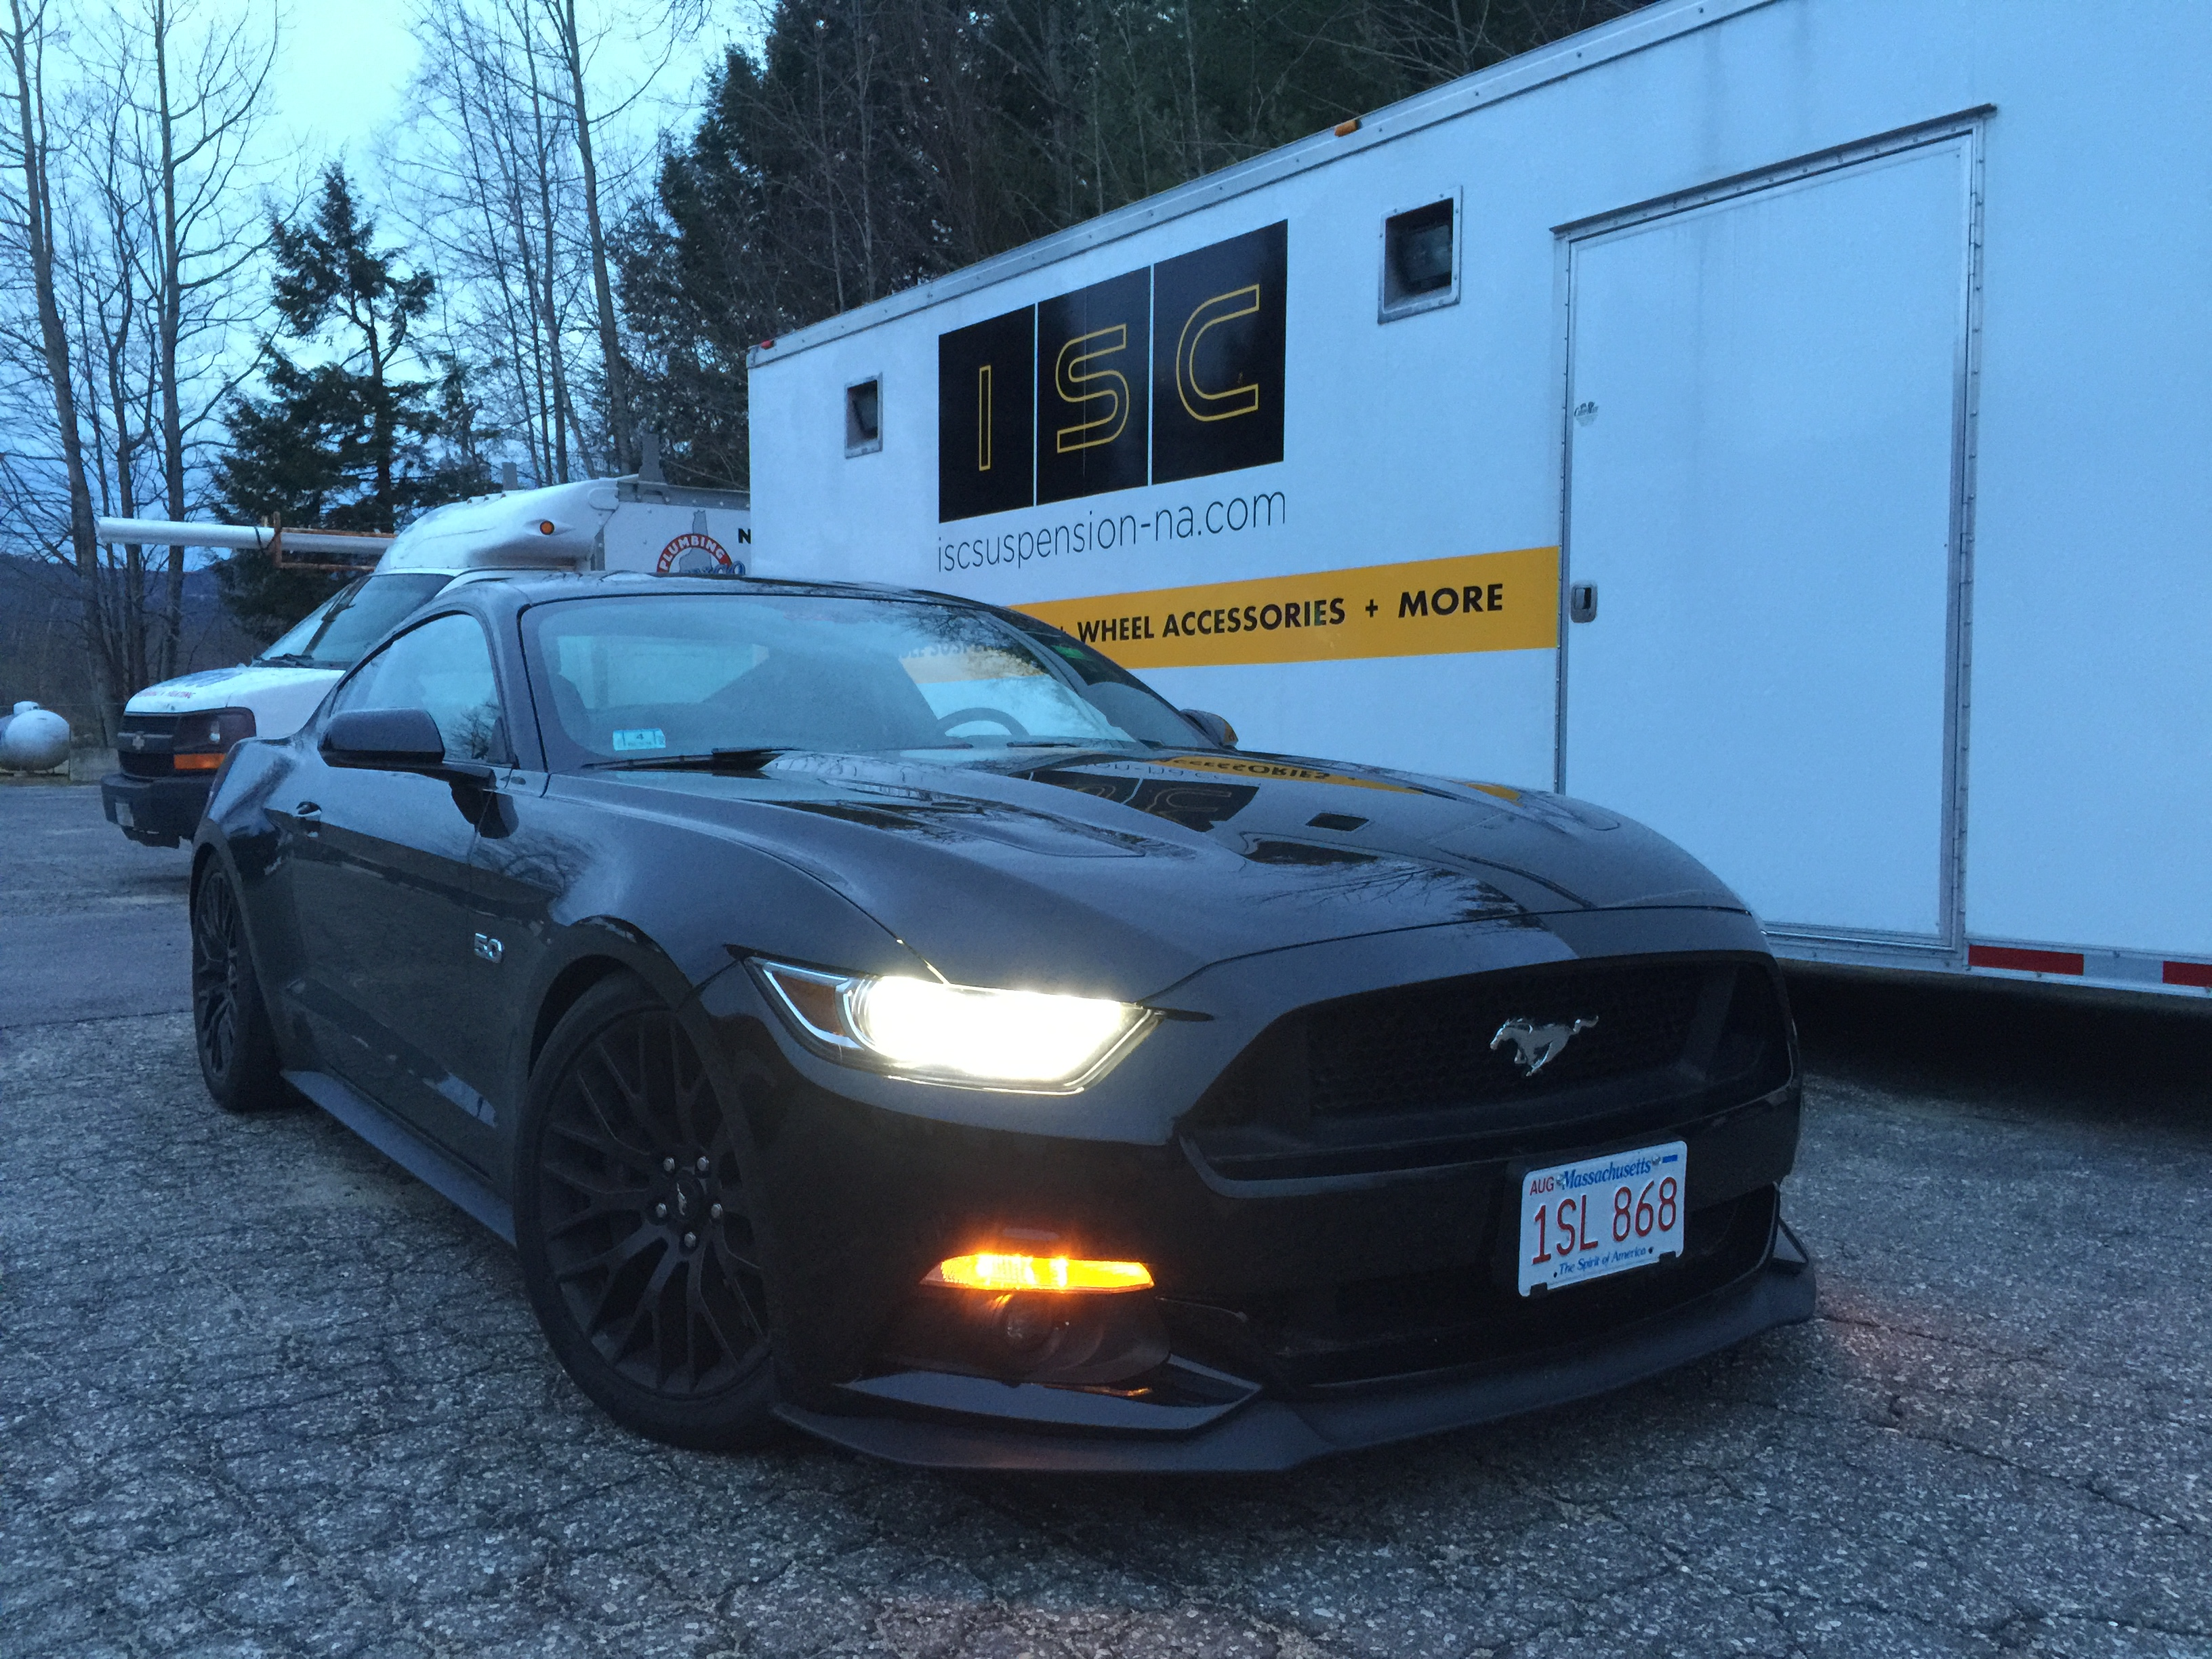
Installed on a 2015 Mustang 5.0

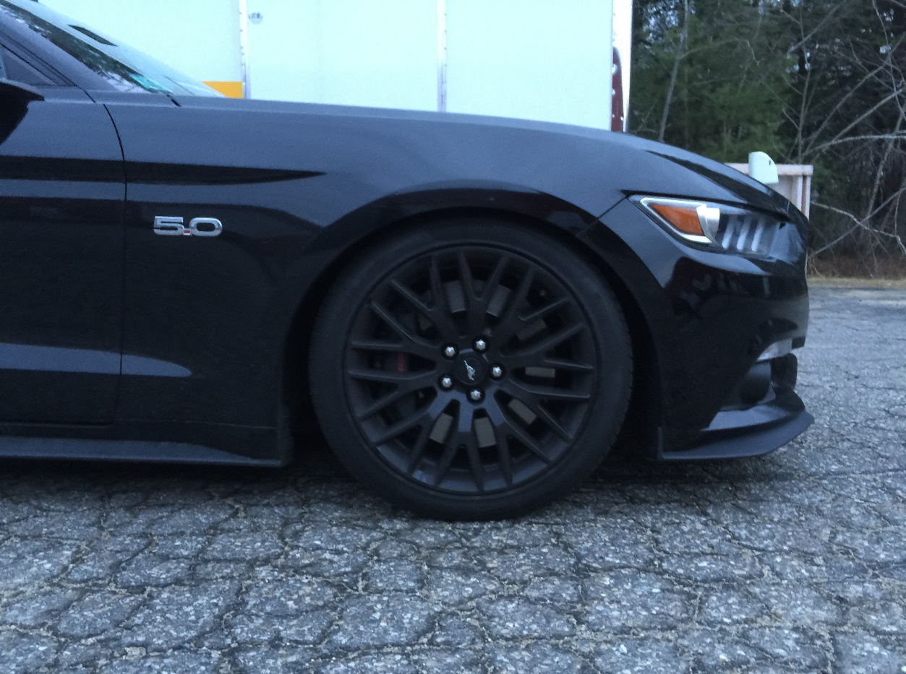
Front
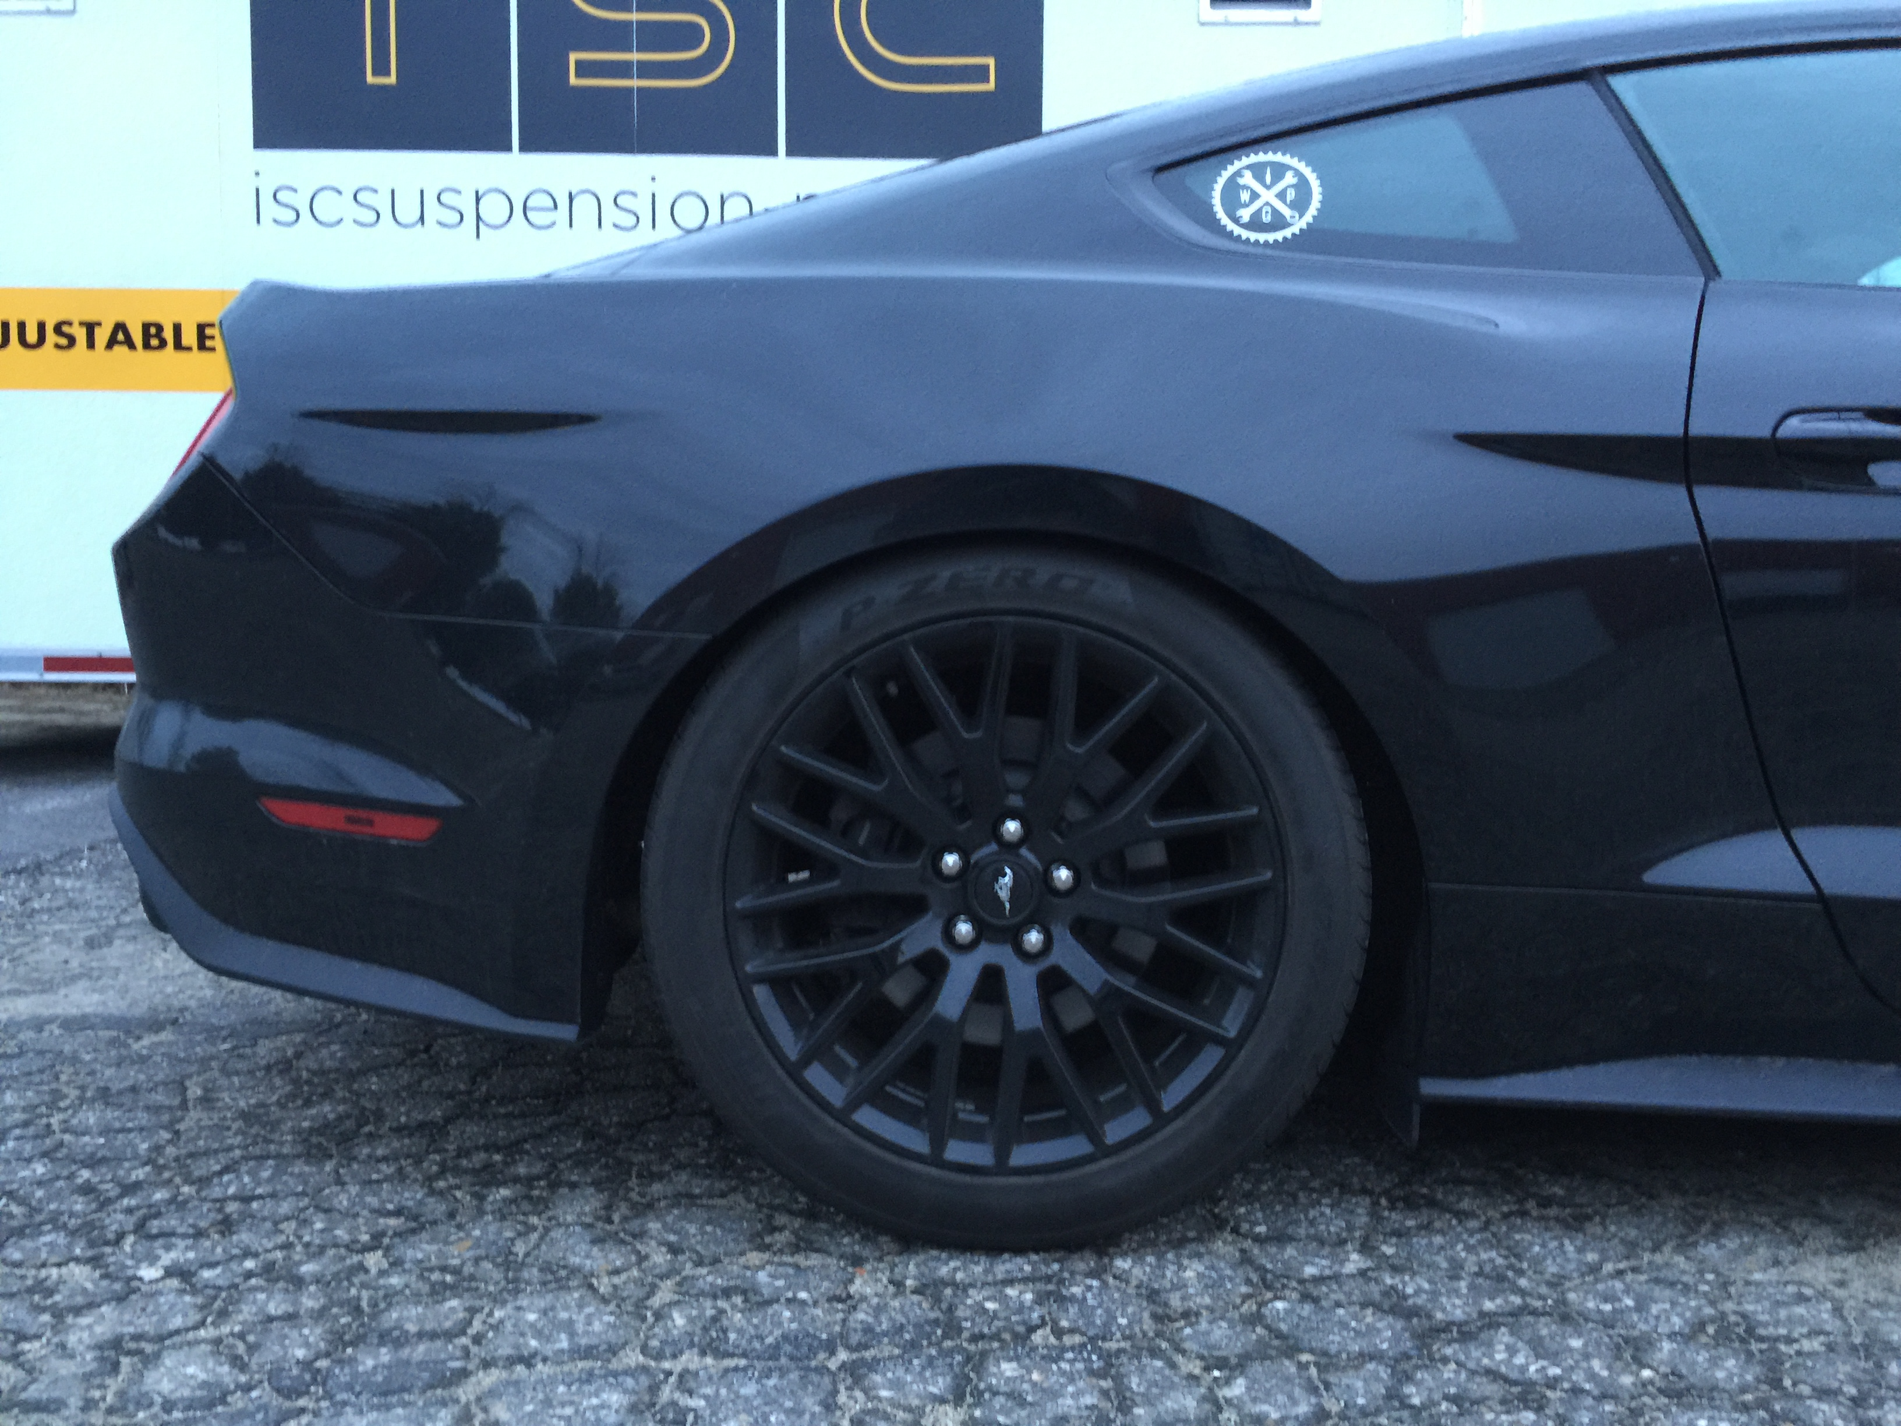
Rear

