How to Install ISC Extended Wheel Studs
Begin by removing your factory studs, if you plan on not reusing the factory wheel studs you can simply hammer these out of your hub. If you do wish to reuse these, then you will need to use some form of punch.
Install the new studs by placing them into the new hub, we recommend using a wheel stud installer that is created for installing new wheel studs.
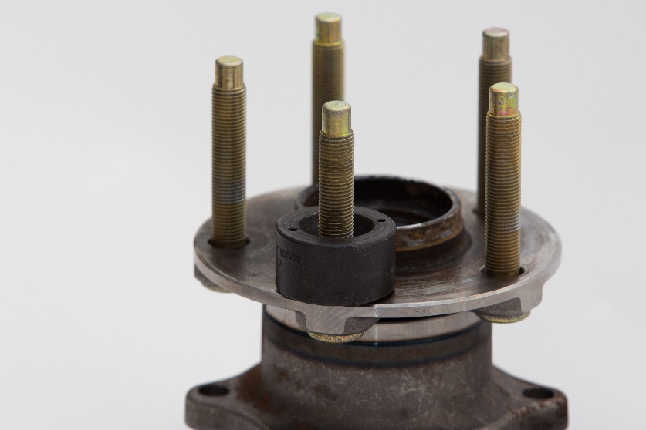
Next install a lugnut to bring the new wheel stud into the hub and tighten, repeat for all 5.