Hyundai Sonata Rear Installation

Begin by removing the OEM components including the strut assembly and the spring.
Remove the strut assembly first, and then remove the spring. This makes it much easier to take the spring out.
The rear spring assembly should be assembled and look likes this. Refer to the ISC Installation guide on how to setup the ride height.

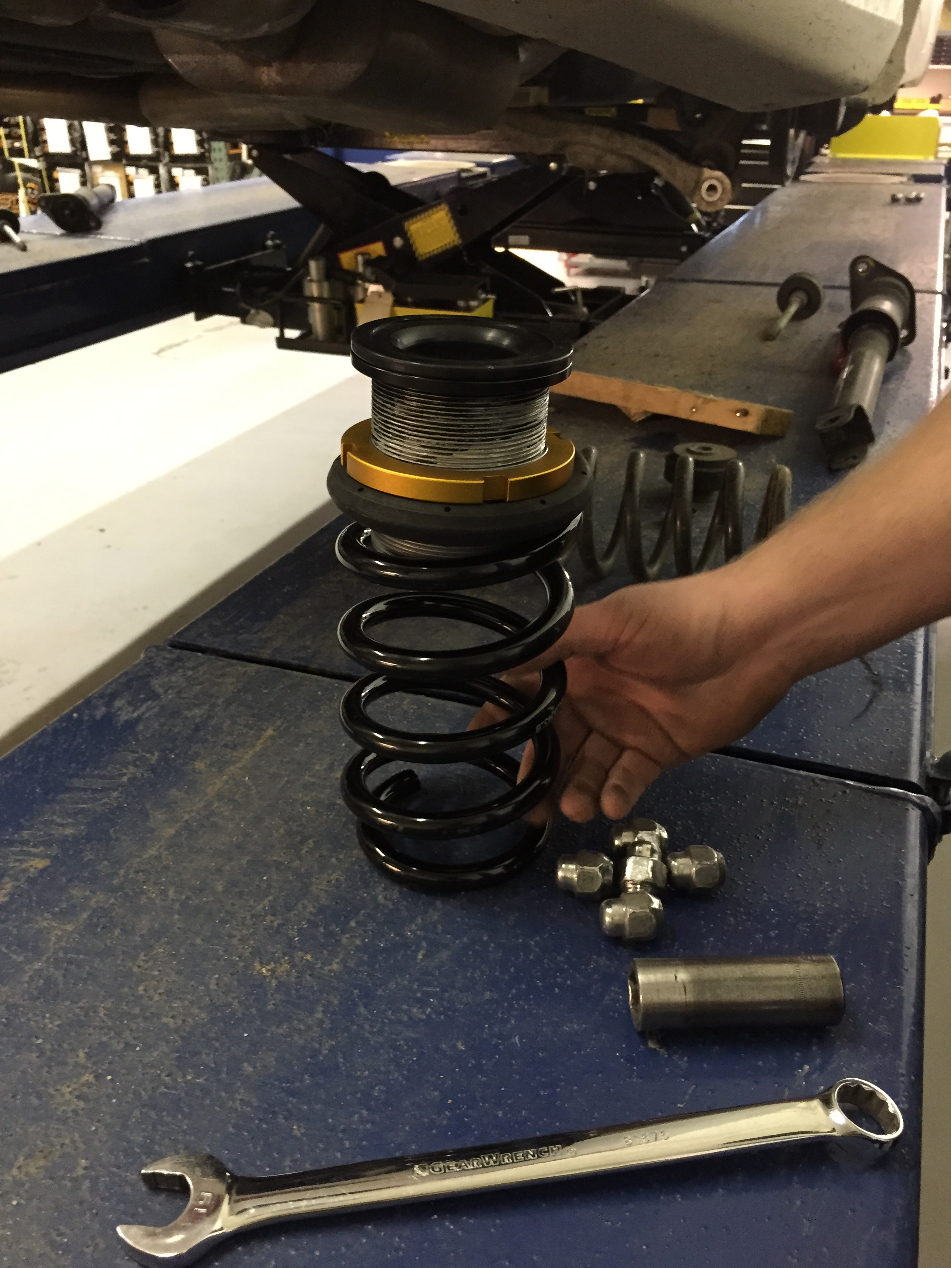

You should have a rubber boot on top, followed by the spring collar and then spring. Make sure to anti-seize the collars to avoid the collars seizing.

You can now install the spring assembly with new spring perch. You will need to lower the rear arm and then pop the new assembly into where the only spring sat.
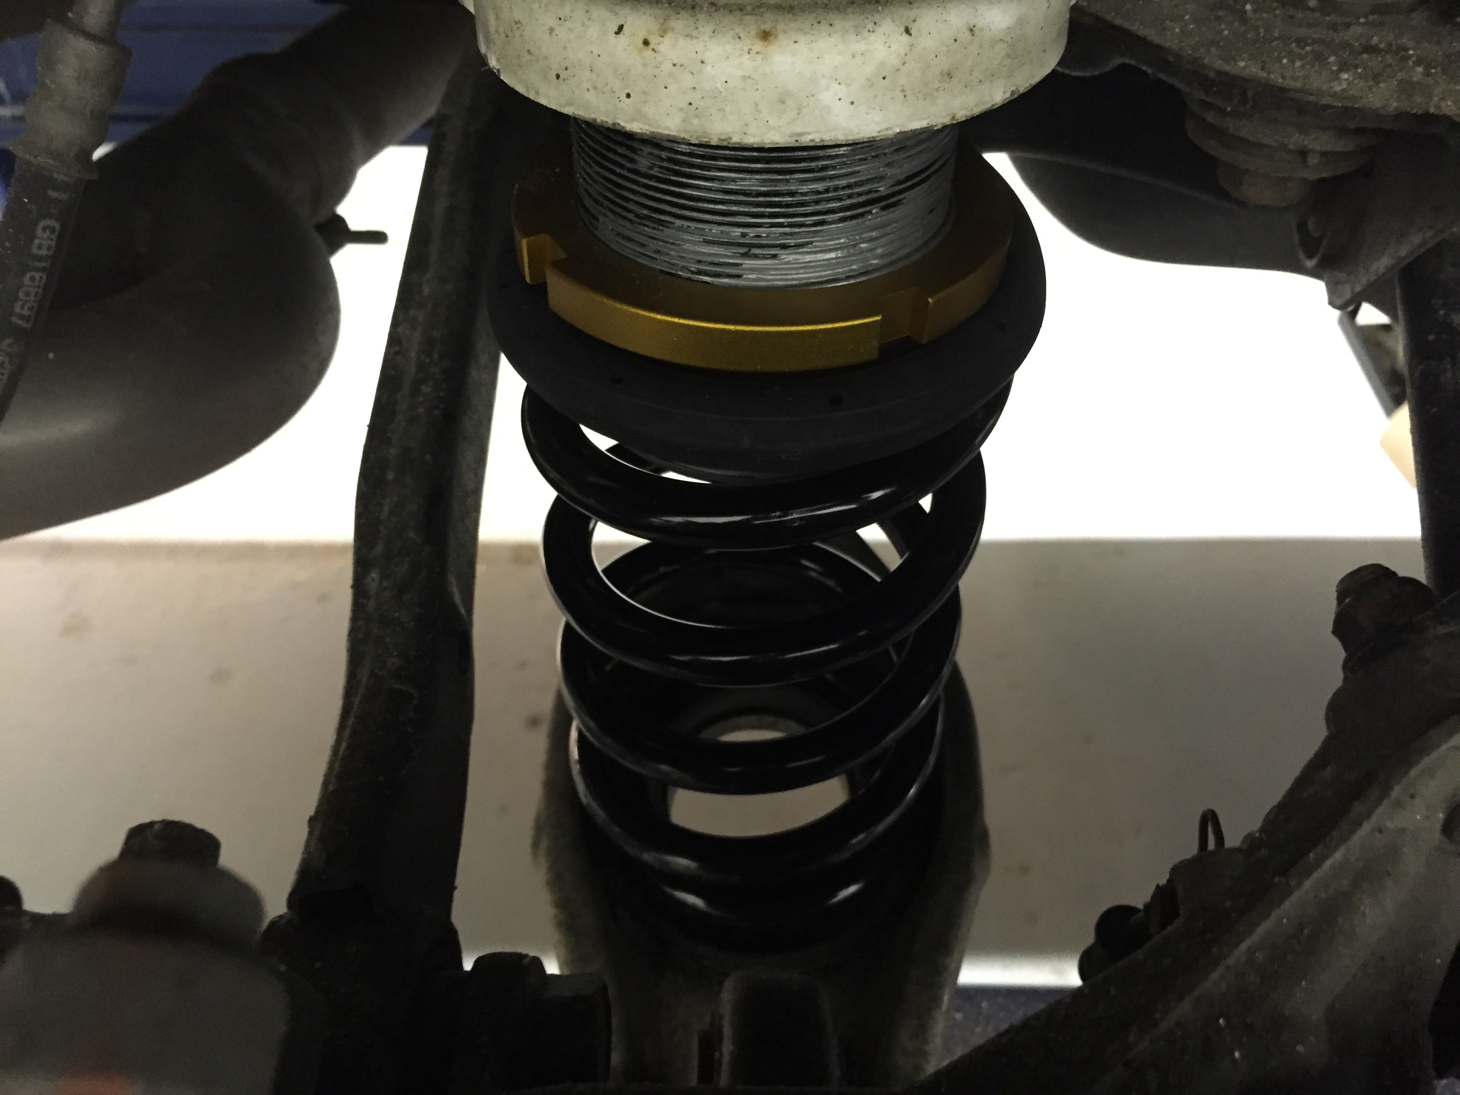
You will now need to assemble your rear strut. The rear shafts do not come with top plates, so you will need to reuse your old top hats. These can be unbolted using the two bolts shown here.
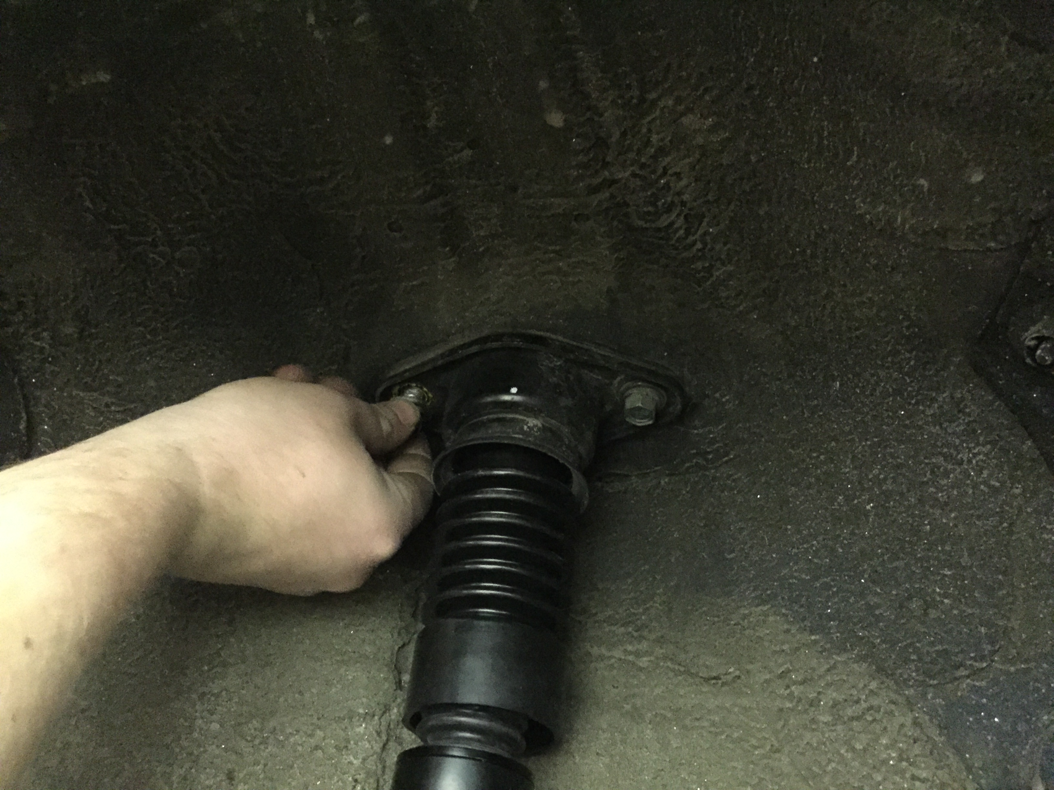

Once removed, the top hat can be simply snapped loose from the dust boot.

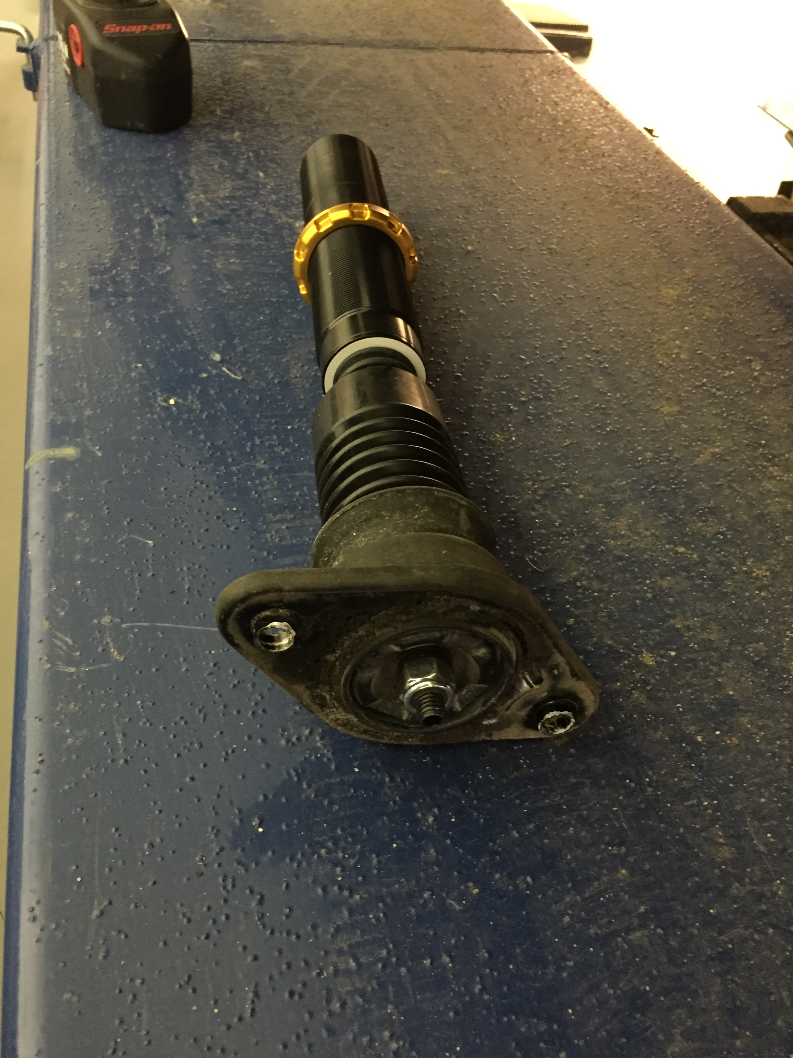
Now you can remove the top plate and then install onto the shaft like pictured above.
Reinstall, and you are good to go. Adjust ride height according to the installation guide and set your damping at whichever level works best for you!

