Rear Adjustable Control Arm Installation (By Tom Loo):
1. if possible, spray all the bolts being removed ( lower shock bolt, sway bar end link bolts, and inner and outer control arm bolts) a few times for few days before the installation.
2. Remove the lower shock bolts, along with the sway bar end link bolts.
3. Remove the inner and outer control arm bolts. These are very tight so a large breaker bar with impact sockets will work best. (I had a 3 foot breaker bar on it and also had to use a torch to heat up the nut to remove mine).
4) Now that the OEM control arm is out of the car. You can begin to setup the ISC control arm. To establish a starting point, I un-threaded the Heim joint all the way from the arm itself and from the extension nut. Apply anti-seize to all threads. Then I simultaneously started to thread the Heim joint and the extension nut into the end of the arm, so that there was equal adjustment on both sides of the nut. Since one side of the nut is a left handed thread and one side is a right handed thread, all you have to do is hang the arm off the end of a table, hold the Heim joint still and spin the extension nut all the way till it bottoms out. I then adjusted the ISC arm to the same length as the stock OEM control arm. Tighten down both locknuts to assure the length of the arm does not change.
5. Pack the Heim joint with lots of grease. I also found some rod end dust seals online and decided they would be a good addition to keep the joint free of road debris.
6. Install ISC control arm into back into the car. New hardware is supplied for the sway bar and the lower shock mount, but the original hardware is re used for the inner mount. Be sure everything is tight/properly torqued.
7. Repeat steps for the other side of car.
8. Since the length of the control arm was only eye-balled, the alignment of the car could be way off, or it could be close. GO GET AN ALIGNMENT ASAP!!
___________________________________________________________________________________________________________
5x100 to 5x114 Wheel Adapter Installation: (By Tom Loo)
Here is a quick step by step with pictures that explains how to install the 15mm and 25mm wheel adapters.
1. Gather all the parts that you need for the install
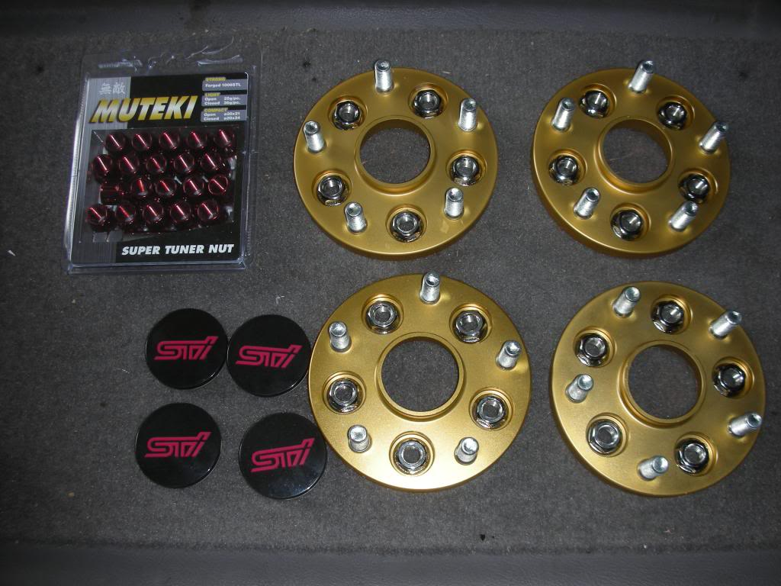
2. I also did a quick test fit of the adapters into the back of the new wheels, just as a double check. As I expected, the ISC adapters fit flawlessly into my BBS.
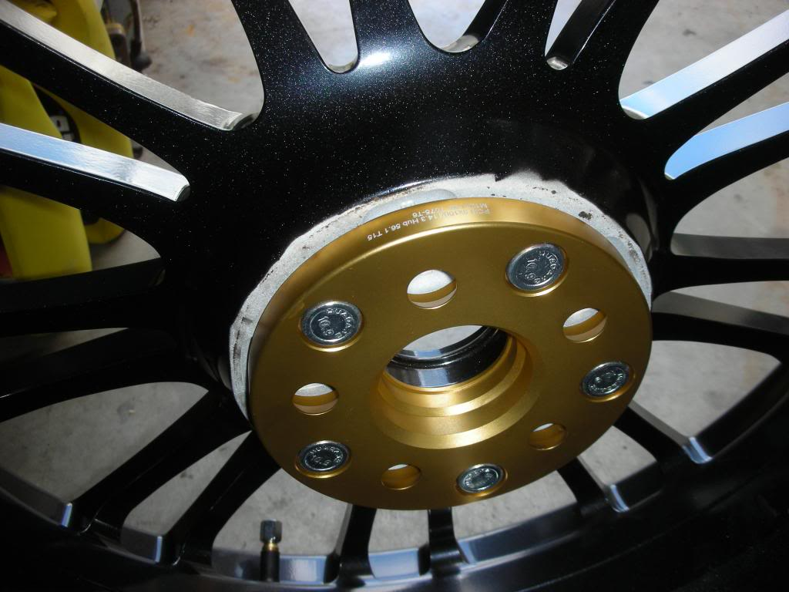
3. Get the car off the ground and remove all 4 wheels. If you don't have access to a lift, a jack and 4 jack stands works just as well.
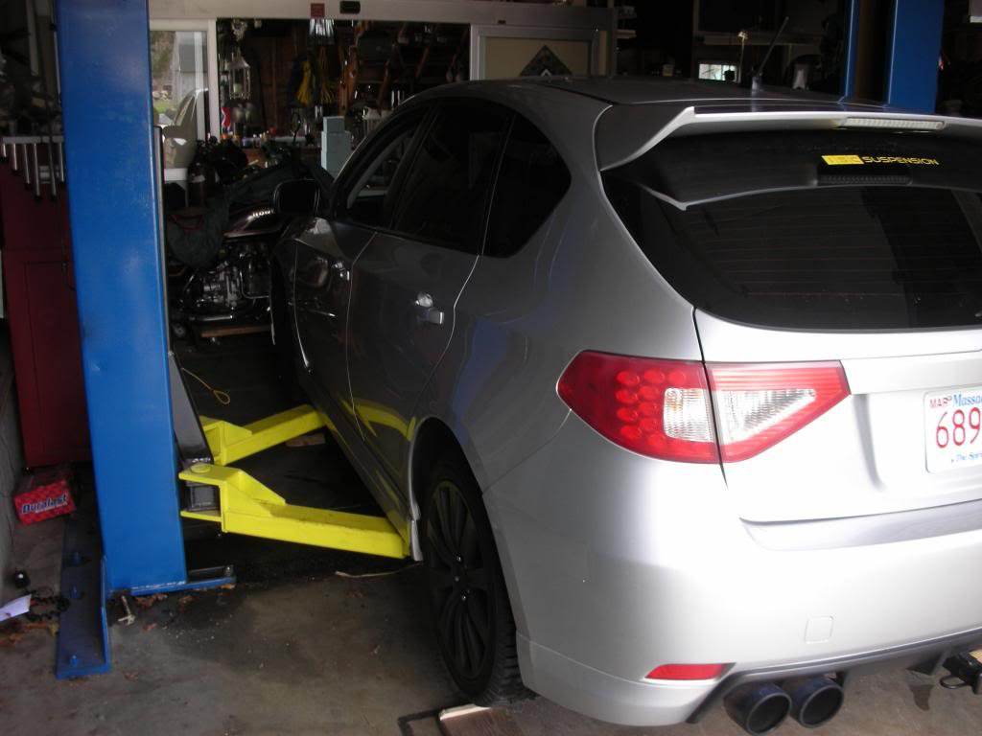
4. Once all the wheels are off, take a wire brush and clean up all the surfaces the adapters will be mating to. If you do not do this you may get a vibration at high speeds!
5. Add a little bit of anti-seize around the center bore pilot, so that the adapters will come back off when it is time for the winter wheels to go back on.
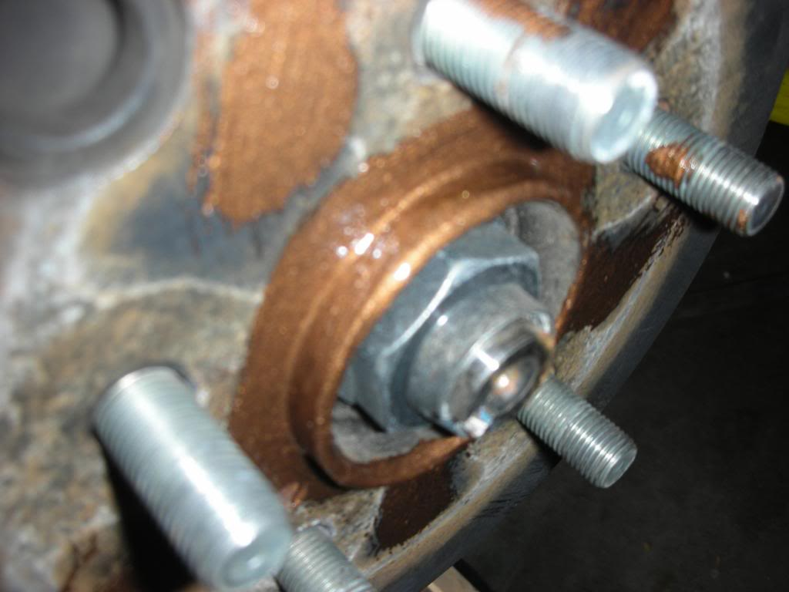
6. Install the spacers over the car's studs with the supplied hardware from ISC. Tighten these bolts in a cross star-like pattern, just as you would tighten wheel lug nuts. Torque to 86 ft-lbs.
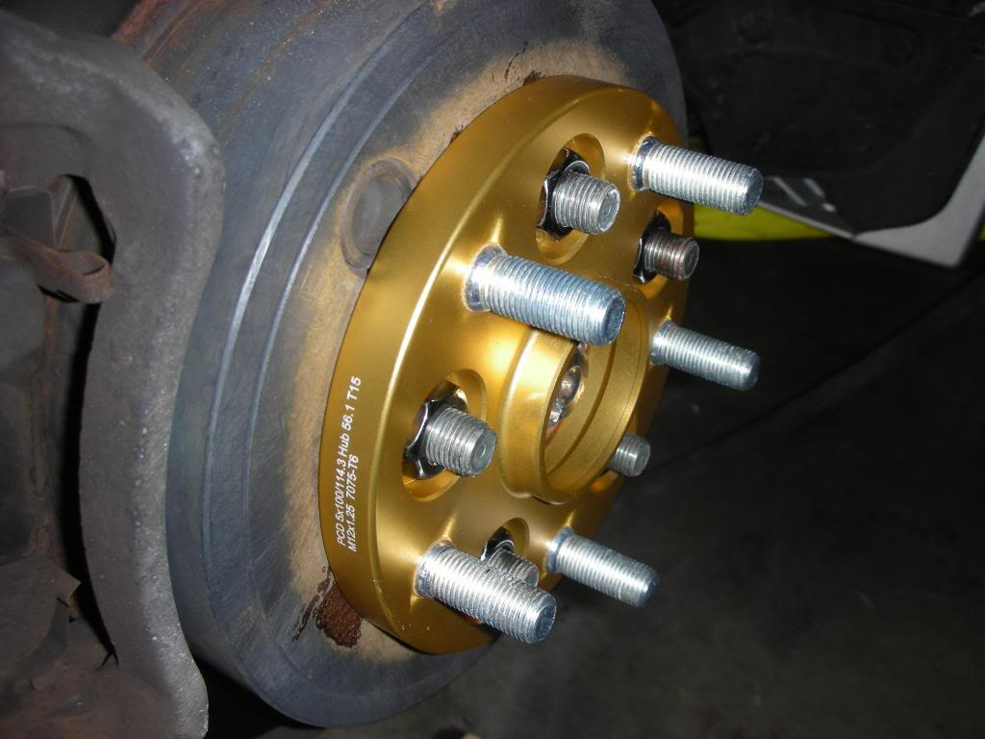
As you can see from the above photo, the lugs are sticking out pretty far past the adapters. This will cause problems when trying to mount the wheel,causing the wheel to hit the studs before actually tightening down, so be careful. Wheel stud modification is only required with the 15 mm adapters and the 25 mm adapters require no modification to your stock wheel studs. Some wheels will do just fine with the 15mm, it depends on the pockets behind the wheel. test fit first, modify if needed.
7. The OEM STi BBS wheels that I am mounting on the car have pockets on the back of the wheel, but were not deep enough. so, I had to trim 1/4" off of each stud. Also, cutting this little amount off allows me to still run my winter wheels without the adapters installed.To do this, I used a cutoff wheel on an air tool, but if you are good with a sawzall, that will work too. After all 20 studs were cut, I used a M12 x 1.25 thread chaser to clean up any and all threads that may have gotten damaged. This was a very easy process, just time consuming due to the number of studs. Re-install the adapters on the car.
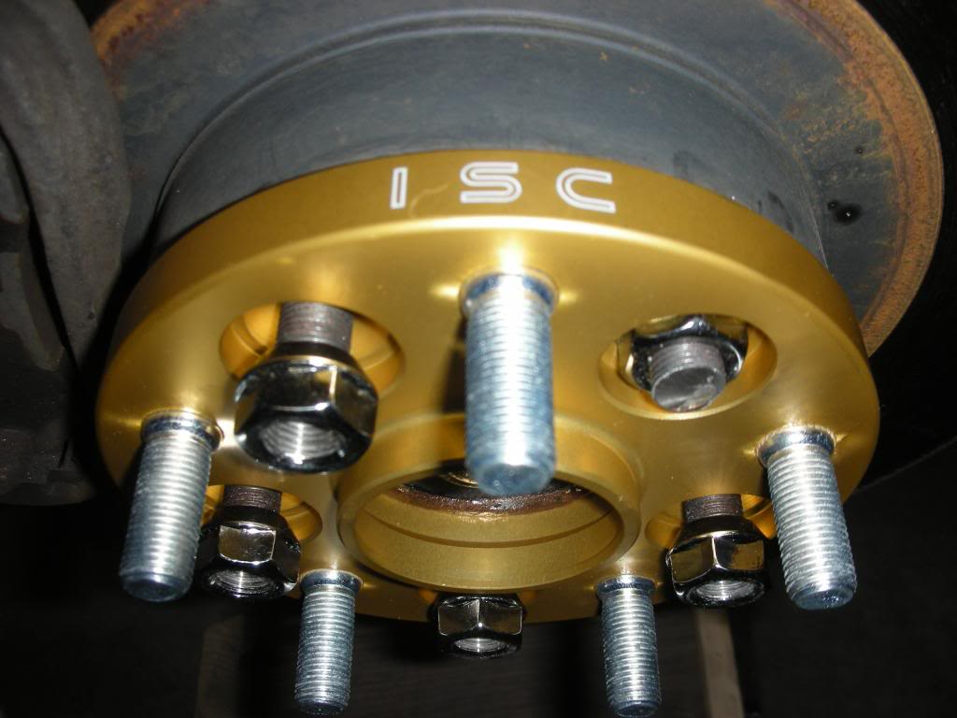
8. Test fit the wheels on the car. Take special notice to where the wheel meets the mating surface of the adapter, making sure that it is flat and there is no clearance issues with the lugs hitting the wheel.
9. If everything looks good, you're ready to put your new, 5 x 114 STI bolt pattern wheels on. Be sure to torque all wheels to 86 ft-lbs. Because the wheel adapters are new, it will take some time for the new studs to seat properly into the aluminum body of the adapter. I torqued all my wheels as usual, then went around the car again and re-did them all again. I then drove the car around the block, and re-torqued them a third time. I also re-torqued them after 100 miles of driving, just to be sure.
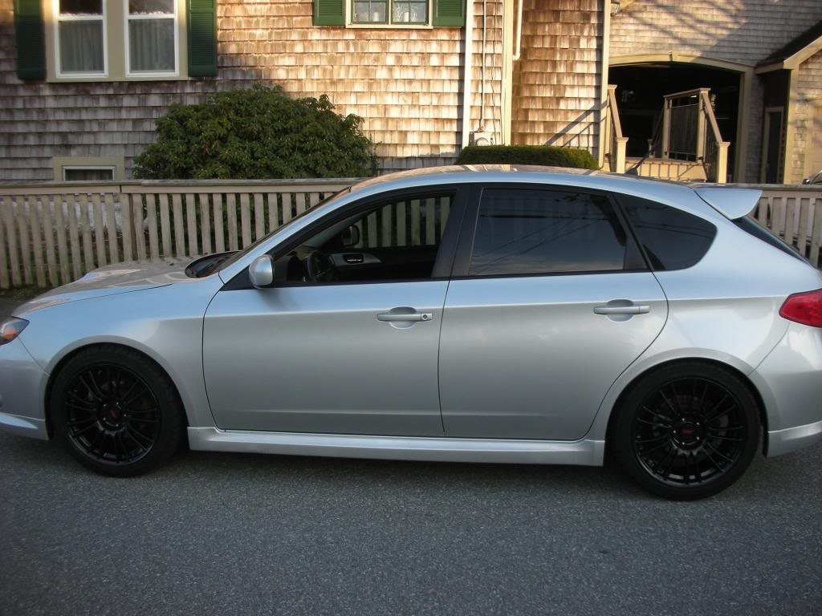
After driving on these for almost a week, there is nothing but positive things I can say about these. All winter I struggled with a new summer wheel decision and the lack of variety in the 5x100 bolt pattern. Once I heard that ISC had the 5x100 to 5x114 adapters coming out this spring, it increased my options ten fold. I love the way my car looks with the new wheels, and that wouldn't have been possible without the quality and affordability of these adapters from ISC. TWO THUMBS UP FROM ME!!
- Tom Loo

