2015+ WRX/STi Coilover Install
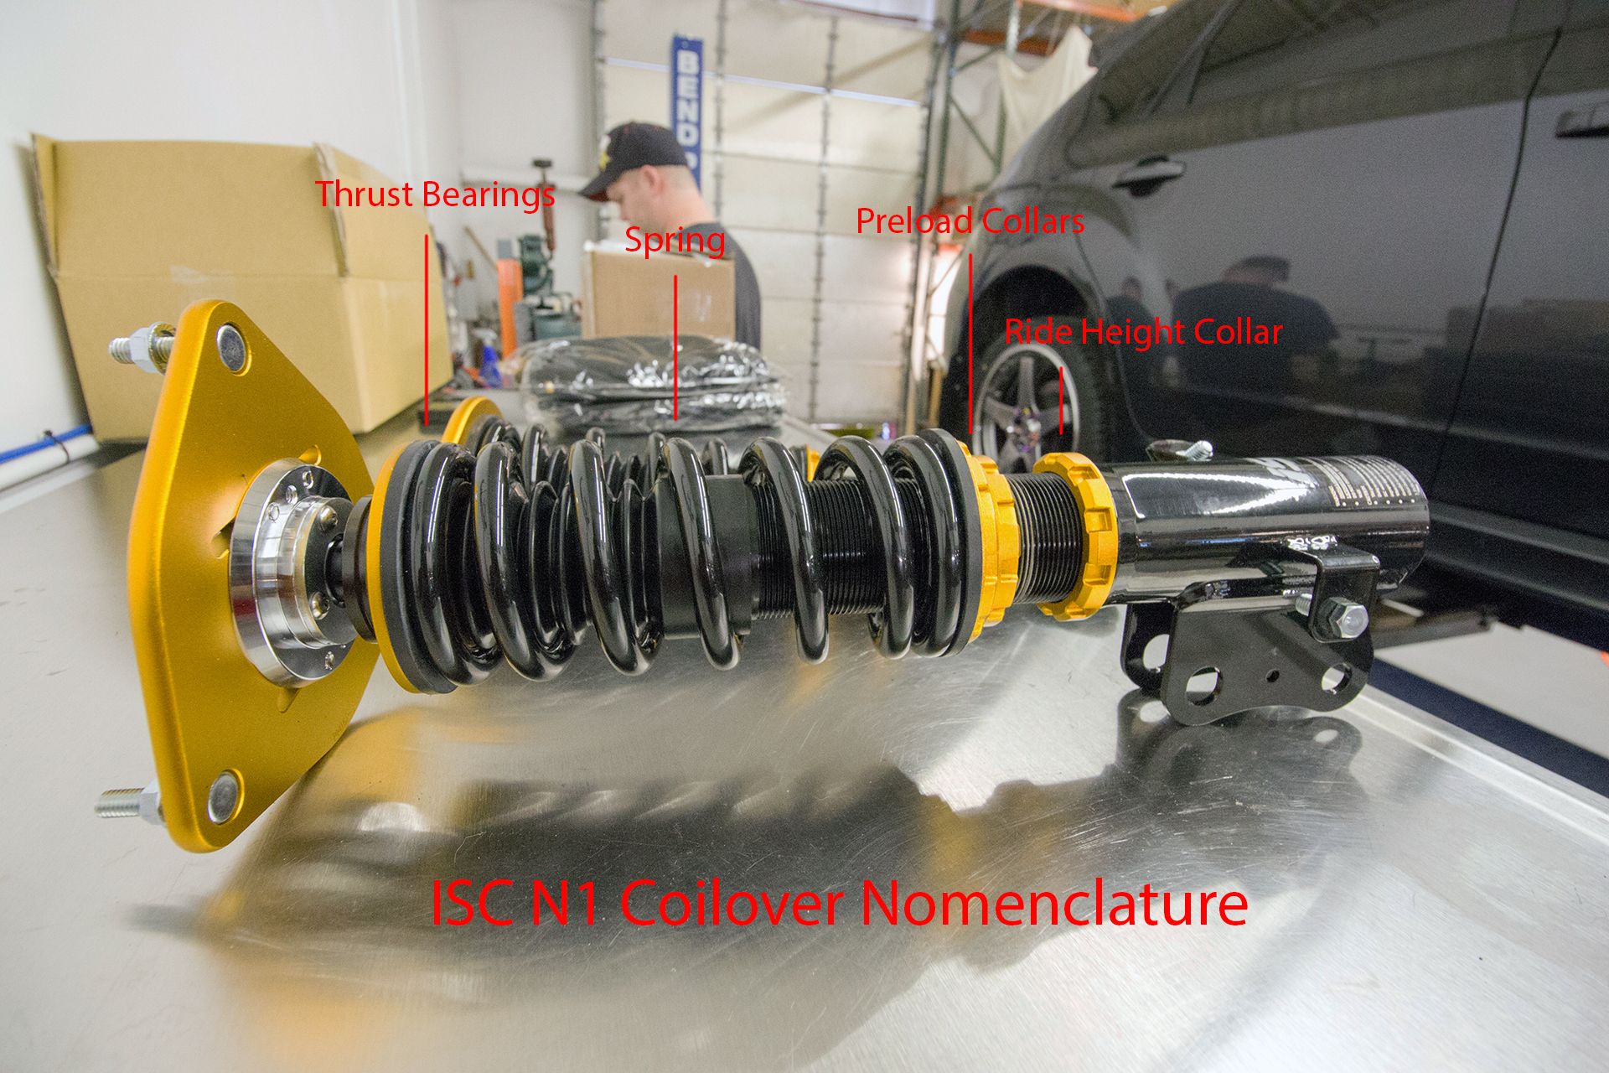
- Ensure that all collars have been anti-seized. We recommend breakdown of the coilovers to the base levels so that you can apply anti-seize to the collars and shaft. Base level means having only the shaft and top plate on the coilovers. From there you can anti-seize where the pre-load collars connect, and also where the bottom mount and ride height collar will be located at. Please view the following diagram for a breakdown of parts.

2. You can begin in the front, or the rear. For this installation we began in the rear. Remove the (1) 14mm bolt and the (2) 17mm bolts from the control arm assembly and let your control arm hang. This allows you to remove the rear coilover bottom mount. Repeat for the opposite side.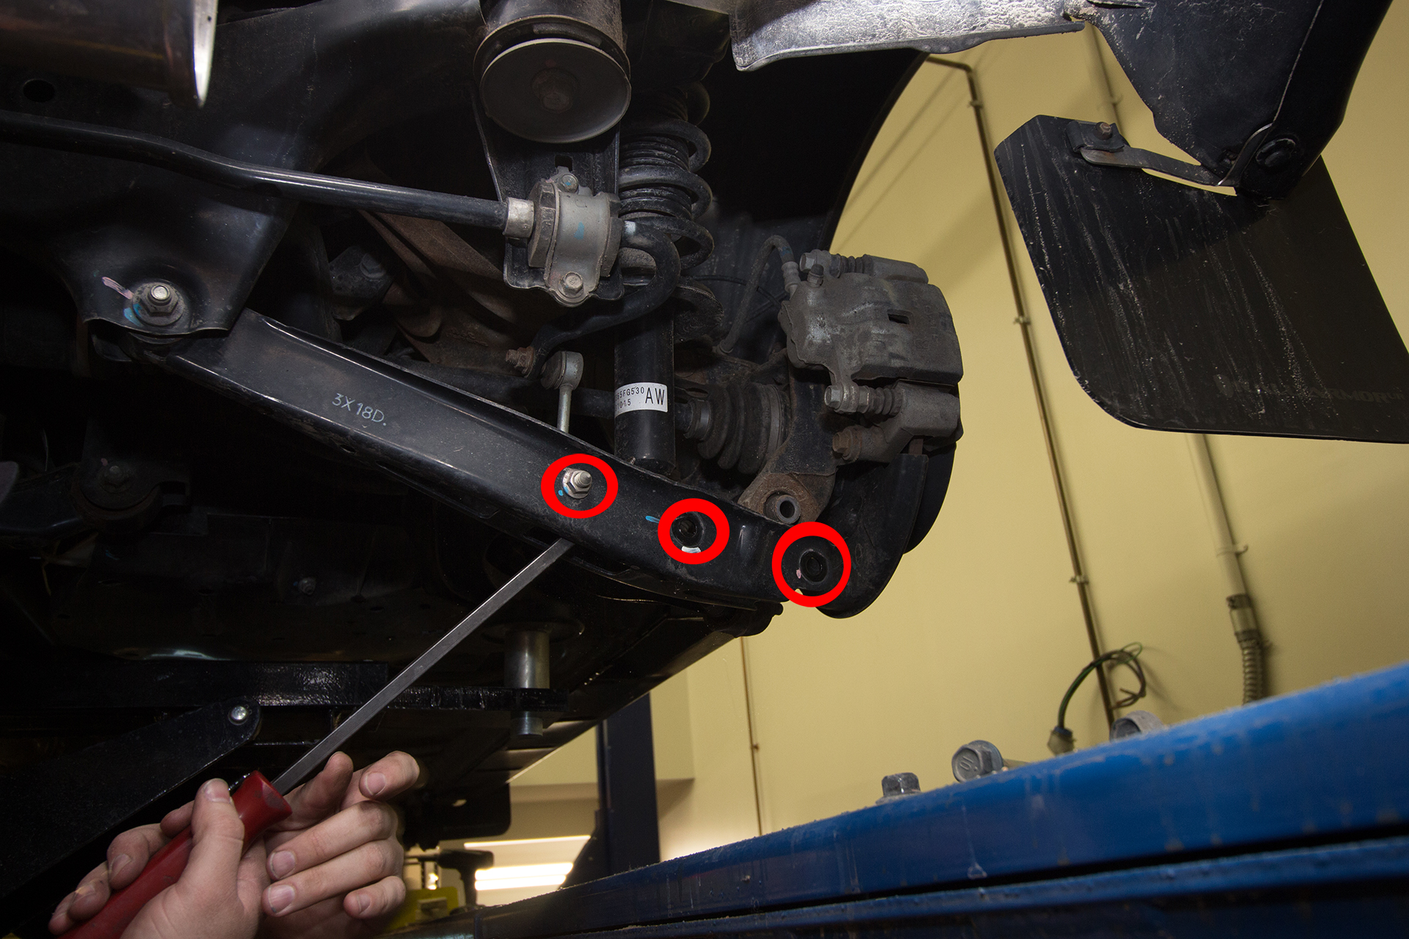

- Remove your rear trunk cover and plastic pieces. (2) 17mm bolts on both sides (circled in red). These bolts hold your OEM spring and strut combination in place.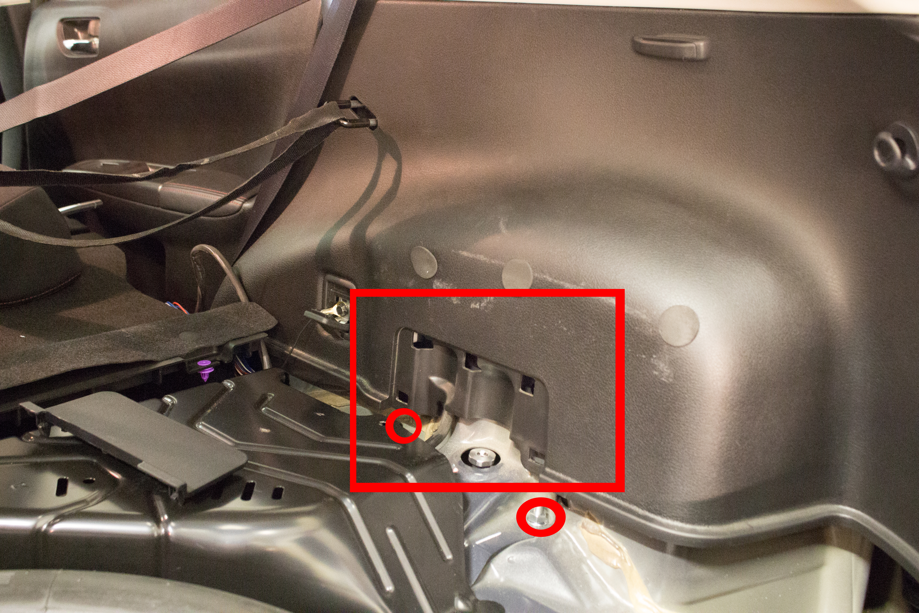
- Now you will simply need to re-bolt up the three bolts you removed earlier. A jack may be of assistance to get the rear hub assembly back into place, depending on how low you are going. You can adjust the ride height later on once the front coilovers are on. We suggest leaving the ride height collars loose until you can finalize your ride height. This can sometimes take a little while to figure out, make sure you are taking accurate measurements. Repeat on the opposite side.
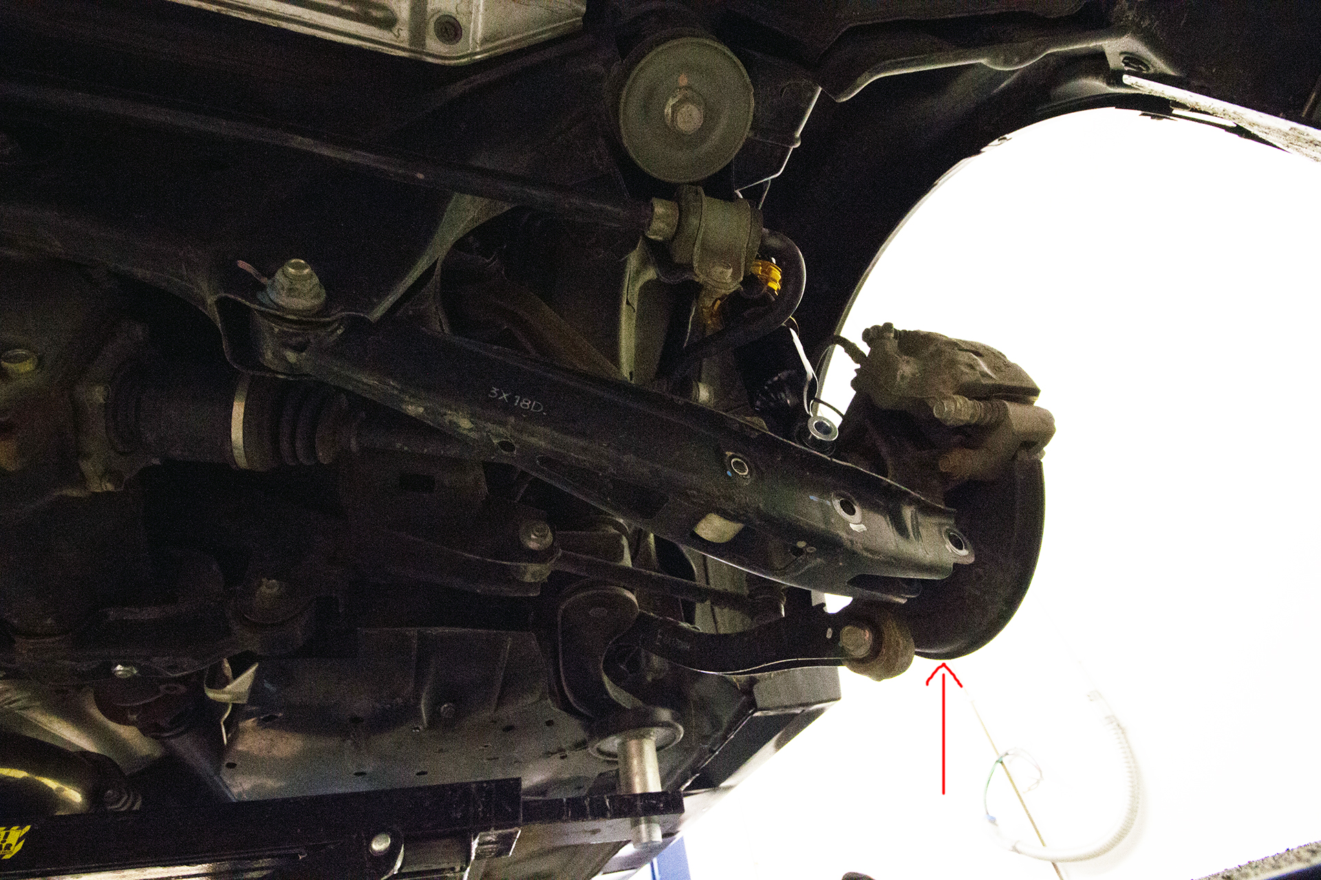
- Now you can move onto the fronts. On the top of the front coilovers there are (3) 12mm top nuts that hold your top plate in place. On the bottom mounts you also have (2) 19mm bolts, one of them being your camber bolt. Remove the (2) 19mm bolts (Squared in Red) first, then move onto the top (2) nuts. You can also remove you ABS sensor line and brake like bracket (Red Circled)
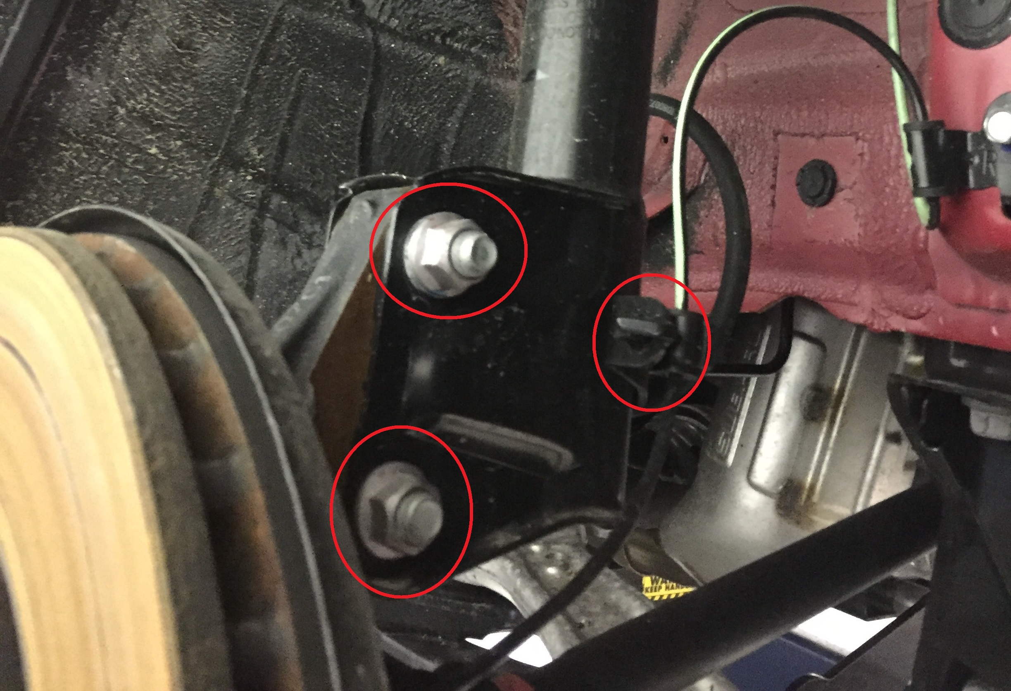

- Now you can move onto the top (3) bolts (circled in red) that keep the top of the spring and strut held in place. Remove these and then remove your OEM assembly.

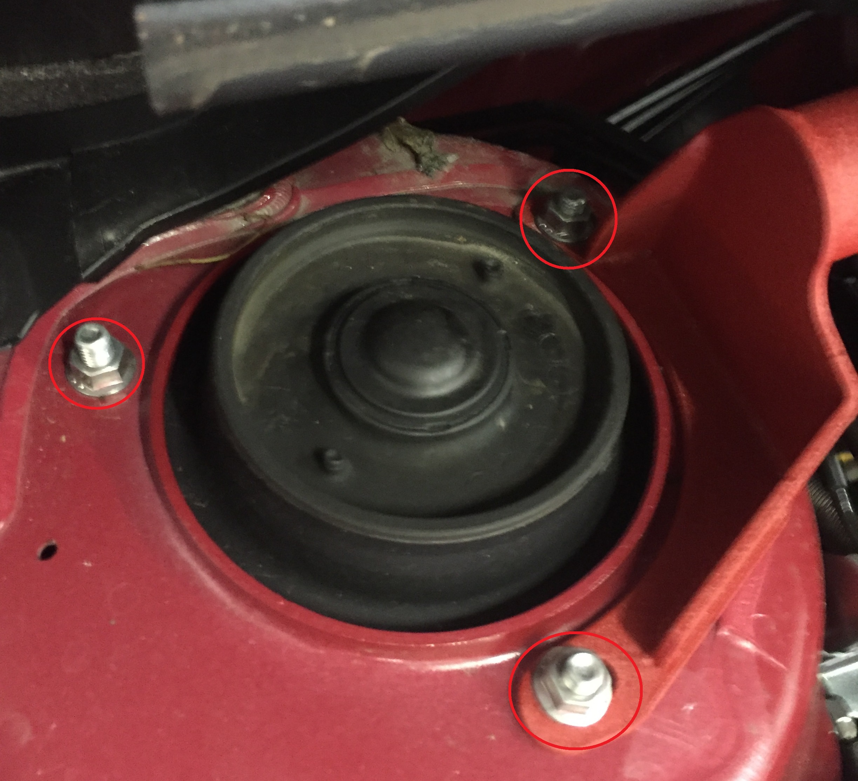

- Now you can install the new coilover. Ensure that you line up the camber plate correctly. Below is a photo of the proper camber plate orientation, which should be parallel (view arrow). For coilovers without camber plates, disregard the camber plate orientation.
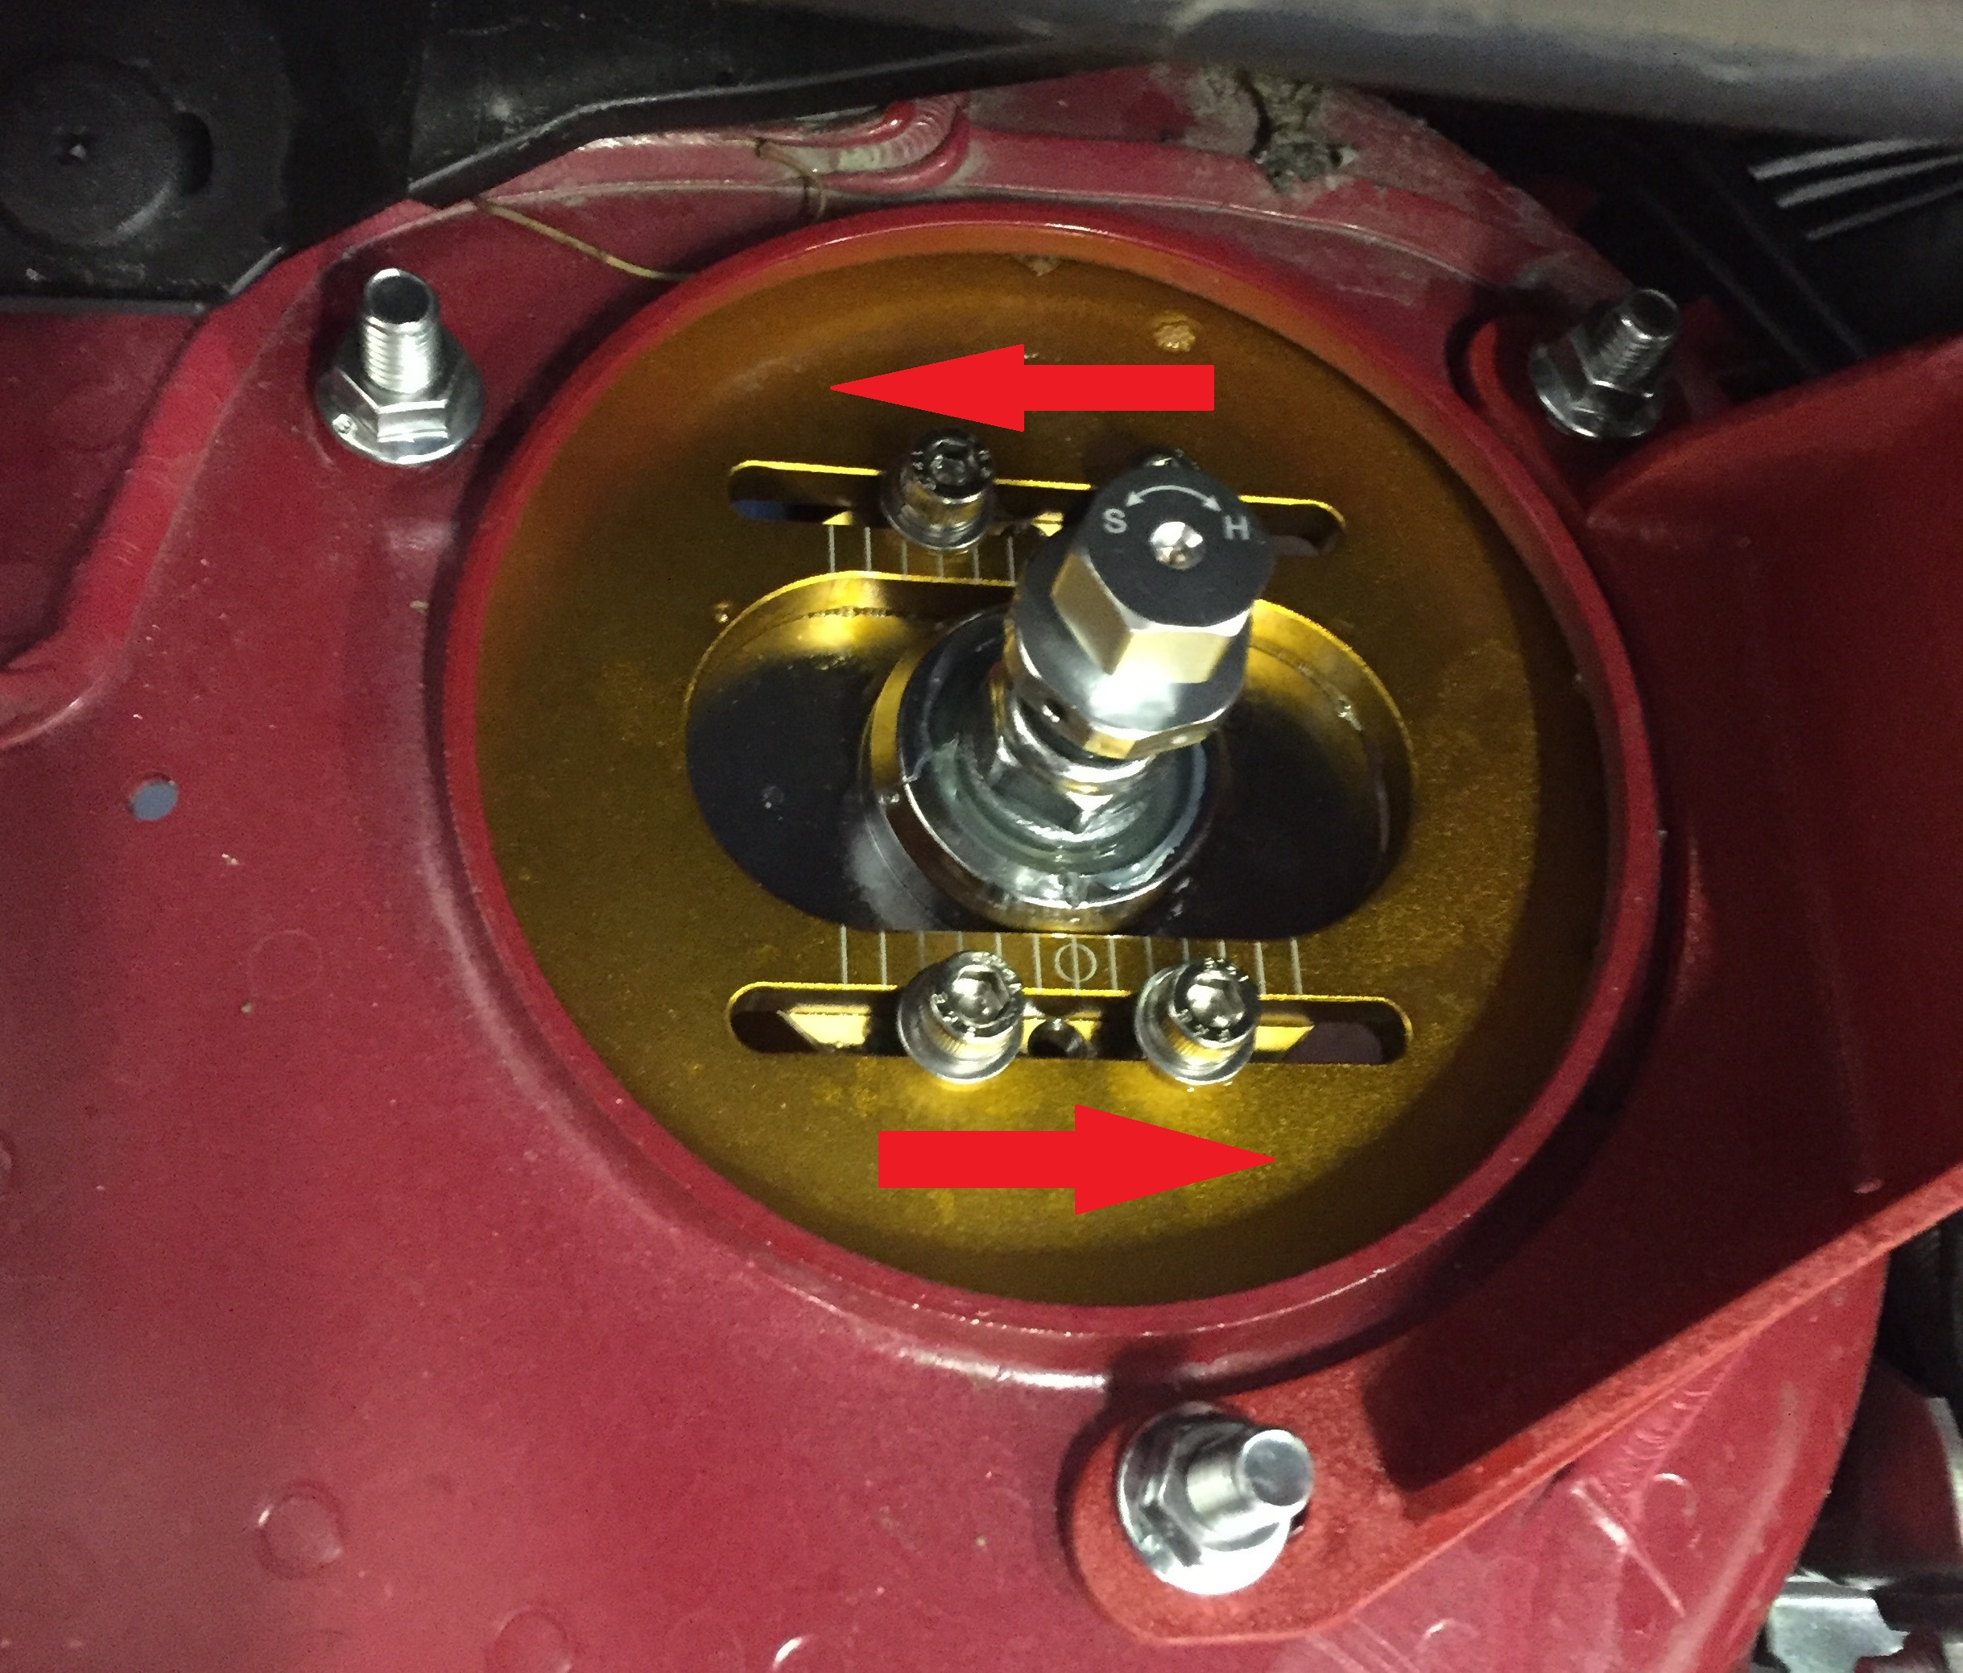
- Now that the top plate has been fully installed you can work on connecting the bottom mount to the front hub assembly. Shown below in red are both sides of the coilovers. You can see the (2) 19mm bolts and nuts as well as the brake line and abs sensor mounting points. Follow these steps for the opposite side as well. Again, we recommend keeping the ride height collars loose until you have finalized it. This makes it easier to make small adjustments.
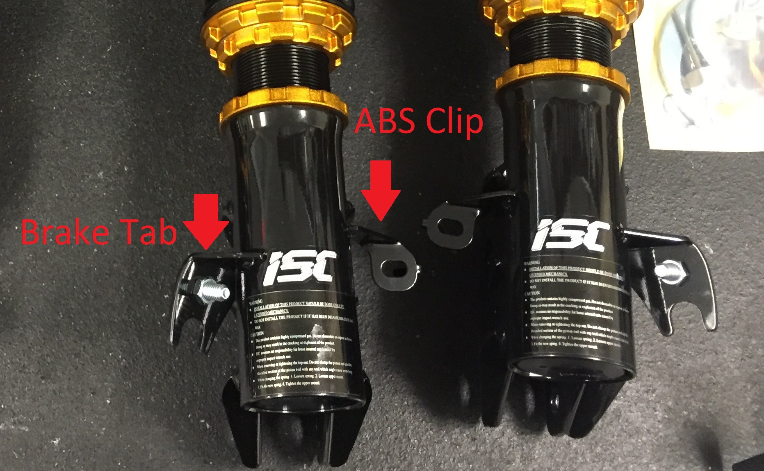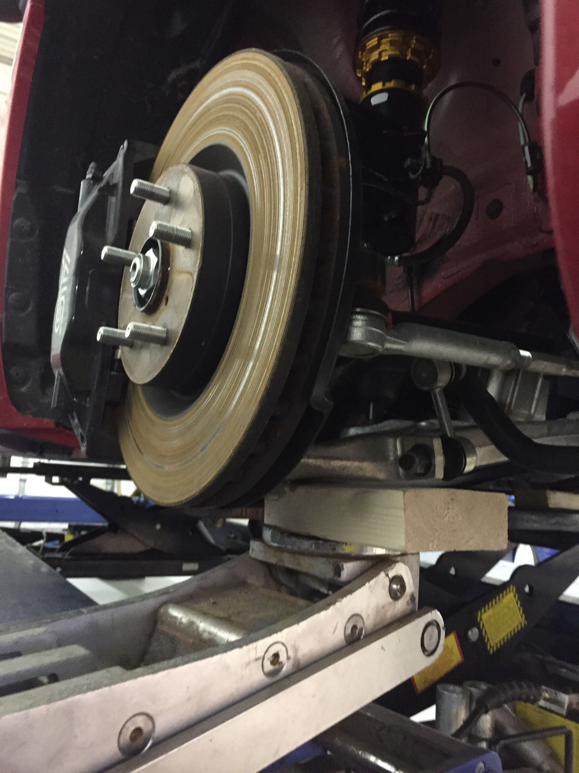

- You are almost done! Now that all the coilovers are installed, put your wheels back on and check ride height. Ride height will become lower once springs have settled. Rolling the vehicle back and forth will help the car settle closer to its final ride height. Dial in your ride height by measuring your fenders to the ground, adjust bottom mount as needed.

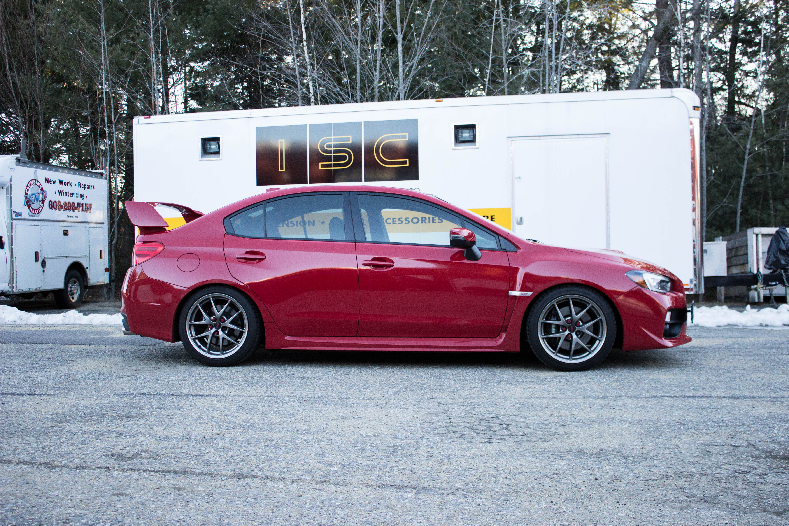

Adjusting Damping
- Bring your coilovers all the way to soft and adjust from there. Start at soft and move to hard. Do not go past 32 hard.

Now enjoy your coilovers!
